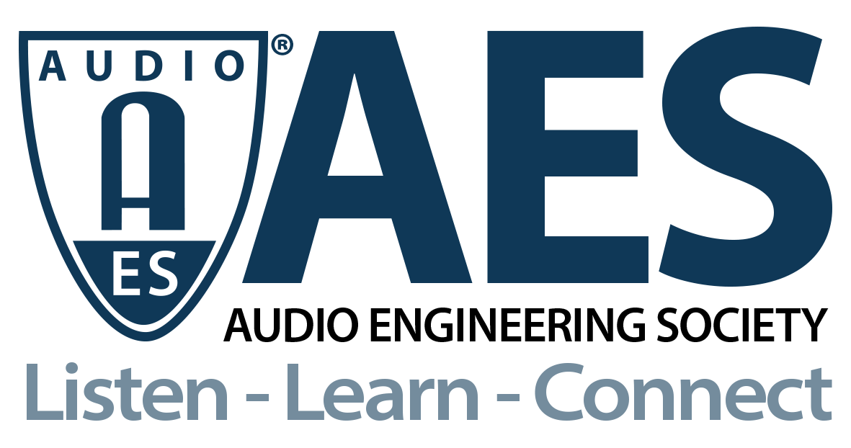

FOR IMMEDIATE RELEASE

New AES APEI Webinar to Focus on Audio Product Test and Manufacturing Strategies

— Two companies will detail cutting-edge solutions and strategies for detecting and solving problems and inefficiencies in the production line, focusing on audio product examples —

New York, NY, July 26, 2021 — The Audio Product Education Institute (APEI), an initiative of the Audio Engineering Society (AES), will host the webinar "Production Test and Manufacturing Strategies to Build Better Audio Products” on Wednesday, July 28 (12pm ET). The online event will address production line challenges with insights from audio test and measurement solutions supplier Audio Precision and from Instrumental, an AI-powered discovery, analysis and real-time monitoring manufacturing solutions provider, joined by supply chain and sourcing experts, David Lindberg (DB Enterprises) and Mike Klasco (Menlo Scientific).

Anna-Katrina Shedletsky, the co-founder of Instrumental, will explain how her company solves complex production line challenges when building products. Additionally, Daniel Knighten, General Manager, and Eric Hodges, Director of Marketing and Sales Operations, for Audio Precision, will explain how a new integrated audio test system helps with quality assessments, reducing setup and reconfiguration time.

Detecting and solving problems and inefficiencies in the factory floor is key to consistent and successful product strategies. The new product launch process is being challenged by compressed timelines and dramatically increasing engineering complexity. 20% of every dollar spent in manufacturing alone is wasted on things like scrap, rework, product returns, mistakes, experiments, and underutilized human resources.

Large audio manufacturers such as Bose, as well as many consumer electronics companies, trust Instrumental to accelerate product development timelines and improve production yields of their audio products by using artificial intelligence (AI) to aggregate and analyze all of their product data to discover root causes of production line problems and to resolve even the most complex issues. In the webinar, Shedletsky will explain how Instrumental can help eliminate defects in development and production through manufacturing case studies of audio devices with key components such as speakers, microphones and antennae.

Manufacturing test strategies for audio products depend greatly upon the management of variables for both “cost of test” and “cost of failure.” The goal of a manufacturing test is to ensure that the products manufactured, and ultimately shipped to retail or directly to customers, meet design specifications and perform as intended. Unfortunately, uncontrolled variability or tolerances in materials and manufacturing processes can directly, and negatively, impact the ability to achieve this goal. In this webinar, Audio Precision will explain the most effective way to test products to ensure they meet specifications. Knighten and Hodges will also detail how the new APx517B acoustic audio analyzer, developed specifically with the manufacturing environment in mind, can be conveniently and efficiently adapted for different test strategies.

After the presentations, attendees will have a valuable opportunity to ask the presenters questions. The pillar chairs and the presenters will also address topics such as the pandemic-based challenges on the production chain and broken supply chains, finding and selecting manufacturing partners in different regions of the globe, the manufacturing reliance on China, and foreseeable challenges and misalignments in electronics manufacturing.

Webinar information and registration: https://audioproducteducationinstitute.org/production-test-and-manufacturing-strategies-to-build-better-audio-products/

…ends 471 words

Photo File 1: APEI2021SocialPromo-SupplyChain9-12x9.jpg
Photo Caption 1: The AES Audio Product Education Institute addresses cutting-edge solutions and strategies for detecting production line problems, and testing audio products, in the webinar "Production Test and Manufacturing Strategies to Build Better Audio Products” on Wednesday, July 28, at 12:00pm EDT.

Photo File 2: APEI2021SocialPromo-SupplyChain9TClean.jpg
Photo Caption 1: A new AES Audio Product Education Institute webinar "Production Test and Manufacturing Strategies to Build Better Audio Products” – focused on Supply Chain & Sourcing – jumps directly to the factory floor and focuses on specific production line challenges.

About the Audio Engineering Society
The Audio Engineering Society, celebrating over 70 years of audio excellence, now counts over 12,000 members throughout the U.S., Latin America, Europe, Japan and the Far East. The organization serves as the pivotal force in the exchange and dissemination of technical information for the industry. Currently, its members are affiliated with 90 AES professional sections and more than 120 AES student sections around the world. Section activities include guest speakers, technical tours, demonstrations and social functions. Through Conventions, Conferences, Training and Development and Member Events, and the Society’s vast online resources, members experience valuable opportunities for professional networking and personal growth. For additional information, visit AES.org.

About the Audio Product Education Institute (APEI)
The Audio Product Education Institute (APEI) was launched in January 2020, as an initiative of the Audio Engineering Society (AES), to focus on promoting methodologies, practices and technologies involved in developing and bringing audio products to market. The Institute roadmap intends to focus on seven educational pillars: Voice and DSP; Supply Chain and Sourcing; Modeling and Measurement; Product Management; Automotive Audio; Artificial Intelligence and Machine Learning; and Business Management. For more information, visit https://audioproducteducationinstitute.org.

Join the conversation and keep up with the latest AES News and Events:
Twitter: #AESorg (AES Official)
Facebook: facebook.com/AES.org

AES Marketing Communications:
Email: robert.clyne@aes.org
Tel: 615-662-1616, Fax: 615-662-1636,
Clyne Media, Inc.,
169-B Belle Forest Circle, Nashville, TN 37221;
Web: http://www.clynemedia.com

