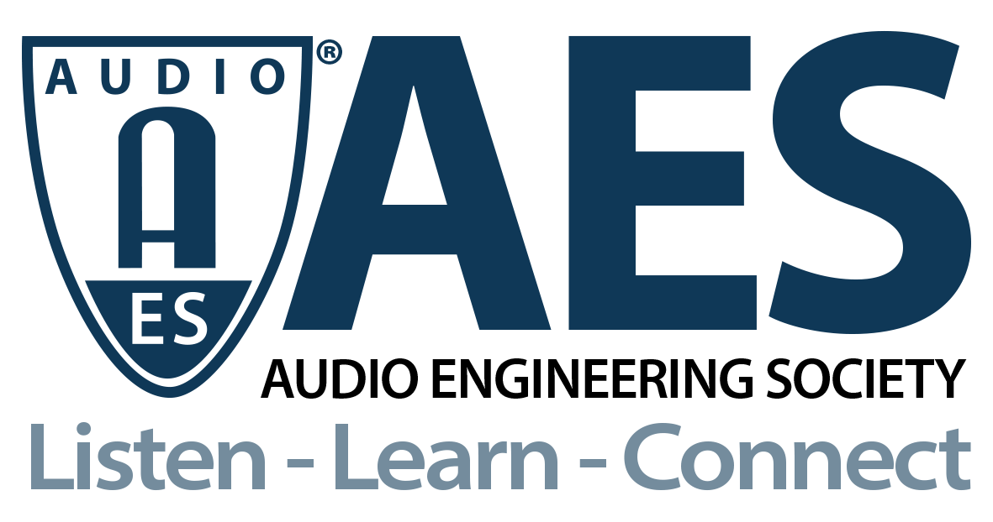

FOR IMMEDIATE RELEASE

AES Audio Product Education Institute Webinar Explores Automotive Immersive Audio

— September 15 webinar will feature presentations from Dolby Laboratories and Dirac Research detailing the technologies enabling the expansion of vehicle acoustic perceptions —

New York, NY, September 8, 2021 — The AES Audio Product Education Institute (APEI), created to promote methodologies, practices and technologies involved in developing and bringing audio products to market, will present a new free webinar on its Automotive Audio education pillar, addressing “Immersive Audio in Automobiles,” on Wednesday, September 15 (12:00pm EDT).

Expanding on a series of webinars covering automotive audio design and applications, the session will explore the different ways to translate immersive audio content and generate immersive experiences. Currently top-of-mind for both automotive brands and consumers, immersive audio reproduction results from a convergence of multiple technologies and concepts, from multichannel playback to acoustic auralization of perceived listening spaces, to DSP enhancement of sound reproduction.

The term “Immersive Audio” used to describe a channel-based, height-inclusive, object-oriented production process first appeared eleven years ago, and criteria standards by the Society of Motion Picture and TV Engineers (SMPTE) were added subsequently. With consumers now being offered immersive, 3D audio, and spatial audio experiences in all types of playback platforms, and with actual immersive audio formats, such as Dolby Atmos, becoming widely recognized, it’s only natural that automotive audio has followed the trend and strives to take it a step further.

During this webinar, Roger Shively (JJR Acoustics), APEI’s Automotive Audio pillar chair, will discuss what we define as “Immersive Audio,” how this is driving automotive audio speaker architectures, and how existing architectures are being used. Other topics to be explored include the challenges of tuning and distributing sound for the intended experience, the role of cross-talk cancellation, a comparison of content-based up-mixing vs. context-based up-mixing, and how to tune the car for immersive sound formats. Furthermore, what approaches are relevant for entry-, mid- and highest-tier systems?

To detail these topics and discuss the available technologies and solutions, Shively invited two key industry vendors, both leading the space from different perspectives.

Mathias Johansson, the Co-Founder and Chief Product Officer of Dirac Research, will discuss the nature of immersive content and the desired immersive experience and how to tune a car accordingly. Johansson will also cover other uses of immersive audio such as unconventional speaker layouts or Advanced Driver-Assistance Systems (ADAS). As a pioneer in the field of sound processing and optimization, Johansson has a rich experience in sound field control and immersive audio. He holds a PhD in signal processing from Uppsala University, Sweden.

Andreas Ehret, Director, Automotive, at Dolby Laboratories, will discuss how Dolby Atmos extracts the spatial objects from music and reproduces them to reveal details that provide great spatial clarity and depth, and how that is applied to automotive audio. Based out of Nuremberg, Germany, Ehret works on developing and expanding Dolby’s Automotive business with Dolby Atmos in cars a key strategic ingredient.

Learn more and register for free here: https://audioproducteducationinstitute.org/immersive-audio-in-automobiles/.

…ends 456 words

Photo File 1: APEI-2021-ImmersiveAutomotiveAudio-Sept15-12x9.jpg
Photo Caption 1: Mathias Johansson (Dirac Research) and Andreas Ehret (Dolby) will detail the design and technologies for automotive immersive experiences in the next AES Audio Product Education Institute webinar on Wednesday, September 15.

Photo File 2: APEI-2021-ImmersiveAutomotiveAudio-Sept15-cleanT.jpg
Photo Caption 2: The AES Audio Product Education Institute will present the free webinar “Immersive Audio in Automobiles” on Wednesday, September 15, at 12:00pm EDT.

About the Audio Engineering Society
The Audio Engineering Society, celebrating over 70 years of audio excellence, now counts over 12,000 members throughout the U.S., Latin America, Europe, Japan and the Far East. The organization serves as the pivotal force in the exchange and dissemination of technical information for the industry. Currently, its members are affiliated with 90 AES professional sections and more than 120 AES student sections around the world. Section activities include guest speakers, technical tours, demonstrations and social functions. Through Conventions, Conferences, Training and Development and Member Events, and the Society’s vast online resources, members experience valuable opportunities for professional networking and personal growth. For additional information, visit AES.org.

About the Audio Product Education Institute (APEI)
The Audio Product Education Institute (APEI) was launched in January 2020, as an initiative of the Audio Engineering Society (AES), to focus on promoting methodologies, practices and technologies involved in developing and bringing audio products to market. The Institute roadmap intends to focus on seven educational pillars: Voice and DSP; Supply Chain and Sourcing; Modeling and Measurement; Product Management; Automotive Audio; Artificial Intelligence and Machine Learning; and Business Management. For more information, visit https://audioproducteducationinstitute.org.

Join the conversation and keep up with the latest AES News and Events:
Twitter: #AESorg (AES Official)
Facebook: facebook.com/AES.org

AES Marketing Communications:
Email: robert.clyne@aes.org
Tel: 615-662-1616, Fax: 615-662-1636,
Clyne Media, Inc.,
169-B Belle Forest Circle, Nashville, TN 37221;
Web: http://www.clynemedia.com

