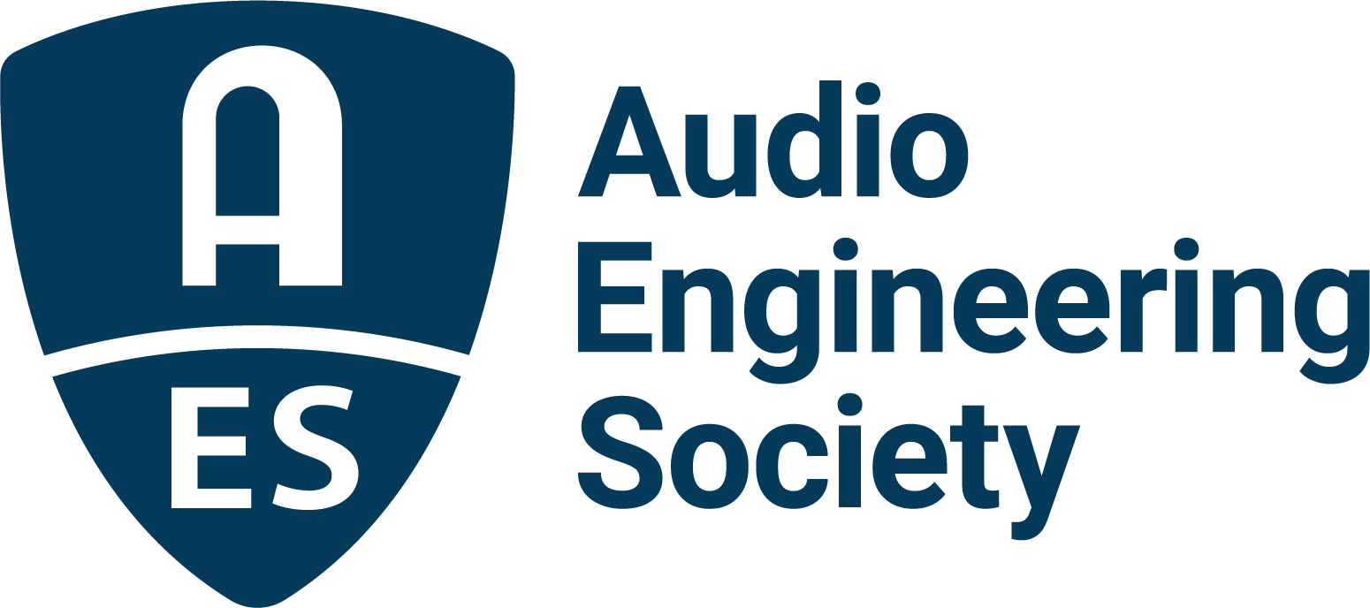

FOR IMMEDIATE RELEASE

AES Recognizes Outstanding Service and Contributions to the Industry

— The Audio Engineering Society congratulates this fall’s recipients of awards signifying exemplary service and dedication to the AES and the industry worldwide —

New York, NY, December 20, 2021 — The Audio Engineering Society announced the fall 2021 slate of honorees receiving AES Awards for distinguished achievement in the field of audio and service to the Society during an online ceremony on December 15. The awards ceremony was introduced by Awards Committee chair Nadja Wallaszkovits, and the awards were presented by AES President Jonathan Wyner.

The Society’s highest technical award, the AES Gold Medal Award, is given in recognition of outstanding achievements, sustained over a period of years, in the field of Audio Engineering. Gold Medal Awards were presented to Richard Factor and Tony Agnello “for making the world sound better – and often weirder – through the continuous development of signal processors that inspire users and delight listeners.” Factor and Agnello were recognized for their substantial and ongoing individual contributions to the advancement and application of audio science. Together, Factor – an Eventide Audio cofounder and chairman – and Agnello – managing director – continue to lead Eventide Audio as their company celebrates its 50th Anniversary of audio innovation.

AES Fellowship Awards, given to Members who have rendered conspicuous service or are recognized to have made a valuable contribution to the advancement in or dissemination of knowledge of audio engineering, or in the promotion of its application in practice, were presented to:
Ian Dennis for his contributions to the improvement of digital audio quality through the continuing development and enhancement of A/D and D/A converters, and test and measurement techniques.
Mark Ethier in recognition of significant contribution to the advancement of audio signal processing technology, innovation and accessibility.
Paul Gallo for decades of commitment to the growth and ongoing health of the professional audio industry and for unflagging advocacy for, and dedication to, the Audio Engineering Society.
Leslie Gaston-Bird for her ongoing commitment to audio education, for her years of AES section and regional leadership and as the inaugural Chair of the AES Diversity and Inclusion Committee.
Alexey Lukin in recognition of significant innovations and contributions in the areas of audio signal processing and audio education.
Doug McClement for decades of foundational contributions to the art of remote recording and for his crucial role in the education of countless audio professionals.
Valerie Tyler for her tireless contributions to AES Events and to the leadership of the Society.

AES Board of Governors Awards, given to Members rendering exceptional service to the Audio Engineering Society, were presented to:
Aníbal Ferreira in recognition of co-chairing the 2019 International AES Conference on Audio Forensics.
Valerie Tyler in recognition of co-chairing the 147th AES Convention in New York.
Joel Brito in recognition of co-chairing the 2020 International AES Latin American Conference, Virtual Rio.
Valerie Tyler in recognition of co-chairing the 149th AES Convention – AES Show 2020.
Paul Womack in recognition of co-chairing the 149th AES Convention – AES Show 2020.
Jonathan Wyner in recognition of co-chairing the 149th AES Convention – AES Show 2020.
Ruud Kaltofen in recognition of co-chairing the 150th AES Convention.
Bert Kraaijpoel in recognition of co-chairing the 150th AES Convention.
Michael Fleming in recognition of co-chairing the 2021 Audio Education Conference.
Bill Crabtree in recognition of co-chairing the 2021 Audio Education Conference.

The fall 2021 awards ceremony introduced a new category of AES award – The AES President’s Award. This award recognizes that contributions to the goals of the AES are often made collaboratively in groups. The President's Award may be given to a group of individuals in recognition of diligent and significant joint efforts on behalf of the Audio Engineering Society – those efforts making substantial contributions to the science or application of audio engineering.
Presented “for Outstanding Technical Achievement as a member of the TC-BOD drafting group whose exhaustive work resulted in the publication of the TC document TD1008: ‘Recommendations for Loudness of Internet Audio Streaming and On-Demand Distribution,’” the inaugural AES President’s Award went to: David Bialik, Rob Byers, Jim Coursey, Eelco Grimm, Bob Katz, John Kean. Scott Norcross, Robert Orban, Shawn Singh, Jim Starzynski and Alessandro Travaglini.

Additional awards are given at each Convention to the authors of the best peer-reviewed papers for that event. AES papers have driven the progress of audio technologies for over 70 years. During AES Fall 2021 – the 151st International Audio Engineering Convention – Convention Papers chairs Areti Andreopoulou and Braxton Boren presented the following awards:
The Best Technical Paper award, for the paper “Perceptual Evaluation of Interior Panning Algorithms Using Static Auditory Events,” was presented to author Thomas Robotham and co-authors Andreas Silzle, Anamaria Nastasa, Alan Pawlak and Jürgen Herre
The Best Student Paper award, for the paper “InSE-NET: A Perceptually Coded Audio Quality Model based on CNN,” was presented to author Guanxin Jiang and co-authors Arijit Biswas, Christian Bergler and Andreas Maier
Honorable mentions were given for the following outstanding papers:
- “Effects of Near-field Sources on Ambisonics Recording and Playback,” author: Raimundo Gonzalez, co-authors: Archontis Politis and Tapio Lokki
- “Phoneme Mappings for Online Vocal Percussion Transcription,” author: Alejandro Luezas, co-authors: Charalampos Saitis and Mark Sandler
- “Informed post processing for auditory roughness removal for low-bitrate audio coders,” author: Steven van de Par, co-authors: Sascha Disch, Andreas Niedermeier and Bernd Edler.

The Awards ceremony can be viewed on the AES YouTube channel, and the awards ceremony program, with recipient bios, is online for viewing and download.

The AES 2021 Fall Awards Ceremony program: https://drive.google.com/file/d/17Ne7s65LL3Lc10xrMF6WXX1zAFjJ4SLe/view
The AES 2021 Fall Awards Ceremony video:
https://www.youtube.com/watch?v=yY1fYnbx0ww

…ends 883 words

Photo File 1: AES_Awards_2021.JPG
Photo Caption 1: The Audio Engineering Society presented its annual AES Awards for distinguished achievement in the field of audio and service to the Society during an online ceremony on December 15, 2021.

About the Audio Engineering Society
The Audio Engineering Society, celebrating over 70 years of audio excellence, now counts over 12,000 members worldwide. The organization serves as the pivotal force in the exchange and dissemination of technical information for the professional audio community. Currently, its members are affiliated with 90 AES professional sections and more than 120 AES student sections around the world. Section activities include guest speakers, technical tours, demonstrations, online events and social functions. Through Conventions, Conferences, Training and Development, and Member Events, as well as the Society’s vast online resources, members experience valuable opportunities for professional networking and personal growth. For additional information, visit aes.org.

Join the conversation and keep up with the latest AES News and Events:
Twitter: #AESorg (AES Official)
Facebook: facebook.com/AES.org

AES Marketing Communications:
Email: robert.clyne@aes.org
Tel: 615-662-1616, Fax: 615-662-1636,
Clyne Media, Inc.,
169-B Belle Forest Circle, Nashville, TN 37221;
Web: http://www.clynemedia.com

