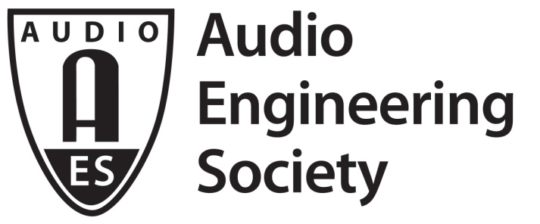

FOR IMMEDIATE RELEASE

AES Announces Results of 2021 Elections

— Bruce Olson will join the Board of Directors as President-Elect —

New York, NY, July 29, 2021 — The Audio Engineering Society has announced the incoming Officers and Governors following the 2021 Board of Directors and Board of Governors elections. The Society’s membership has elected AES’s Standards Committee Chair for the past decade, Bruce Olson, as President-Elect. Additionally, Jorge M. Azama has been elected as Vice President Latin America Region; Kazuhiko Kawahara has been elected as Vice President Asia-Pacific Region; Ewa Lukasik has been elected as Vice President Central Region, Europe; Alberto Pinto has been re-elected as Vice President Southern Europe/Middle East/Africa Region; and Bill Schulenburg has been elected Vice President Central Region, USA/Canada. Newly elected Governors are Prince Charles Alexander, Areti Andreopoulou and Hyunkook Lee. Save for the President-Elect, each newly-elected individual will serve a two-year term, while Pinto will have his current term of office extended by an additional two years. Olson will serve a year on the AES Board of Directors as President-Elect, in 2023 as President, in 2024 as Past-President, followed by two years as a Governor. All those newly elected will begin their terms on January 1, 2022.

Outgoing from the Board of Governors as regional Vice Presidents are Ian Corbett (Central Region, USA/Canada), Thomas Görne (Central Region, Europe), Cesar Lamschtein (Latin America Region) and Shusen Wang (Asia-Pacific Region). Governors with terms ending at the end of 2021 are Brecht De Man, Valeria Palomino and Magdalena Piotrowska. De Man will continue to serve as a Board of Governors-elected Director in 2022. Additionally, Governor and Past-President (twice removed) David Scheirman will complete his five-year commitment to the BoG. Board of Governors-elected Director Alex Kosiorek will step down from the Board of Directors while continuing his final year as VP Western Region USA/Canada in 2022 and current Past-President Agnieszka Roginska will transition to Governor for the first year of a two-year term. Beginning one-year terms are President Jonathan Wyner, who will transition to Past-President, and President-Elect Joshua Reiss, who will become President.

“The AES is extremely fortunate to have so many amazing audio professionals willing to serve the Society in our elected leadership positions,” says President Jonathan Wyner. “Congratulations to all the newly elected Governors and officers – we look forward to working with them in the coming year. We sincerely thank all the candidates who stepped up and put their names on the ballot. To those whose terms of service are coming to a close, we express our deepest gratitude for their service and commitment to the Society.”

In addition to the Board elections, the AES Membership approved Bylaws updates on the timing of the Board of Governors-elected Director selection process and Bylaws document clarifications and formatting.

The election was monitored, and the results presented, by Gary Louie, Chair of the AES’s Tellers Committee.

For more information on the Audio Engineering Society, please visit www.aes.org.

The 2022 Audio Engineering Society Board of Directors will be:
Joshua Reiss: President
Jonathan Wyner: Past-President
Bruce Olson: President-Elect
Valerie Tyler: Secretary
Marina Bosi: Treasurer
Brecht De Man: Director
One additional Director will be named by the Board of Governors per the AES Bylaws within the next 60 days.

In addition to the Directors listed above, the 2022 Board of Governors will be:
Bill Schulenburg: Vice President, Central Region, USA/Canada
Ewa Lukasik: Vice President, Central Region, Europe
Gabriel Herman: Vice President, Eastern Region, USA/Canada
Alex Kosiorek: Vice President, Western Region, USA/Canada
Jorge M. Azama: Vice President, Latin American Region
Elena Prokofieva: Vice President, Northern Region, Europe
Alberto Pinto: Vice President, Southern Europe/Middle East/Africa Region
Kazuhiko Kawahara: Vice President, Asia-Pacific Region
Prince Charles Alexander: Governor
Areti Andreopoulou: Governor
Hyunkook Lee: Governor
Brad McCoy: Governor
Agnieszka Roginska: Governor
Nadja Wallaszkovits: Governor
Paul “Willie Green” Womack: Governor
Jun Yamazaki: Governor

...ends 697 words

Photo File: Bruce_Olson.JPG
Photo Caption: Bruce Olson, AES President-Elect 2022

About the Audio Engineering Society
The Audio Engineering Society, celebrating over 70 years of audio excellence, now counts over 12,000 members throughout the U.S., Latin America, Europe, Japan and the Far East. The organization serves as the pivotal force in the exchange and dissemination of technical information for the industry. Currently, its members are affiliated with 90 AES professional sections and more than 120 AES student sections around the world. Section activities include guest speakers, technical tours, demonstrations and social functions. Through local AES section events members experience valuable opportunities for professional networking and personal growth. For additional information, visit aes.org.

Join the conversation and keep up with the latest AES News and Events:
Twitter: #AESorg (AES Official)
Facebook: facebook.com/AES.org

AES Marketing Communications:
Email: robert.clyne@aes.org
Tel: 615-662-1616, Fax: 615-662-1636,
Clyne Media, Inc.,
169-B Belle Forest Circle, Nashville, TN 37221;
Web: http://www.clynemedia.com

