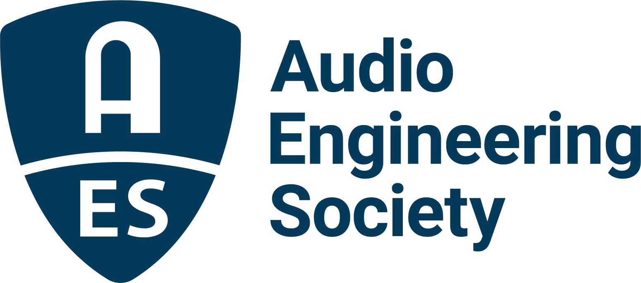

FOR IMMEDIATE RELEASE

AES Mastering Academy to Demystify the Art and Science of Mastering

— Two-day dedicated event will bring together mastering engineers to provide learning and insights on the craft —

New York, NY, November 1, 2021 — The Audio Engineering Society continues its presentation of industry-leading technical programs and events with the upcoming AES Mastering Academy: Demystified, being held online November 17 – 18, 2021. Chaired and organized by AES President Jonathan Wyner, sessions will host a wide range of industry professionals who will provide experience, knowledge, advice and guidance on a variety of topics, from project management and legal decisions, to gear, acoustics, loudness, and more. The AES Mastering Academy: Demystified is sponsored by Gold Partners iZotope and Steinberg, and Key Partner The Recording Academy® Producers & Engineers Wing®. Registration and preliminary program information is available on the AES Mastering Academy: Demystified event page.
“Technology has developed to the point that the discipline of mastering is approachable by everyone with a CPU and a competent DAW. While workflows have changed, mastering audio requires a knowledge and skill set that the practitioner would do well to become familiar with. The proliferation of audio formats and new technologies brings challenges in processing, formatting and delivery of the final distribution-ready master to convey the artist’s vision to the listener,” states Wyner. “This first event in our new AES Mastering Academy series will ‘demystify’ some of the process of mastering. I look forward to hearing from more than 20 accomplished mastering engineers from around the world and from all aspects of the industry.”

At this first event in the AES’s new Mastering Academy event series, sessions will begin with “Mastering studio business and technology infrastructure,” including topics such as legal entities, marketing, deliverables, project management and other important considerations for operating a successful mastering business. The program will continue with a primer on “Core Issues of the Discipline,” offering insights on acoustics, gear (including headphone options), and the asset formats required for 21st-century distribution. The session “Essential Topics in Processing” will walk attendees through the process of creating a master, from initial assessment to establishing realistic aesthetic goals to incorporating references and preparing content for final output. Another featured session will take on advanced topics with a deep-delve into mid/side sum difference processing, loudness issues, translation between formats, artificial intelligence and machine learning in mastering, and ways to practice and improve your own techniques in the studio.

Registration for the AES Mastering Academy: Demystified is $49 for AES Members and $99 for non-members. AES Student Members can register for just $25. Registration and additional information can be found on the AES Mastering Academy: Demystified event page.

…ends 405 words

Photo File 1: AES_MasteringAcademyDemystified.JPG
Photo Caption 1: The AES announces its AES Mastering Academy: Demystified event to take place November 17 – 18, 2021

Photo File 2: Jonathan_Wyner.JPG
Photo File 2: Jonathan Wyner, AES President and Mastering Academy: Demystified chair

About the Audio Engineering Society
The Audio Engineering Society, celebrating over 70 years of audio excellence, now counts over 12,000 members worldwide. The organization serves as the pivotal force in the exchange and dissemination of technical information for the professional audio community. Currently, its members are affiliated with 90 AES professional sections and more than 120 AES student sections around the world. Section activities include guest speakers, technical tours, demonstrations, online events and social functions. Through Conventions, Conferences, Training and Development, and Member Events, as well as the Society’s vast online resources, members experience valuable opportunities for professional networking and personal growth. For additional information, visit aes.org.

Join the conversation and keep up with the latest AES News and Events:
Twitter: #AESorg (AES Official)
Facebook: facebook.com/AES.org

AES Marketing Communications:
Email: robert.clyne@aes.org
Tel: 615-662-1616, Fax: 615-662-1636,
Clyne Media, Inc.,
169-B Belle Forest Circle, Nashville, TN 37221;
Web: http://www.clynemedia.com

