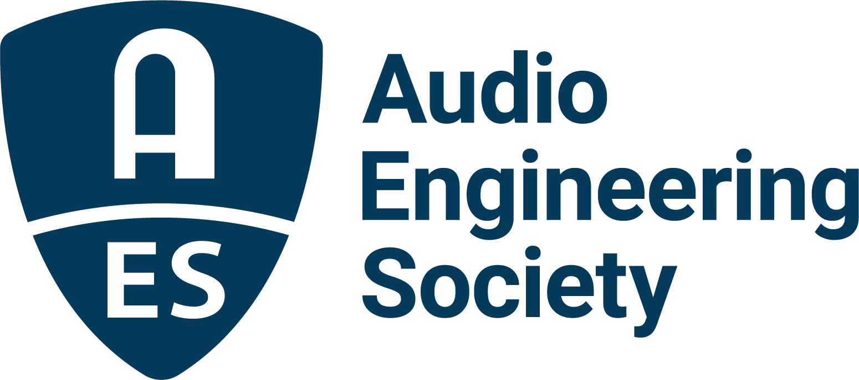

FOR IMMEDIATE RELEASE

AES DEI and Arup Announce Diversity in Audio Scholarship

New York, NY, August 26, 2022 – The Audio Engineering Society’s Diversity, Equity & Inclusion committee, in partnership with global built environment consulting firm Arup, is pleased to announce the Diversity in Audio Scholarship. This scholarship will support underrepresented voices in the industry and provide an opportunity for students to connect with and learn from leaders in the profession. “We are proud to partner with AES on this exciting opportunity to support the brightest minds. Through this scholarship we will continue to advance our shared goals of increased equity, diversity and inclusion within our industry. AES has our commitment, and we are looking forward to meeting our future leaders,” says Nathan Blum, Associate Principal and Acoustics, AV, Theatre and Experience Design Leader at Arup.
The recipients of the scholarship will be invited to attend the international AES New York 2022 Convention, where they will have the opportunity to experience the full range of learning and development opportunities offered throughout the event. Two students will each receive $2,000 toward travel, accommodations and costs associated with attending the convention. A professional from Arup’s Audiovisual team will accompany the scholarship recipients to offer support throughout the event, as well as mentorship and career guidance.

“Nurturing audio industry opportunities for students across all races, genders and gender identities, physical abilities, and nationalities is a core goal of the AES Diversity, Equity & Inclusion Committee,” says Cecelia Wu, AES DEI Committee co-chair. “Our partners at Arup have embraced that goal by funding and promoting the Diversity in Audio Scholarship which will provide what will no doubt be an amazing and life-changing experience for the Scholarship recipients.”

Eric Euting, Americas Equity, Diversity, and Inclusion Director at Arup, says, “The biggest challenge we face in diversifying workforce is the talent pipeline and ensuring to engage students’ interest in the industry at an early age. As part of Arup’s commitment to equity, diversity and inclusion, we created a scholarship program in 2021, and it has continued to expand in a short amount of time. We are excited to partner with AES as part of this continued expansion to help diversify our industry.”

Dedicated to sustainable development, Arup is a collective of designers, consultants and experts working globally to provide design, engineering, architecture, planning and advisory services across every aspect of the built environment.

Interested students must complete the online application and submit their resume/CV by September 5, 2022, to be considered for the scholarship. Detailed eligibility, criteria and application information can be found at https://tinyurl.com/Arup-AES-DEI.

…ends 411 words

Photo File 1: AES_DEI_logo.jpg
Photo Caption 1: The Audio Engineering Society’s Diversity, Equity & Inclusion committee, in partnership with global built environment consulting firm Arup, has announced the Diversity in Audio Scholarship to sponsor the AES New York 2022 Convention attendance of student recipients

About the Audio Engineering Society
The Audio Engineering Society, celebrating over 70 years of audio excellence, serves as the pivotal force in fostering the development and dissemination of technical information for the audio community. Currently, its members are affiliated with 90 AES professional sections and more than 120 AES student sections around the world. Section activities include guest speakers, technical tours, demonstrations, online events and social functions. Through Conventions, Conferences, Training and Development, Member Events and peer-reviewed Publications, as well as the Society’s vast online resources, members experience valuable opportunities for professional networking and personal growth. For additional information, visit AES.org.

Join the conversation and keep up with the latest AES News and Events:
Twitter: #AESorg (AES Official)
Facebook: facebook.com/AES.org
LinkedIn: https://www.linkedin.com/company/audio-engineering-society
Instagram: https://www.instagram.com/aes_org/

AES Marketing Communications:
Email: robert.clyne@aes.org
Tel: 615-662-1616
Clyne Media, Inc.,
169-B Belle Forest Circle, Nashville, TN 37221;
Web: http://www.clynemedia.com

