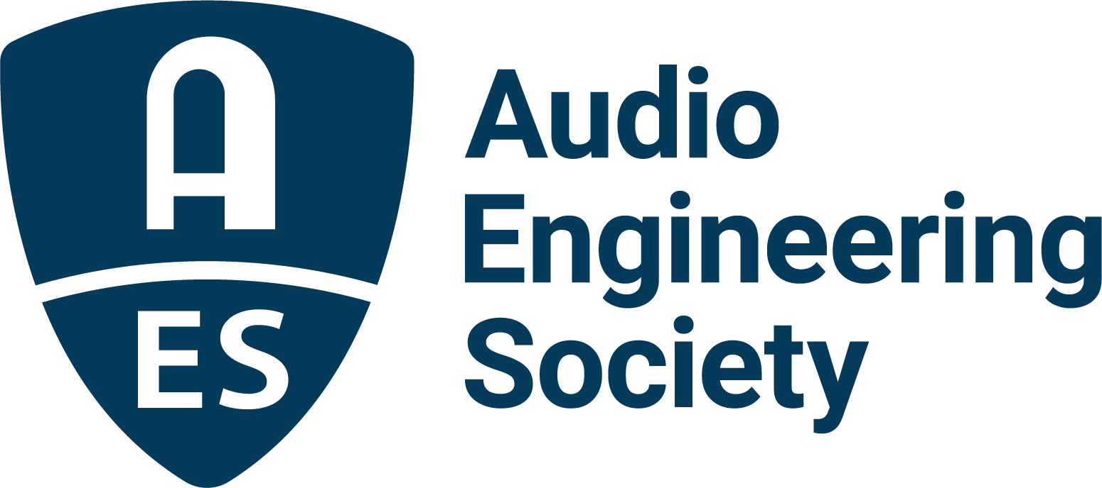

FOR IMMEDIATE RELEASE

AES New York Convention Early Bird Registration Options Extended Through September 12

— Register now before best pricing ends, and join the worldwide audio community at the Jacob Javits Center this October for the AES’s return to in-person U.S. conventions —

New York, NY, August 31, 2022 – The Audio Engineering Society has announced that Early Bird Registration rates and options for the upcoming AES New York 2022 Professional Audio Convention – making its return to the Jacob Javits Center this October – have been extended through September 12. AESShow.com is the destination for the best rates on All Access and Exhibits+ registration and for the Convention’s online-only component, as well as the portal for newly announced Tech Program session details, exhibitor information, discounted housing options and more. The highly anticipated return of the in-person Convention is co-located with the 2022 NAB New York Show to offer expansive opportunities for content creators, designers, students and researchers to engage with their peers, explore new hardware and software, and get up to date on the latest in audio science and practice.

Recently announced sessions include “Summer of Soul: Cultural Phenomenon and Technical Tour De Force,” a session taking an in-depth look at the challenges and triumphs of creating the Questlove-produced documentary celebrating the Harlem Cultural Festival of 1969, which captured performances by many of the biggest names in music of the day. The film was left largely uncompleted until last year, when it won the Sundance Festival’s Best Original Documentary Award, followed by a 2022 Academy Award. Additionally, a screening of the Summer of Soul documentary will take place on the evening of Wednesday, October 19th at the Dolby Theater. Registration will be required – details will be posted at AESShow.com.

Other special events will include the presentation “Recording and Mixing Bruce Springsteen’s ‘Born in the USA'” with engineers Toby Scott and Bob Clearmountain guiding attendees through the detailed process of recording this iconic track, featuring photos from the studio sessions and playback examples via digital transfers from the original multitrack, as well as “Power Station History and Innovation” where Emmy-winning composer and educator Stephen Webber will recount the storied history and technical innovations which made the Power Station a hub of musical and technical creativity, from its origins to its current incarnation as an extension of Berklee College of Music.

For the technically minded, the session “Real-Time Parallel DSP Processing on GPUs: An Introduction” will offer an AES-exclusive “first-look” at what could be a game-changing new use of current technologies for a variety of audio processing platforms and beyond, while the workshop “Mixing Spatial Audio in the Game Engine” will explore the workflow and sonic possibilities that are pushing the envelope for gamers and developers who seek the most demanding audio performance.

On the production front, “Atmos Music From Stems to Stern” will explore the ins-and-outs of one of the most popular immersive production platforms available with two of the most prominent engineers working in the genre – Buddy Judge and Andrew Scheps. And the session “Democratizing Music Creation,” led by Nadine Raihani and Caroline Lacoste, will discuss new and innovative assistive technologies in the service of music creativity and how innovative assistive tools can unleash creativity and make music creation more accessible to everyone.

Those sessions are just a sampling of AES New York 2022’s two full in-person days and two days of exclusive online streaming and on-demand content packed with workshops, special events and Papers covering all things audio. The AES New York 2022 Convention Tech Program page has the latest updates on the sessions and events and registration at Early Bird rates through September 12.

About the AES New York 2022 Convention
The ultimate audio experience begins in New York City with the return of the AES in-person Convention on October 19–20 (with additional training opportunities on October 18 and Tech Tours and Networking events on October 21). Then, on October 26–27, the online event will bring its own separately curated program of workshops and papers to a world-wide audience.

AES New York 2022 event partners include Dell, IMES (Iron Mountain Entertainment Services) and Qualcomm. The Convention will once again be collocated with NAB Show New York with a shared exhibits space. Exhibits+ registration, giving access to the in-person exhibition floor and related sessions, is free during the Early Bird period, while full technical program registration for the in-person or online components and All Access bundles are available at Early Bird pricing through September 12 at AESShow.com. AES members benefit from preferential pricing and complimentary Exhibits+ registration.

…ends 709 words

Links
AES New York 2022 Convention
AES New York 2022 Convention Preliminary Tech Program Details

Photo File 1: Summer_of_Soul.JPG
Photo Caption 1: The AES New York 2022 Convention featured session “Summer of Soul: Cultural Phenomenon and Technical Tour De Force” will examine the documentary celebrating the Harlem Cultural Festival of 1969, which captured performances by many of the biggest names in music of the day. A screening of the documentary will take place on the evening of the opening day of the Convention at the Dolby Theater in New York City.

Photo File 2: Born_in_the_USA.JPG
Photo Caption 2: In the AES New York 2022 Convention featured session “Recording and Mixing Bruce Springsteen’s ‘Born in the USA’,” Toby Scott and Bob Clearmountain will examine the process of recording this iconic track, featuring photos from the studio sessions and playback examples via digital transfers from the original multitrack.

About the Audio Engineering Society
The Audio Engineering Society, celebrating over 70 years of audio excellence, serves as the pivotal force in fostering the development and dissemination of technical information for the audio community. Currently, its members are affiliated with 90 AES professional sections and more than 120 AES student sections around the world. Section activities include guest speakers, technical tours, demonstrations, online events and social functions. Through Conventions, Conferences, Training and Development, Member Events and peer-reviewed Publications, as well as the Society’s vast online resources, members experience valuable opportunities for professional networking and personal growth. For additional information, visit AES.org.

Join the conversation and keep up with the latest AES News and Events:
Twitter: #AESorg (AES Official)
Facebook: facebook.com/AES.org
LinkedIn: https://www.linkedin.com/company/audio-engineering-society
Instagram: https://www.instagram.com/aes_org/

AES Marketing Communications:
Email: robert.clyne@aes.org
Tel: 615-662-1616
Clyne Media, Inc.,
169-B Belle Forest Circle, Nashville, TN 37221;
Web: http://www.clynemedia.com

