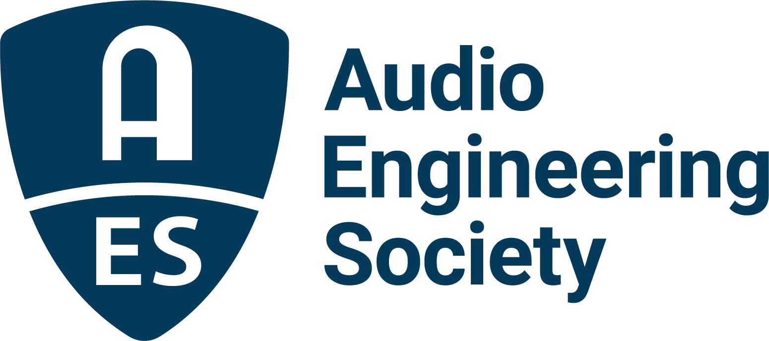

FOR IMMEDIATE RELEASE

The Twists and Turns of a Career in Audio Examined in Convention Heyser Lecture by Dr. Gilbert Soulodre at AES New York 2022

— This year’s popular Heyser Lecture will examine the many facets of a multi-disciplinary career in audio —

New York, NY, October 7, 2022 – With less than two weeks to go, as excitement for the AES New York 2022 Convention ramps up the Audio Engineering Society has announced that this year’s Heyser Lecture will be given by AES Fellow Dr. Gilbert Soulodre on Thursday, October 20, at 6:00pm. “A Funny Thing Happened on the Way to the Heyser Lecture – The Twists and Turns of a Career in Audio” will take an inspiring look at Soulodre’s winding path of converging audio opportunities and breakthrough moments that have helped his career and contributions to the collective audio community.
“Audio engineering is truly a multi-disciplinary field that combines aspects of room acoustics, psychoacoustics, spatial perception, analog and digital signal processing, mathematics, electromagnetics, computer modeling, psychology, musicality and artistry,” shares Dr. Soulodre. “Working in audio allows you to try your hand in completely different areas while still moving toward the same goal. For me, the AES has always served as the primary crossroads between these various fields and is the unique place where diverse viewpoints from all disciplines can come together. In this talk, I will discuss some of the research and product development work that I have done over the years, including a look at subjective listening test methods, spatial perception and immersion, loudness perception and metering, and sound source separation. During the unexpected winding path that my career has taken, I have had the great privilege of meeting and working with some of the ‘big names’ in the world of audio and acoustics. I will share anecdotes about some of these encounters and how they influenced my path forward, including a notable encounter with Richard Heyser early on in my career.”

Established in 1999 by the AES Technical Council and the Board of Governors, in conjunction with the Richard Heyser Scholarship fund, the Heyser Lecture series, featured at each AES Convention, brings eminent individuals in audio engineering and related fields to speak on a relevant topic of choice.

The Heyser Lecture is part of the AES New York 2022 Convention Special Event Series open to all registered Exhibits+ and All Access attendees. The extensive show floor exhibition showcasing over 100 brands and AES Experience sessions and select Student and Education events are available to all registrants. Upgrading to the comprehensive All Access Tech Program extends access to 100+ workshops, papers, panel discussions and more. The Convention Schedule-at-a-Glance, full Tech Program listings and registration options are available at AESShow.com.

About the AES New York 2022 Convention
The ultimate audio experience begins in New York City with the return of the AES in-person Convention on October 19–20, with additional training opportunities on October 18 and Tech Tours and Networking events on October 21. Then, on October 26–27, our online event will bring its own separately curated program of workshops and papers to a world-wide audience.

AES New York 2022 event partners include Avid, Dell, IMES (Iron Mountain Entertainment Services), The Recording Academy Producers & Engineers Wing and Qualcomm. The Convention will once again be collocated with NAB Show New York with a shared exhibits space. Exhibits+ registration, giving access to the in-person exhibition floor and related sessions, is free for AES Members and with available VIP codes. Full technical program registration for the in-person or online components and All Access bundles are also available for the full Convention experience. AES members benefit from preferential All Access pricing with deep discounts for student members. Find out more and register now at AESShow.com.

…ends 575 words

Links
AES New York 2022 Convention

Photo File 1: Gilbert_Soulodre.JPG
Photo Caption 1: Dr. Gilbert Soulodre will give the AES New York 2022 Convention Heyser Lecture “A Funny Thing Happened on the Way to the Heyser Lecture – The Twists and Turns of a Career in Audio” on Thursday, October 20, at 6:00pm.

About the Audio Engineering Society
The Audio Engineering Society, celebrating over 70 years of audio excellence, serves as the pivotal force in fostering the development and dissemination of technical information for the audio community. Currently, its members are affiliated with 90 AES professional sections and more than 120 AES student sections around the world. Section activities include guest speakers, technical tours, demonstrations, online events and social functions. Through Conventions, Conferences, Training and Development, Member Events and peer-reviewed Publications, as well as the Society’s vast online resources, members experience valuable opportunities for professional networking and personal growth. For additional information, visit AES.org.

Join the conversation and keep up with the latest AES News and Events:
Twitter: #AESorg (AES Official)
Facebook: facebook.com/AES.org
LinkedIn: https://www.linkedin.com/company/audio-engineering-society
Instagram: https://www.instagram.com/aes_org/

AES Marketing Communications:
Email: robert.clyne@aes.org
Tel: 615-662-1616
Clyne Media, Inc.,
169-B Belle Forest Circle, Nashville, TN 37221;
Web: http://www.clynemedia.com

