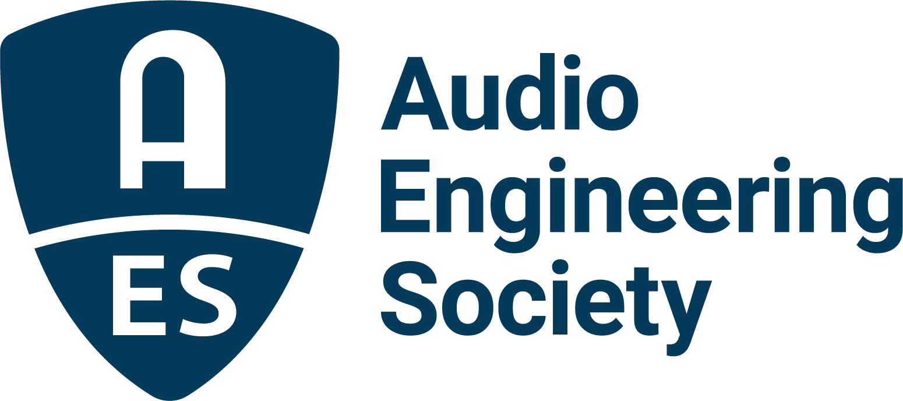

FOR IMMEDIATE RELEASE

Susan Rogers to Deliver Keynote at AES New York 2022 Convention

— Multi-talented producer, engineer and researcher will share insights on her latest explorations into audio cognition and perception, based on her storied career, experience and research —

New York, NY, August 25, 2022 – The Audio Engineering Society has announced that Susan Rogers will deliver the Thursday, October 20 Keynote at the AES New York 2022 Audio Engineering Convention.

Sharing her powerful perspectives as a multi-platinum producer/engineer, audio technician, author, educator and researcher, Rogers’ presentation, “This Is What It Sounds Like: A New Model of Music Cognition,” will give insights into a new model of music cognition that focusses on the “listener profile” – the constellation of individualized preferences mapped to an array of musical and aesthetic dimensions to create a better understanding of our own unique auditory experience. Rogers notes, “Before we become expert music makers, we must become expert listeners. Learning where the sweet spots reside on your unique ‘listener profile’ will deepen your relationship with the music you love.”

Rogers, a professor of cognitive neuroscience with a doctoral degree in experimental psychology from McGill University, is widely known for her work with Prince during the height of his career in the mid-1980s, along with a roster of artists including David Byrne, Barenaked Ladies, Geggy Tah, Nil Lara, Robben Ford, Tricky, Michael Penn and Jeff Black. Her Keynote address will explore the ties between musical and aesthetic dimensions of our listening, as well as the science behind our musical preferences and what may be inferred about us as creators and consumers of audio.
Rogers’ abstract for her “This Is What It Sounds Like: A New Model of Music Cognition” address reads in part: “Record making involves an implicit understanding of what generates a response in music listeners. How are these assumptions supported by science? Models of music perception and preference have recently expanded to include the unique, subjective ways in which listeners respond to stimuli...The music we respond to the most powerfully can reveal those parts of ourselves that are robustly linked to our sense of self identity. The brain structures underlying music preferences are formed over a lifetime of musical experiences, resulting in a profile that is unique for every music lover. The ways in which music preferences form and how they differ will be discussed.”

Rogers’ impact on the industry continued through her professorship at Berklee College of Music, where she taught psychoacoustics and record production in the department of Music Production & Engineering, and she became the first female recipient of the Music Producers Guild Award for Outstanding Contributions to U.K. Music in 2021. Most recently Rogers has coauthored a book with neuroscientist Ogi Ogas on her keynote topic: This Is What It Sounds Like: What the Music You Love Says About You, slated for release in September 2022.
Rogers’ full abstract for her Keynote address, along with a listing of confirmed sessions covering a comprehensive range of topics and presenter names, is now posted at the AES New York 2022 website with more details to follow soon.

About the AES New York 2022 Convention
The ultimate experience begins in NYC with the return of the unparalleled interaction of an in-person Convention on October 19–20 (with additional training opportunities on October 18 and Tech Tours and Networking events on October 21). Then, on October 26–27, the online event will bring its own separately curated program of workshops and papers to a world-wide audience.

AES New York 2022 event partners include Dell, IMES (Iron Mountain Entertainment Services) and Qualcomm. The Convention will once again be collocated with NAB Show New York with a shared exhibits space. Exhibits+ registration, giving access to the in-person exhibition floor and related sessions, is free during the Early Bird period, while full technical program registration for the in-person or online components and All Access bundles are available at Early Bird pricing through August 31 at AESShow.com. AES members benefit from preferential pricing.

…ends 618 words

Links
AES New York 2022 Convention

Photo File 1: Susan_Rogers.JPG
Photo Caption 1: Multi-talented producer, engineer, mixer, audio technician and educator Susan Rogers will share insights and her latest explorations in audio cognition and perception in her AES New York 2022 Convention Keynote “This Is What It Sounds Like: A New Model of Music Cognition.”

About the Audio Engineering Society
The Audio Engineering Society, celebrating over 70 years of audio excellence, serves as the pivotal force in fostering the development and dissemination of technical information for the audio community. Currently, its members are affiliated with 90 AES professional sections and more than 120 AES student sections around the world. Section activities include guest speakers, technical tours, demonstrations, online events and social functions. Through Conventions, Conferences, Training and Development, Member Events and peer-reviewed Publications, as well as the Society’s vast online resources, members experience valuable opportunities for professional networking and personal growth. For additional information, visit AES.org.

Join the conversation and keep up with the latest AES News and Events:
Twitter: #AESorg (AES Official)
Facebook: facebook.com/AES.org
LinkedIn: https://www.linkedin.com/company/audio-engineering-society
Instagram: https://www.instagram.com/aes_org/

AES Marketing Communications:
Email: robert.clyne@aes.org
Tel: 615-662-1616
Clyne Media, Inc.,
169-B Belle Forest Circle, Nashville, TN 37221;
Web: http://www.clynemedia.com

