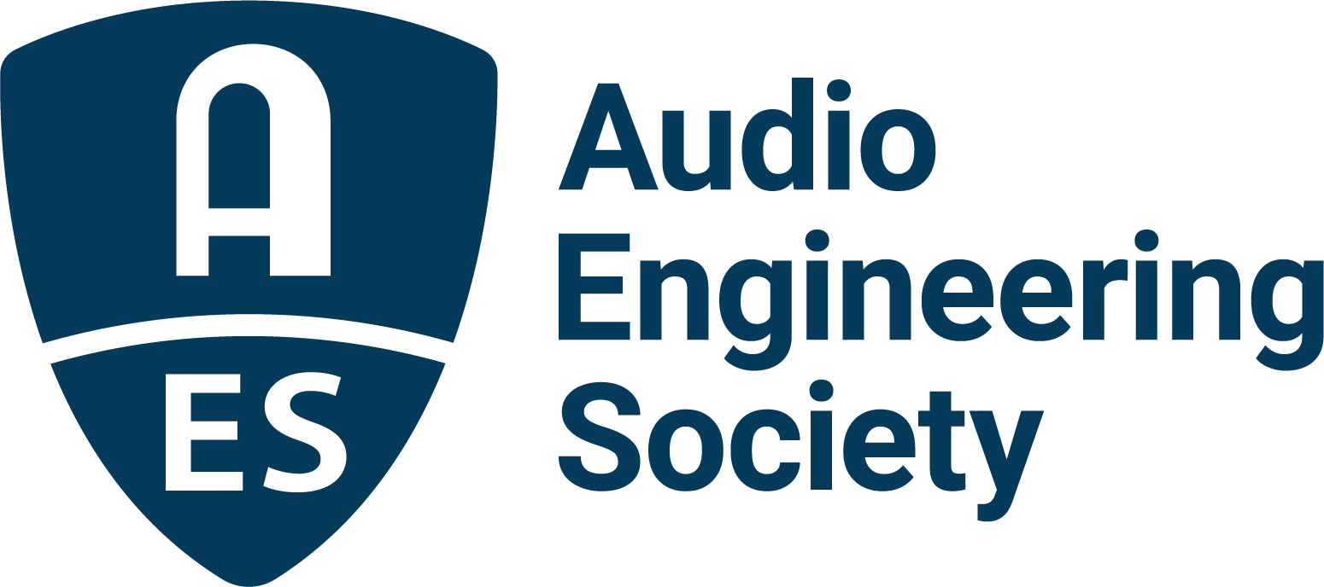

FOR IMMEDIATE RELEASE

Full Tech Program and Event Details Announced for AES New York Convention

— The AES gives attendees “All Access” to the latest in audio technology and practice along with the hottest names in music, games, live events and more this October —

New York, NY, September 16, 2022 – The details are now online of the content-packed, in-person All Access Technical Program for October’s eagerly-anticipated AES New York 2022 Convention. Early Bird pricing is still available until Friday September 23 for the first in-person Audio Engineering Society international convention in three years.

The A-Z list of presenters – more than 250 audio professionals ranging from Chuck Ainlay to Tomasz Zernicki – will deliver a hundred-plus new Workshops, Tutorials, Papers presentations and other sessions, with full details now available in the schedule at https://aesshow.com/aes-show-fall-2022/program/.

New events listed include the Recording and Technology sessions on a well-rounded variety of topics such as “Becoming Immersive in Music” and “Make Your Room Sound Right – Basics, Tips & Tricks,” as well as a look at “Remote Location Recording – From Here to Anywhere” and “Inspiring Creativity Through Music AI on TikTok and Beyond.” Newly announced Applications in Audio sessions include an examination from both production and consumer standpoints of “Trends in Audio Hardware,” which continues the Convention’s new audio tech focus; a “Score Mixing Compendium,” taking a look at different approaches to mixing a film score; and a pair of sessions examining the relationship of the analog and digital domains in “Software Modeling of Historical Analog Instrument Circuits” and “Producing Electronic Music Without a Computer.”

AESShow.com is the destination to claim best pricing on All Access or complimentary Exhibits+ registration through the Early Bird period. Exhibits+ registration offers two days of access to the Exhibition Floor, Keynotes and Special Event Series sessions, Experience Stages and more, while All Access registration also lets attendees experience the comprehensive Tech Program. It’s all taking place at the Jacob Javits Center, October 19–20, with additional training opportunities on October 18 and Tech Tours and Networking events on October 21. The Convention continues online, October 26–27, with a separately curated program of workshops, papers and presentations to a world-wide audience.

The complete AES New York 2022 Convention Tech Program information and announcements, hotel options and Early Bird registration are online at AESShow.com.

About the AES New York 2022 Convention
The ultimate audio experience begins in New York City with the return of the AES in-person Convention on October 19–20 (with additional training opportunities on October 18 and Tech Tours and Networking events on October 21). Then, on October 26–27, the online event will bring its own separately curated program of workshops and papers to a world-wide audience.

AES New York 2022 event partners include Avid, Dell, IMES (Iron Mountain Entertainment Services), The Recording Academy Producers & Engineers Wing and Qualcomm. The Convention will once again be collocated with NAB Show New York with a shared exhibits space. Exhibits+ registration, giving access to the in-person exhibition floor and related sessions, is free for all during the Early Bird period, while full technical program registration for the in-person or online components and All Access bundles are available at Early Bird pricing through September 12 at AESShow.com. AES members benefit from preferential pricing and complimentary Exhibits+ registration.

…ends 496 words

Links
AES New York Tech Program Schedule
AES New York 2022 Convention

Photo File 1: AESNY_Experience.JPG
Photo Caption 1: Full details of the upcoming AES New York 2022 Convention are now available online at AESShow.com.

Photo File 2: AESNY_Program.JPG
Photo Caption 2: AES New York 2022 Convention Technical Program session details are now online at AESShow.com.

About the Audio Engineering Society
The Audio Engineering Society, celebrating over 70 years of audio excellence, serves as the pivotal force in fostering the development and dissemination of technical information for the audio community. Currently, its members are affiliated with 90 AES professional sections and more than 120 AES student sections around the world. Section activities include guest speakers, technical tours, demonstrations, online events and social functions. Through Conventions, Conferences, Training and Development, Member Events and peer-reviewed Publications, as well as the Society’s vast online resources, members experience valuable opportunities for professional networking and personal growth. For additional information, visit AES.org.

Join the conversation and keep up with the latest AES News and Events:
Twitter: #AESorg (AES Official)
Facebook: facebook.com/AES.org
LinkedIn: https://www.linkedin.com/company/audio-engineering-society
Instagram: https://www.instagram.com/aes_org/

AES Marketing Communications:
Email: robert.clyne@aes.org
Tel: 615-662-1616
Clyne Media, Inc.,
169-B Belle Forest Circle, Nashville, TN 37221;
Web: http://www.clynemedia.com

