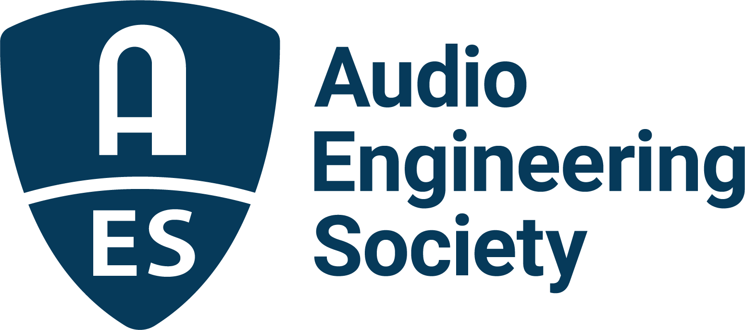

FOR IMMEDIATE RELEASE

Keynotes and Program Announced for AVAR 2022: AES International Conference on Audio for Virtual and Augmented Reality

— The AES’s fourth International AVAR Conference will feature keynotes from representatives of Sennheiser, Brandenburg Labs and Hear XR, as well as presentations from leading researchers and industry experts —

New York, NY, July 29, 2022 – The latest in AES’s series of International Conferences on Audio for Virtual and Augmented Reality (AVAR) is to be held August 15 – 17 at the DigiPen Institute of Technology in Redmond, WA. Curated by event co-chairs Rémi Audfray of Meta Reality Labs and Lawrence Schwedler of DigiPen Institute of Technology, this year’s event will again bring together researchers, engineers, VR and AR developers and content providers to learn from and interact with industry leader presenters whose work defines the leading edge of the burgeoning VR and AR marketplace.

“From keynotes, panels, papers, and workshops to exhibitions, tech demos, and pub hangs, it’s going to be another amazing AVAR conference at DigiPen Redmond,” says Schwedler in anticipation of the upcoming Conference. “Workshops will include technical sessions on tools to create XR content as well as discussions focused on a diverse pallet of immersive audio use cases spanning music, exhibition, gaming, and hearing impairment to name a few. We will be welcoming XR champions from big tech such as Meta, Magic Leap and Microsoft, audio giants including Sennheiser, Harman and Zylia, as well as thought leaders from Princeton, NYU, Stanford and the University of York, among many others. I’m sure I'm not the only one excited to meet in-person again with this amazing community of spatial audio experts. I hope you can join us!”

The comprehensive program will explore the future of technologies and applications, including spatial audio capture, rendering and synthesis; binaural, Ambisonics and wave field synthesis techniques; 3D sound field navigation; HRTF modeling and derivation from optical and/or acoustic measurements; reverb and room acoustics synthesis; 3D audio mixing and content production; and sound design and best practices for VR/AR production. Complete program details, registration, housing and more are now available online.

Highlighting the AVAR Conference series are the dynamic and thought provoking keynote presentations, each immediately followed by a dedicated post-keynote discussion panel. This year’s daily Keynote presenters are:
Anastasia Devana, founder of Hear XR, addressing “From Hype to Hope: Navigating the Changing Landscape of Spatial Audio.” Terms like “spatial audio” and “metaverse” have rapidly entered the public discourse in recent years. While this might be great news for XR, it has also brought about much confusion and hyperbole. In this talk, Devana separates the hype from reality, dispels misconceptions, refines definitions, and highlights what will be important for audio technology in the long run.
Dr. Veronique Larcher will deliver the second day’s keynote address. Larcher is director of Sennheiser’s AMBEO Immersive Audio program, which builds on Sennheiser and Neumann’s five decades of binaural technology research and product development by applying contemporary processing technologies to enable completely new binaural mixing workflows and offer the ability to enhance the audio with spatially processed spot microphones.
Karlheinz Brandenburg, CEO of Brandenburg Labs, will complete the keynote offerings with his presentation “Making the Dream of Plausible Binaural Audio Come True: Which Cues Are Most Important?” For decades, researchers have tried to make binaural audio sound like the real world. Repeatedly, the results have been less than satisfactory. Brandenburg will examine the most effective spatial audio cues, contrast new and old techniques, and delve into the (still unsolved) problem of transparent listening via headphones. With the latest research, new applications of binaural audio will become possible, and Brandenburg will open a window into the new possibilities for AR and VR.

The AVAR Conference’s robust Papers and Workshops schedule will take attendees on a deep dive into VR and AR topics led by researchers and experts in the field. Visit the AVAR Conference Program page for complete details and abstracts on over a dozen scheduled Workshops and 50 Papers and Posters presentations taking place throughout the three days of the conference: https://aes2.org/event-extra/aes-2022-avar-program/

Attendees can register now and start planning their AVAR 2022 Conference experience by visiting AES.org. Conference Partners contributing support and resources to the event include: Platinum Partner Meta Reality Labs; Gold Partners Brandenberg Labs and Head Acoustics; Silver Partner Audioscenic; and Bronze Partner Microsoft.

…ends 661 words

Photo File 1: AES_AVAR_2022.JPG
Photo Caption 1: The 2022 AES International Conference on Audio for Virtual and Augmented Reality, August 15 – 17, returns to the DigiPen Institute of Technology in Redmond, WA.

Links:
AES International Conference on Audio for Virtual and Augmented Reality

About the Audio Engineering Society
The Audio Engineering Society, celebrating over 70 years of audio excellence, serves as the pivotal force in fostering the development and dissemination of technical information for the audio community. Currently, its members are affiliated with 90 AES professional sections and more than 120 AES student sections around the world. Section activities include guest speakers, technical tours, demonstrations, online events and social functions. Through Conventions, Conferences, Training and Development, Member Events and peer-reviewed Publications, as well as the Society’s vast online resources, members experience valuable opportunities for professional networking and personal growth. For additional information, visit AES.org.

Join the conversation and keep up with the latest AES News and Events:
Twitter: #AESorg (AES Official)
Facebook: facebook.com/AES.org
LinkedIn: https://www.linkedin.com/company/audio-engineering-society
Instagram: https://www.instagram.com/aes_org/

AES Marketing Communications:
Email: robert.clyne@aes.org
Tel: 615-662-1616
Clyne Media, Inc.,
169-B Belle Forest Circle, Nashville, TN 37221;
Web: http://www.clynemedia.com

