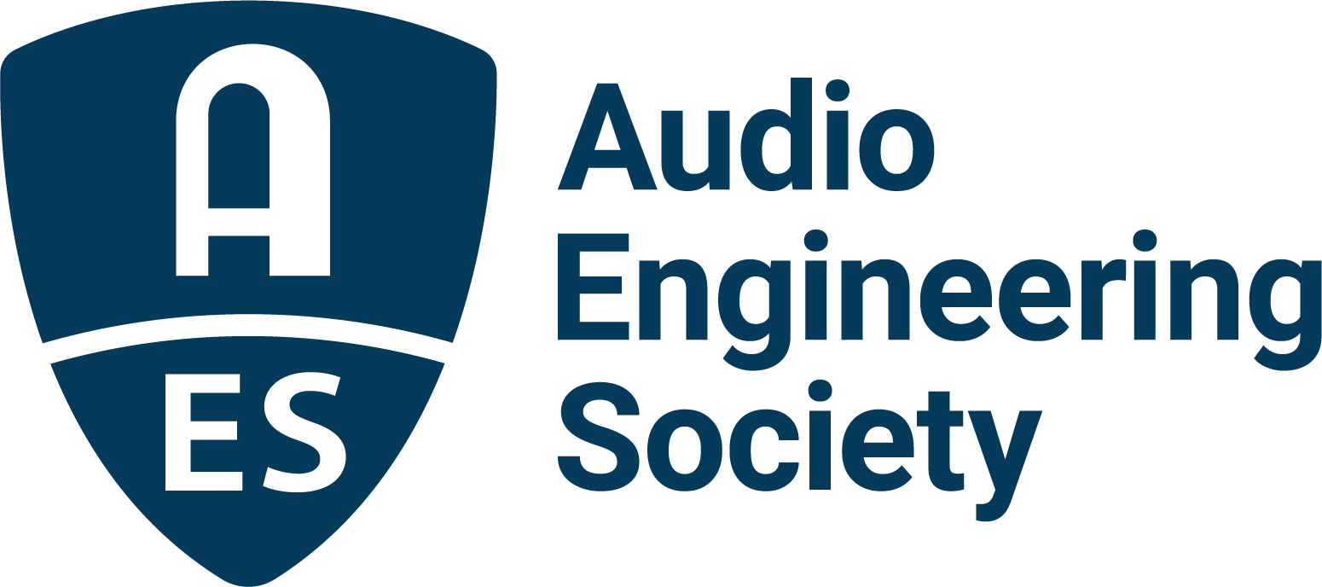

FOR IMMEDIATE RELEASE

The Audio Engineering Society Offers Immersive Experiences in Virtual and Augmented Reality, August 15 – 17 at DigiPen Institute

— Upcoming AES International Audio for Virtual and Augmented Conference will draw innovators from leading companies in the VR/AR world to share latest production technologies and techniques —

New York, NY, August 5, 2022 – Drawing from both the regional U.S. Pacific Northwest hub of technology incubators and a worldwide collective wealth of talent and industry expertise, the AES 2022 International Conference on Audio for Virtual and Augmented Reality will be held on the campus of DigiPen Institute in Redmond, WA, August 15 – 17. This fourth-in-series AES AVAR Conference is designed to expand upon the market-leading and genre-defining gathering of influencers and innovators begun with the first AES AVAR event in 2016 and amplified in each subsequent Conference.

AVAR 2022 continues the series’ role as the preeminent destination for the exchange of ideas and information between the industry leaders shaping the XR industry. Held in conjunction with event sponsors Reality Labs Research, Brandenburg Labs, HEAD acoustics, Audioscenic and Microsoft, the Conference reinforces AES’s role as a leading force in audio innovation and standard-setting research that continues to help drive our industry.

In addition to extensive research presentation sessions and demonstrations, the Conference will offer unique perspectives and opportunities for further discourse and education. Each day’s informative and inspirational Keynote address is followed by a panel of experts joining the Keynote presenter for focused discussions. For example, on the opening day of AVAR 2022, following her keynote on the changing landscape of spatial audio, Anastasia Devana of Hear XR will be joined by industry leaders from Meta Reality Labs, SonicCloud and Aalborg University Copenhagen for a panel discussion on procedural sound synthesis for AR/VR.

Further illustrating the elite caliber of research organizations and institutions participating in AVAR 2022, the Conference features a wealth of workshops with presenters from AudioLab – University of York, GN Audio/Jabra, IRCAM, Magic Leap, Meta, Microsoft, Stanford University, Treble Technologies, University of Florida and Zylia, to name only a sampling. The session topics span every creative and technical aspect of extended reality (XR) production from capture to distribution to the consumer experience. That pattern continues throughout three days packed with content curated to drive XR technology, open doors of opportunity for engineers and facilities, and enhance user experiences.

The AES International Conference on Audio for Virtual and Augmented Reality session and demo schedules, abstracts for each session and the full list of individual presenters can be explored at the AVAR 2022 website’s program page: aes2.org/event-extra/aes-2022-avar-program/. Details on registration, housing and venues are a click away at the AES International Conference on Audio for Virtual and Augmented Reality event page.

…ends 396 words

Photo File 1: AES_AVAR_2022.JPG
Photo Caption 1: The 2022 AES International Conference on Audio for Virtual and Augmented Reality, August 15 – 17, returns to the DigiPen Institute of Technology in Redmond, WA with an expansive program and a host of expert presenters.

Links:
AES International Conference on Audio for Virtual and Augmented Reality

About the Audio Engineering Society
The Audio Engineering Society, celebrating over 70 years of audio excellence, serves as the pivotal force in fostering the development and dissemination of technical information for the audio community. Currently, its members are affiliated with 90 AES professional sections and more than 120 AES student sections around the world. Section activities include guest speakers, technical tours, demonstrations, online events and social functions. Through Conventions, Conferences, Training and Development, Member Events and peer-reviewed Publications, as well as the Society’s vast online resources, members experience valuable opportunities for professional networking and personal growth. For additional information, visit AES.org.

Join the conversation and keep up with the latest AES News and Events:
Twitter: #AESorg (AES Official)
Facebook: facebook.com/AES.org
LinkedIn: https://www.linkedin.com/company/audio-engineering-society
Instagram: https://www.instagram.com/aes_org/

AES Marketing Communications:
Email: robert.clyne@aes.org
Tel: 615-662-1616
Clyne Media, Inc.,
169-B Belle Forest Circle, Nashville, TN 37221;
Web: http://www.clynemedia.com

