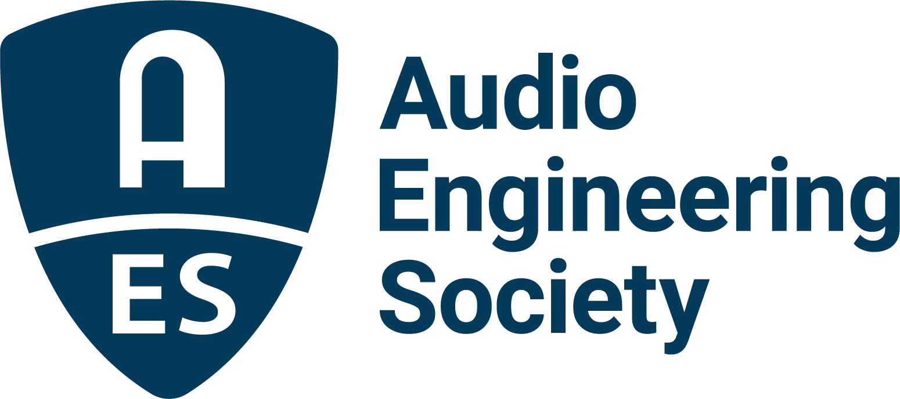

FOR IMMEDIATE RELEASE

Registration Now Open for AES 2022 Automotive Audio International Conference

— Advancements in automotive audio will take center stage at this year’s event through topical presentations, keynotes and attendee experiences —

New York, NY, March 10, 2022 — The Audio Engineering Society has opened registration for the 2022 AES Automotive Audio International Conference, taking place in-person June 8 – 10 in Detroit, MI, at the historic Dearborn Inn. Bringing together leading experts in automotive audio design and implementation, the Conference will offer a host of ways for attendees to learn about and connect with the latest technologies through research paper presentations, keynotes, workshops and discussion panels, alongside attendee networking opportunities and special events.

Many of today’s most advanced technologies apply specifically to automotive audio. The AES Automotive Audio Conference will address topics such as how the impact of audio streaming, autonomous vehicles, Battery Electric Vehicles (BEVs), ownership models and ride- and car-sharing are having a profound effect on the way we think about, and interact with, sound in and around both public and private vehicles. Additional presentation topics will include System Architecture and Hardware, Active Sound Management Solutions, Sound Reproduction in Cars, Evaluation of Sound, Virtual Acoustics and other related fields of study.

In additional to topical presentations, the AES Automotive Audio Conference will offer several keynote presenters. Those bringing their insights and knowledge to the Conference’s educational experiences include Andreas Ehret, Director of Automotive at Dolby, and Andrew Jones, Vice President Engineering at ELAC. Conference Sponsors include: Palladium Partners, Dolby and Panasonic; Platinum Partners, Fraunhofer and HEAD Acoustics; Gold Partners, Dirac and PCB Piezotronics; and Silver Partner, Listen, Inc.

Additional AES Automotive Audio International Conference details, topics and registration information are available here, with discounts available for AES Members and Student Members. Attendees looking to have their work featured at the Conference can submit proposals through March 31.

…ends 270 words

Photo File 1: AES_Automotive_Audio_Conference_2022.JPG
Photo Caption 1: Registration is now open for the 2022 AES Automotive Audio International Conference, taking place in-person, June 8 – 10 in Detroit, MI, at the historic Dearborn Inn.

About the Audio Engineering Society
The Audio Engineering Society, celebrating over 70 years of audio excellence, serves as the pivotal force in fostering the development and dissemination of technical information for the audio community. Currently, its members are affiliated with 90 AES professional sections and more than 120 AES student sections around the world. Section activities include guest speakers, technical tours, demonstrations, online events and social functions. Through Conventions, Conferences, Training and Development, Member Events and peer-reviewed Publications, as well as the Society’s vast online resources, members experience valuable opportunities for professional networking and personal growth. For additional information, visit AES.org.

Join the conversation and keep up with the latest AES News and Events:
Twitter: #AESorg (AES Official)
Facebook: facebook.com/AES.org
LinkedIn: https://www.linkedin.com/company/audio-engineering-society
Instagram: https://www.instagram.com/aes_org/

AES Marketing Communications:
Email: robert.clyne@aes.org
Tel: 615-662-1616
Clyne Media, Inc.,
169-B Belle Forest Circle, Nashville, TN 37221;
Web: http://www.clynemedia.com

