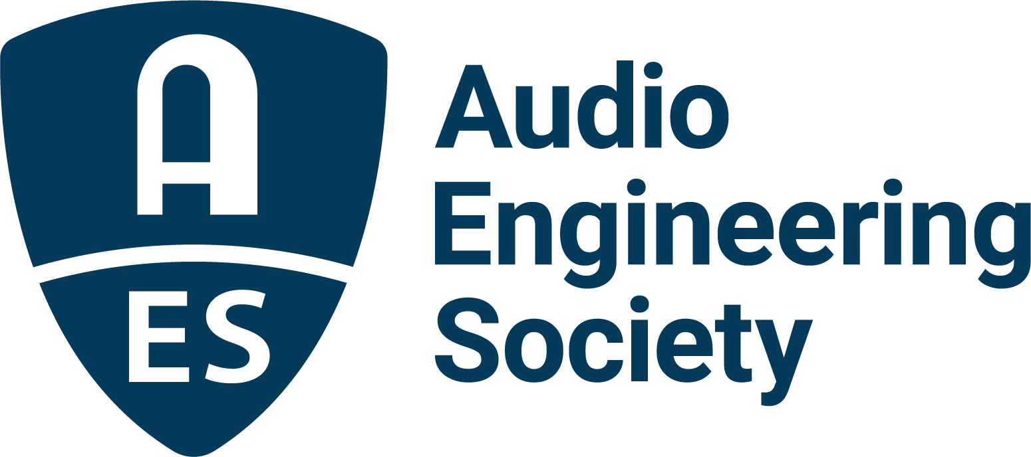

FOR IMMEDIATE RELEASE

The AES Heads for Detroit for the 2022 International Automotive Audio Conference, June 8 - 10

— Latest AES Automotive Audio Conference to offer Keynotes, Research Paper Sessions, Tutorials, Panel Discussions, AES Audio Product Education Institute Presentations and more —

New York, NY, May 24, 2022 – Back by popular demand, the Audio Engineering Society hits the road to the home of the U.S. automotive industry for the AES 2022 International Automotive Audio Conference on June 8 - 10 at the Dearborn Inn, Michigan. In addition to Keynote addresses by industry leaders from Dirac and Dolby, attendees will be immersed in a wide range of topics and technologies, including automotive acoustics, virtual speaker integration, modeling and measurement, system architecture and hardware, and supply chain and sourcing issues, among others.

“Automotive Audio has developed remarkably in both complexity and performance not even dreamt of in the days of AM radios and mono dashboard speakers,” says Roger Shively, Chair of the Conference. “Understanding the science and technology applied to automotive sound systems in today’s vehicles, and to the design of advanced infotainment and communication systems of tomorrow, requires exploration of acoustics, DSP processing, test and evaluation, and the full span of additional specialties. For audio professionals engaged in the development of vehicle sound systems, the AES Automotive Audio Conference 2022 is an unparalleled and crucial opportunity to expand their knowledge and engage with leading experts.”

Highlights for the Conference include the Keynote sessions that will begin the first two days’ events, offering personal insights into some of the hottest topics affecting automotive audio designers and integrators today, including: “The Automotive Industry Transformation and the Demand for High In-Car Audio Quality” presented by Dirac Research’s Mathias Johansson; and “Immersive Audio Experience in Automobiles” led by Dolby’s Andreas Ehret.

Attendees are also invited to attend a series of five panel discussion sessions on topics including In-car Acoustic Measurements for Frequency Response, Max SPL and Impulsive Distortion Measurements, as well “Making Immersive Audio in Cars a Reality,” and “Noise and Sound.” Panelists will share their experience in working with leading automotive audio powerhouses including Audi, Bose, Dolby, Ford, Fraunhofer, General Motors, Harman, Klippel, Nissan, Panasonic and Volvo.

This year’s AES International Automotive Audio Conference event committee is led by Chair Roger Shively (JJR Acoustics) with Vice-Chair and Treasurer Dan Field (Panasonic), who is also managing sponsorships with committee member Lars Carlsson (Dirac). Papers Chair is Yu “Dewey” Du (Harman) and Samira Mohamady (IAV) is Papers Vice-Chair. Overseeing Conference Communications and Website are Patrick Dennis (Nissan) and Spencer Shively (JJR Acoustics). Dennis is also working with Peter Ryan (Ford Motor Company) on the Conference’s Local Support & Facilities.

AES 2022 International Automotive Audio Conference Partners include BdSound, Comsol, Dolby, Dirac, DSP Concepts, Fraunhofer IIS, Harman, Head Acoustics, Impulse Audio Lab, Listen, Panasonic, PCB Piezotronics, Sennheiser and Tymphany.

Additional Research Paper Sessions, Tutorials, Panel Discussions, AES Audio Product Education Institute presentations and the complete schedule of events are now available online, with registration options including significant discounts for AES Members and AES Student Members.

…ends 460 words

Links
AES 2022 International Automotive Audio Conference

Photo File 1: AES_2022_Automitive_Audio.JPG
Photo Caption 1: The Audio Engineering Society will host the AES 2022 International Automotive Audio Conference, June 8 – 10 in Detroit, Michigan.

About the Audio Engineering Society
The Audio Engineering Society, celebrating over 70 years of audio excellence, serves as the pivotal force in fostering the development and dissemination of technical information for the audio community. Currently, its members are affiliated with 90 AES professional sections and more than 120 AES student sections around the world. Section activities include guest speakers, technical tours, demonstrations, online events and social functions. Through Conventions, Conferences, Training and Development, Member Events and peer-reviewed Publications, as well as the Society’s vast online resources, members experience valuable opportunities for professional networking and personal growth. For additional information, visit AES.org.

Join the conversation and keep up with the latest AES News and Events:
Twitter: #AESorg (AES Official)
Facebook: facebook.com/AES.org
LinkedIn: https://www.linkedin.com/company/audio-engineering-society
Instagram: https://www.instagram.com/aes_org/

AES Marketing Communications:
Email: robert.clyne@aes.org
Tel: 615-662-1616
Clyne Media, Inc.,
169-B Belle Forest Circle, Nashville, TN 37221;
Web: http://www.clynemedia.com

