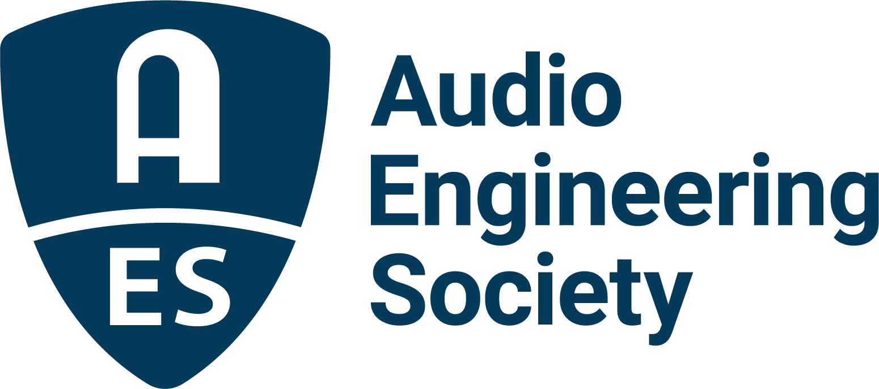

FOR IMMEDIATE RELEASE

Audio Engineering Society Educational Foundation Announces Awardees for the 2022/2023 Academic Year

— Annual grants and scholarships continue to help audio students realize their full potential in educational programs around the world —

New York, NY, August 23, 2022 – The Audio Engineering Society Educational Foundation’s president Jim Anderson has announced the awardees of AES Educational Scholarships and Grants for Graduate and Undergraduate Studies in Audio Engineering for the upcoming academic year, 2022/2023. The AES Educational Foundation’s awards are made possible by a host of contributions from benefactors, including from manufacturers Audio Precision, Dolby, Genelec and L-Acoustics, and the estates of John Eargle, Emil Torick and the Mary Lee Simpson family.

“This year’s AES Grants and Scholarships’ recipients once again represent the future generation of audio professionals who will continue to advance the art and science of audio,” states Anderson. “With the continued support of our contributing sponsors and benefactors, we aim to both honor past industry pioneers and their deep commitment to furthering the field of audio engineering while supporting and inspiring this next generation. We congratulate this year’s awardees and encourage all audio students to stay informed on next year’s AES Educational Foundation opportunities.”

The Board of the Audio Engineering Society Educational Foundation is pleased to name the following scholarship awardees:

Audio Precision’s Tom Kite Advancing Audio Scholarship – Cesar Lamschtein, attending University of Colorado, Denver, Colorado, USA
Genelec Ilpo Martikainen Audio Visionary Scholarship – Emily Kuo, attending Stanford University's Center for Computer Research in Music and Acoustics (CCRMA), Stanford, California, USA
Genelec Mike Chafee Audio Pioneering Scholarship – Aizhou Liu, attending New York University's Music Technology program, New York City, New York, USA

Dolby Institute Scholarship – Charbel Hourani, who is attending and pursuing a PhD at the University of Derby, United Kingdom
L-Acoustics Dr. Christian Heil Future of Sound Scholarship – Lara Ann Villanueva, a student at Baltimore's Peabody Institute, Baltimore, Maryland, USA

John Eargle Award – Ashell Fox, attending University of Colorado Denver, Denver, Colorado, USA
Emil Torick Award – Allie McSwain, attending New York University, New York City, New York, USA
AES Educational Foundation Scholarship – Jiang Zhi-Xiong, attending Pusan National University, Busan, South Korea

AES Educational Foundation Scholarship – Mike Middleton, attending the University of York, Heslington, England

AES Educational Foundation Scholarship – Nathaniel Stoll, attending Middle Tennessee State University, Murfreesboro, TN, USA

AES Educational Foundation Scholarship – Thiago Marcelo Veiga Picolo, attending the University of York, Heslington, England

AES Educational Foundation Scholarship – Kexin Wang, a student at Johns Hopkins University, Peabody Institute, Baltimore, Maryland, USA

Mary Lea Simpson Memorial Scholarship – Lily Oppenheim, attending New York University Clive Davis Institute of Recorded Music, New York City, New York, USA

Established in 1984 to encourage talented students to enter the profession of audio engineering, the creation of the AES Educational Foundation illustrates the AES’s commitment to promoting the science and art of audio engineering and related disciplines through the development of future industry leaders. The Foundation welcomes support for these goals from individual benefactors and companies, including in-memoriam contributions. Application forms and additional information are available from the Audio Engineering Society, Audio Engineering Society, Inc., International Headquarters, 697 3rd Avenue, Suite 405 NY, NY 10017, USA, or on its website: aeseducationalfoundation.org.

…ends 486 words

Links:
AES Educational Foundation

Photo File 1: AES_Educational_Foundation.jpg
Photo Caption 1: The Audio Engineering Society Educational Foundation has announced the recipients of the AES Educational Scholarships and Grants for Graduate and Undergraduate Studies in Audio Engineering for the 2022/2023 academic year

About the Audio Engineering Society
The Audio Engineering Society, celebrating over 70 years of audio excellence, serves as the pivotal force in fostering the development and dissemination of technical information for the audio community. Currently, its members are affiliated with 90 AES professional sections and more than 120 AES student sections around the world. Section activities include guest speakers, technical tours, demonstrations, online events and social functions. Through Conventions, Conferences, Training and Development, Member Events and peer-reviewed Publications, as well as the Society’s vast online resources, members experience valuable opportunities for professional networking and personal growth. For additional information, visit AES.org.

Join the conversation and keep up with the latest AES News and Events:
Twitter: #AESorg (AES Official)
Facebook: facebook.com/AES.org
LinkedIn: https://www.linkedin.com/company/audio-engineering-society
Instagram: https://www.instagram.com/aes_org/

AES Marketing Communications:
Email: robert.clyne@aes.org
Tel: 615-662-1616
Clyne Media, Inc.,
169-B Belle Forest Circle, Nashville, TN 37221;
Web: http://www.clynemedia.com

