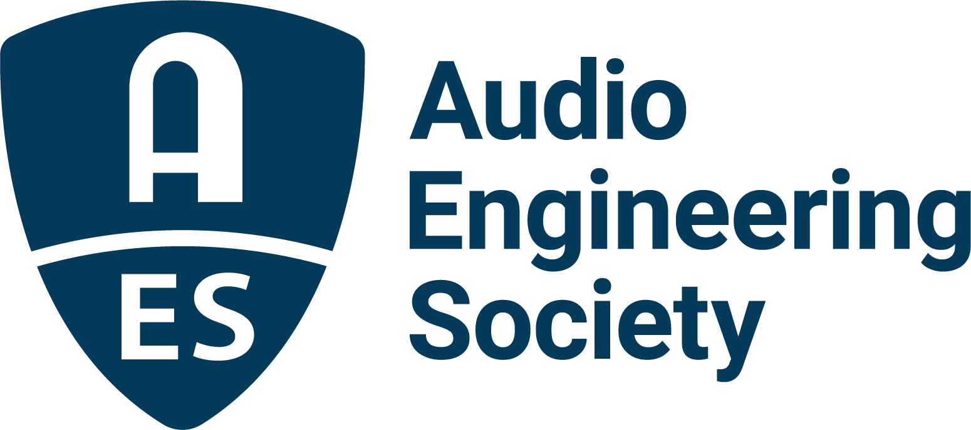

FOR IMMEDIATE RELEASE

All Things Audio on Slate for AES Europe Spring 2022 Convention – Early Bird Registration Ends April 11

— This year’s AES Europe Convention offers a packed schedule in both in-person and online formats; best registration rates ending soon —

New York, NY, April 8, 2022 — Everything audio is the short description of the schedule of events during the AES Europe Spring 2022 Convention. Full technical program details are now online for the return of in-person events, May 7 – 8 at the Amare, Royal Conservatoire in The Hague, Netherlands, and online streaming and on-demand sessions, May 16 – 19. The best rates for registration have been extended through Monday, April 11 – early bird pricing is available for the in-person and online components individually, with bundles offering everything the Convention has in store. AES Members have special pricing with even lower Student Member rates.

“We’re absolutely delighted to see the return of the in-person convention experience in May,” says AES President Josh Reiss. “The real-time interaction and spontaneous personal networking of a live convention are invaluable. That said, throughout the pandemic the AES has refined an online program format that provides maximum impact and access for attendees from anywhere in the world. For both the online and in-person events, the line-up of presenters is exciting, the topics are compelling and the experience unparalleled.”

From the popular convention mainstay Keynote and Heyser Lectures, to a full roster of sessions presenting the latest in audio research, technology and education, this year’s AES Europe Convention will offer more ways for attendees to ”Listen, Learn and Connect” through both its in-person and online events.

AES in-person convention experiences have kept the Audio Engineering Society at the cutting-edge and standards-setting forefront of audio engineering and technology for over 70 years. That rich tradition will continue May 7 and 8 in The Hague. Some of the highlights will be Master Class sessions such as “Acoustics for Budget Studios” presented by Ben Kok, Workshops including “What Gear do You Really Need?” with Ian Corbett, and several opportunities to take an exclusive AES Tech Tour of the Convention venue’s newly-built Art of Sound studio. In the opening day Keynote address, Kees Tazelaar will speak on the topic of “Le poème électronique,” a multimedia performance that took place in the Philips Pavilion during the Brussels World's Fair in 1958 featuring a sound system that can be regarded as a precursor to today’s immersive audio technology. The Convention’s Heyser Lecture follows later that day, with Diemer de Vries presenting “Wave Field Synthesis – Just a Wave…Or a Durable Synthesizer in the Audio Field.” De Vries’ address sets the stage for exclusive opportunities for attendees to experience wave field synthesis utilizing the venue’s new, state of the art, WFS system, used to create a holographic spatial sound image that is independent of the listener's position in the room.

AES Student Members are among the most enthusiastic and engaged convention attendees and the program rewards them with events dedicated to tomorrow’s audio professionals. These include a Master Class on Immersive Production with Tom Ammermann, the sessions “Art of Sound, Education in Amare” which will give an overview of the Master curriculum for the host facility’s Recording, Production and Sound Reinforcement programs, and a special in-person AES Student social event taking place on the evening of the opening day. AES Student Members can also have their recent works presented during one of several AES Student Mix Critique sessions (submissions due April 22).

On May 16 – 19 the AES Europe Spring 2022 Convention continues in AES’s proven online program format with three days of content unique to the online Convention component – live-streamed sessions, interactive Q&As with presenters and real-world listening experiences and demos utilizing the AudioMovers platform. Highly anticipated topics at this year’s AES Europe Convention online event include cutting-edge implementations of Spatial Audio, Audio Synthesis and Effects, Binaural Audio, Extended Reality Audio and related technologies, as well as the latest innovations in core audio gear and its applications.

Streaming Sound Reinforcement sessions during the Convention will range from “Mixing for In-Ear Monitors: Understanding the Work of Monitor Mixing Engineers” with Jan Berg, Tomas Johannesson and Arne Nykänen to “Designing Sound System In-Band Headroom Based on Expected Difference Between C- and A-Weighted Levels” presented by Bob McCarthy, Roger Schwenke and Merlijn van Veen. Two additional presentations will cover the newly released AES75 Standard regarding the predictive measurement of loudspeaker maximum linear sound levels using the newly developed M-Noise test signal.

AES Europe Spring 2022 online Recording and Production topics include a Professional Miking Workshop with Brandon Bell, J.J. Blair, Darrell Thorp, Joey Waronker and Joe Zook offering deep insights into hit-making techniques, and the foundation for new frontiers will be presented in “Immersive Audio Tools for Beginners” with Marcela Rada. New tech will be covered in sessions such as “Multi-Diaphragm Micro-Speaker vs. Single-Diaphragm Micro-speaker” with Wendy Chen, George Wei and Tony Xie.

Additional streaming sessions include subjects ranging from NFT’s, Metadata and Credits, to Electronic Music Performance, Audio Archiving and Restoration and Automotive Audio. AES President Josh Reiss will be featured in a series of sessions on Audio Synthesis and Audio Effects including “Advances in Thunder Sound Synthesis” with co-presenters Eva Fineberg and Jack Walters, and “Neural Synthesis of Footsteps Sound Effects with Generative Adversarial Networks” with Marco Comunità and Huy Phan. Experts from AES Convention partners – including Eventide, Genelec, Harman, New Audio Technology, Prism Sound, Sonoris and Steinberg – and their notable end-users, will contribute insights on products and their applications.

The complete program schedule of AES Europe Spring 2022 Convention in-person and online sessions and presenter information is available at AESEurope.com with best registration pricing ending soon.

…ends 893 words

Photo File 1: AES_Europe_2022.JPG
Photo Caption 1: The AES Europe Spring 2022 Convention will take place in-person, May 7 – 8 at the Amare, Royal Conservatoire in The Hague, Netherlands, and online, May 16 – 19. Registration is now open at AESEurope.com.

The AES Welcomes You to The Hague
The Audio Engineering Society has chosen The Hague for its 152nd International Convention as a central hub of commerce, arts and travel, located conveniently near to Amsterdam’s popular Schiphol Airport, among other easy transportation options. Whether attending your first AES Convention, coming again as a dedicated attendee or presenting your own work to the enthusiastic gathering of attendees from around the world, this year’s return to in-person AES events in The Hague presents a prime opportunity to “Listen, Learn and Connect” with peers and pros in an easily accessible and culturally rich environment. The AES invites you to enjoy our spectacular venue and surrounding area, dotted with gardens and canals, world-class museums and art, restaurants, shops and more. Join us as we celebrate the best in audio art, science and education at the AES Europe Spring 2022 Convention.

About the Audio Engineering Society
The Audio Engineering Society, celebrating over 70 years of audio excellence, serves as the pivotal force in fostering the development and dissemination of technical information for the audio community. Currently, its members are affiliated with 90 AES professional sections and more than 120 AES student sections around the world. Section activities include guest speakers, technical tours, demonstrations, online events and social functions. Through Conventions, Conferences, Training and Development, Member Events and peer-reviewed Publications, as well as the Society’s vast online resources, members experience valuable opportunities for professional networking and personal growth. For additional information, visit AES.org.

Join the conversation and keep up with the latest AES News and Events:
Twitter: #AESorg (AES Official)
Facebook: facebook.com/AES.org
LinkedIn: https://www.linkedin.com/company/audio-engineering-society
Instagram: https://www.instagram.com/aes_org/

AES Marketing Communications:
Email: robert.clyne@aes.org
Tel: 615-662-1616
Clyne Media, Inc.,
169-B Belle Forest Circle, Nashville, TN 37221;
Web: http://www.clynemedia.com

