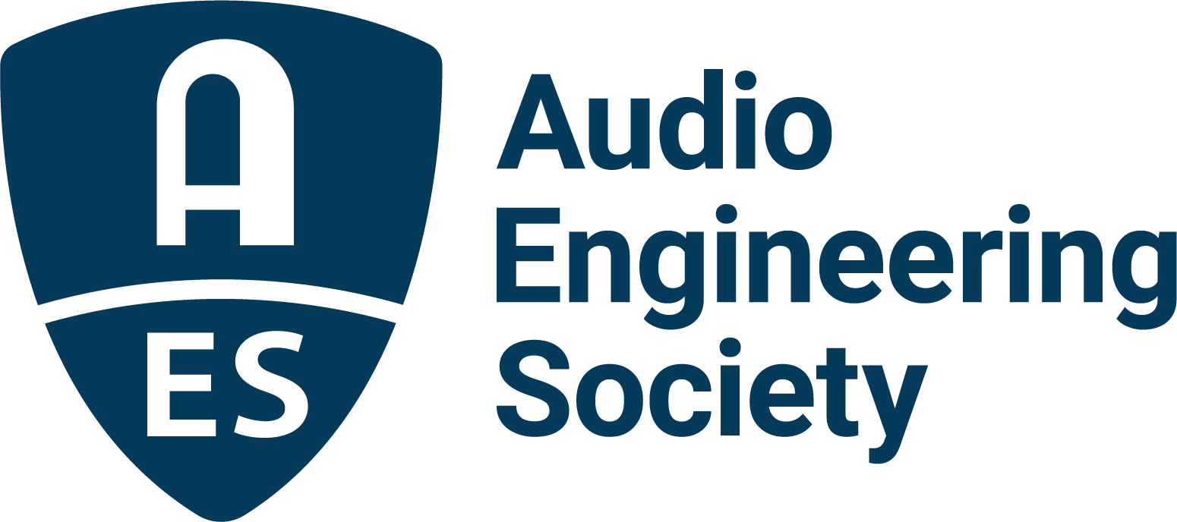

FOR IMMEDIATE RELEASE

AES Executive Director Colleen Harper to Step Down in March

New York, NY, February 3, 2022 — The Audio Engineering Society (AES) today announces that Executive Director Colleen Harper will step down in March 2022. Harper, a Certified Association Executive (CAE), has led the AES headquarters staff for the past three years. Drawing from a wealth of experience in the organizational management of professional membership and other non-profit organizations, Harper worked hand-in-hand with the Society’s volunteer leadership, members and industry partners to shepherd the Society through a period of radical transition due to the repercussions of the global pandemic. During her tenure, the AES has consistently advanced its global role, maintaining its essential contributions to the vitality of the professional audio industry through the promotion of the creative practice of the audio arts, scientific and technological innovation, education and standards development.

“The AES has been privileged to have Colleen’s experience and unique skill set to rely upon during trying times,” said Josh Reiss, AES President. “Not only is the AES in the best financial position it’s been in for years, despite a global pandemic, but Colleen has also helped usher in forward-looking operational plans, procedures and practices that will further solidify the Society’s role as the world’s leading professional audio technological organization. On behalf of the Board of Directors, the Board of Governors and the Society’s membership, we offer Colleen our sincere gratitude and wish her well as her career takes her in new directions.”

“I care deeply about the AES, and I’m very proud of what we’ve accomplished together,” said Harper. “The past three years have been a tremendously rewarding experience and some of the most challenging and enjoyable years I could have imagined. My decision to step down has been a difficult one, but I leave knowing that I have accomplished the goals established when I joined the AES. As I leave to pursue a new challenge, I am genuinely sad to leave the Society, its dedicated staff and leadership, and the wonderful community that has accepted me as one of its own.”

The AES Board of Directors is in the process of creating a search committee to work with an outside search firm in the selection of Harper’s permanent replacement. Bill Foster, a veteran of AES leadership who served as Interim Executive Director during the search that led to the hiring of Harper, has agreed to serve again as Interim Executive Director and will assume the role upon Harper’s departure in early March. “Bill has proven his ability to see the Society through this type of transition,” said Reiss. “The Board of Directors has every confidence that he will once again provide the interim leadership needed. Colleen has set a high standard of performance that will be a perfect template to guide our search for her replacement.”

…ends 453 words

Photo File 1: Colleen_Harper.JPG
Photo Caption 1: Audio Engineering Society Executive Director Colleen Harper will step down in March 2022

Photo File 2: Bill_Foster.JPG
Photo Caption 2: Bill Foster, a veteran of AES leadership, has agreed to serve as Interim Executive Director during the Audio Engineering Society’s search for it’s next Executive Director

About the Audio Engineering Society
The Audio Engineering Society, celebrating over 70 years of audio excellence, serves as the pivotal force in fostering the development and dissemination of technical information for the audio community. Currently, its members are affiliated with 90 AES professional sections and more than 120 AES student sections around the world. Section activities include guest speakers, technical tours, demonstrations, online events and social functions. Through Conventions, Conferences, Training and Development, Member Events and peer-reviewed Publications, as well as the Society’s vast online resources, members experience valuable opportunities for professional networking and personal growth. For additional information, visit aes.org.

Join the conversation and keep up with the latest AES News and Events:
Twitter: #AESorg (AES Official)
Facebook: facebook.com/AES.org

AES Marketing Communications:
Email: robert.clyne@aes.org
Tel: 615-662-1616
Clyne Media, Inc.,
169-B Belle Forest Circle, Nashville, TN 37221
Web: http://www.clynemedia.com

