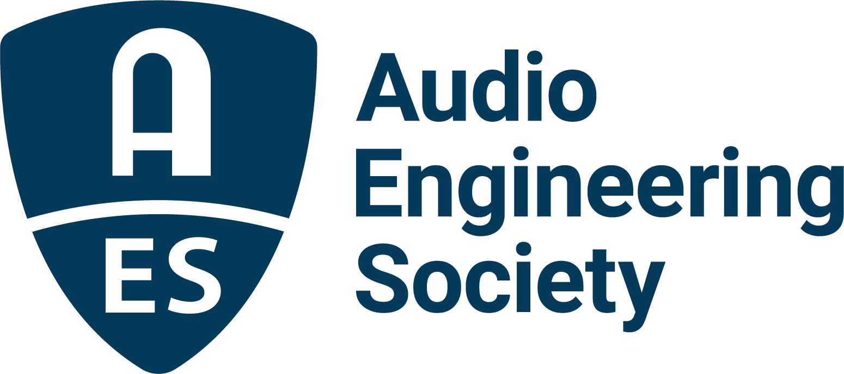

FOR IMMEDIATE RELEASE

Film and TV the focus for the Fourth AES Immersive Audio Academy, Online, November 10

— Fourth edition of AES Immersive Audio Academy to feature leaders from leading streaming brands Amazon Prime, Disney+ and Netflix —

New York, NY, November 8, 2022 — The latest in the Audio Engineering Society’s series of popular online AES Academy events: Immersive Sound for Film and TV, will take place online November 10 at 12pm EST (USA). With Immersive Audio being one of the most widely-talked-about elements of modern audio production, the AES has invited leaders from top film and TV streaming entities – Amazon Prime, Disney+ and Netflix – for a detailed look into workflow and project management on some of today’s biggest on-screen hits.

Streaming networks have helped lead the industry into new horizons, and, along with the AES, have set many of the standards and best practices that engineering teams use in producing and distributing compelling immersive content. In this fourth edition of the AES Immersive Audio Academy, hosted by AES Past-President and immersive audio designer Andres Mayo, panelists Jonathon Lee, Head, Media Engineering & Innovation at Amazon; Michael Patterson, Disney Digital Studio Services; and Scott Kramer, Manager, Sound Technology / Creative Technologies, Netflix, will help attendees make sense of the workflow and deliverables commonly requested across the industry.

“After such a great response from our previous Immersive Audio Academy events, we felt that we needed to focus on the ever-growing immersive production possibilities for film and television,” states AES Immersive Audio Academy host Andres Mayo. “We are excited to have gained support from some of the biggest names in the business as they come to help us all make sense of the shifting landscape of technology and production techniques, and the ways in which consumers will ultimately receive the finished product.”

Registration for the AES Immersive Academy: Immersive Sound for Film and TV is just $25 for AES Members and $75 for non-members. Register now at: https://aes2.org/events-calendar/immersive4.

…ends 282 words

Links
AES Immersive Audio Academy: Immersive Sound for Film and TV

Photo File 1: AES_ImmersiveAudioAcademy_4.JPG
Photo Caption 1: The AES Immersive Academy: Immersive Sound for Film and TV will take place online November 10, featuring industry panelists from Amazon Prime, Disney+ and Netflix, and moderated by AES Past-President and immersive audio designer Andres Mayo.

About the Audio Engineering Society
The Audio Engineering Society, celebrating over 70 years of audio excellence, serves as the pivotal force in fostering the development and dissemination of technical information for the audio community. Currently, its members are affiliated with 90 AES professional sections and more than 120 AES student sections around the world. Section activities include guest speakers, technical tours, demonstrations, online events and social functions. Through Conventions, Conferences, Training and Development, Member Events and peer-reviewed Publications, as well as the Society’s vast online resources, members experience valuable opportunities for professional networking and personal growth. For additional information, visit AES.org.

Join the conversation and keep up with the latest AES News and Events:
Twitter: #AESorg (AES Official)
Facebook: facebook.com/AES.org
LinkedIn: https://www.linkedin.com/company/audio-engineering-society
Instagram: https://www.instagram.com/aes_org/

AES Marketing Communications:
Email: robert.clyne@aes.org
Tel: 615-662-1616
Clyne Media, Inc.,
169-B Belle Forest Circle, Nashville, TN 37221;
Web: http://www.clynemedia.com

