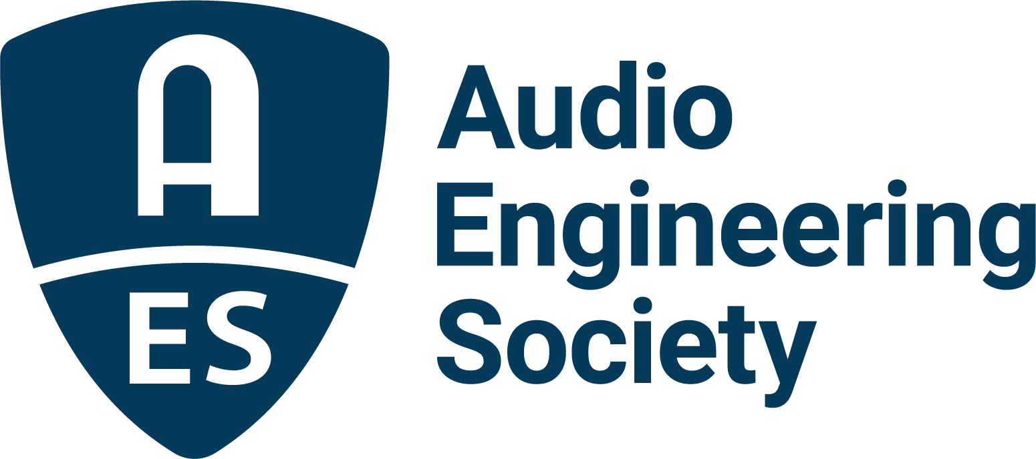

FOR IMMEDIATE RELEASE

AES Music Production Academy to Explore a Diverse Array of Audio Tools and Techniques in Two-Day Event

— New training and development event builds upon last year’s highly-successful Modern Music Production Academy and sets the stage for presentation of the latest in audio art and science, hosted by Paul “Willie Green” Womack —

New York, NY, April 13, 2022 — Modern music production marries time-proven techniques with those enabled by new technologies to produce today’s hottest hits. Recording artist, producer, educator and Audio Engineering Society Governor Paul “Willie Green” Womack will host a diverse array of the music industry’s brightest up-and-coming engineers and producers, leading technological innovators and seasoned professionals for two packed days of illuminating insights into cutting-edge production practices in the AES Music Production Academy, taking place online April 20 – 21. Priced at just $25 for AES Members / $49 for non-members, the AES Music Production Academy will cover topics ranging from vocals to vinyl, offer inside takes on high-profile sessions, and investigate deliverables and good business practices, with additional presentations from event partners Eventide and Sonarworks. Registration, the event schedule and presenter bios are now available online.

Following the Academy kick-off with a special surprise-guest keynote presenter, the core content begins with what promises to be a lively session: “Behind the Scenes of Loud: The History of Reggaeton” with Jeanne Montalvo (John Legend, Cultura Profética, Bobby Sanabria’s Latin Jazz Big Band) and Stephanie Lebow (Director of Engineering at Futuro Media & Futuro Studios). The event continues with a technology presentation from event partner Eventide, followed by “Digital Delivery Concepts – Alternate Release Formats” with Womack (Wiz Khalifa, The Roots, Gimlet Media) and the multi-talented Jawwaad Taylor (Shape of Broad Minds, The Young Mothers, Carrie Mae Weems), as well as an “Advanced Vocal Processing” workshop, also led by Womack.

Day two starts with a look at “Cutting Vinyl Records with Today’s Modern Tools” with Heba Kadry (Mars Volta, Lucy Dacus, Ryuichi Sakamoto) and Josh Bonati (Bonati Mastering), followed by the panel presentation “Let's Talk Production” featuring Stephen Dent (Notorious B.I.G., Diddy, Mary J. Blige), Carlin “Busy Works” Hines (Busy Work Beats), Amond “AJ” Jackson (Snoop Dogg, CeeLo Green, Killer Mike) and Eric "Realistic" Michael (LoveOfPharaoh, Rick Ross, Future). The day continues with a partner presentation from Sonarworks and then on to an in-depth look at the “Hip-Hop Music Biz” with Angela Piva (Michael Jackson, Toni Braxton, Ronnie Spector) and Scott Rubin (Public Enemy, John Mayer, Zac Brown Band). The day concludes with a production Masterclass led by Gloria Kaba (A Tribe Called Quest, Jack White, Kanye West) and Womack.

The full details and registration for the can’t-miss event are available now on the AES Music Production Academy website.

…ends 389 words

Photo File 1: AES_Music_Production_Academy.JPG
Photo Caption 1: The AES invites you to join us for the AES Music Production Academy hosted by Paul “Willie Green” Womack, May 20 – 21.

Photo File 2: Paul_Willie_Green_Womack.JPG
Photo Caption 2: AES Music Production Academy host, recording artist, producer, educator and Audio Engineering Society Governor Paul “Willie Green” Womack

About the Audio Engineering Society
The Audio Engineering Society, celebrating over 70 years of audio excellence, serves as the pivotal force in fostering the development and dissemination of technical information for the audio community. Currently, its members are affiliated with 90 AES professional sections and more than 120 AES student sections around the world. Section activities include guest speakers, technical tours, demonstrations, online events and social functions. Through Conventions, Conferences, Training and Development, Member Events and peer-reviewed Publications, as well as the Society’s vast online resources, members experience valuable opportunities for professional networking and personal growth. For additional information, visit AES.org.

Join the conversation and keep up with the latest AES News and Events:
Twitter: #AESorg (AES Official)
Facebook: facebook.com/AES.org
LinkedIn: https://www.linkedin.com/company/audio-engineering-society
Instagram: https://www.instagram.com/aes_org/

AES Marketing Communications:
Email: robert.clyne@aes.org
Tel: 615-662-1616
Clyne Media, Inc.,
169-B Belle Forest Circle, Nashville, TN 37221;
Web: http://www.clynemedia.com

