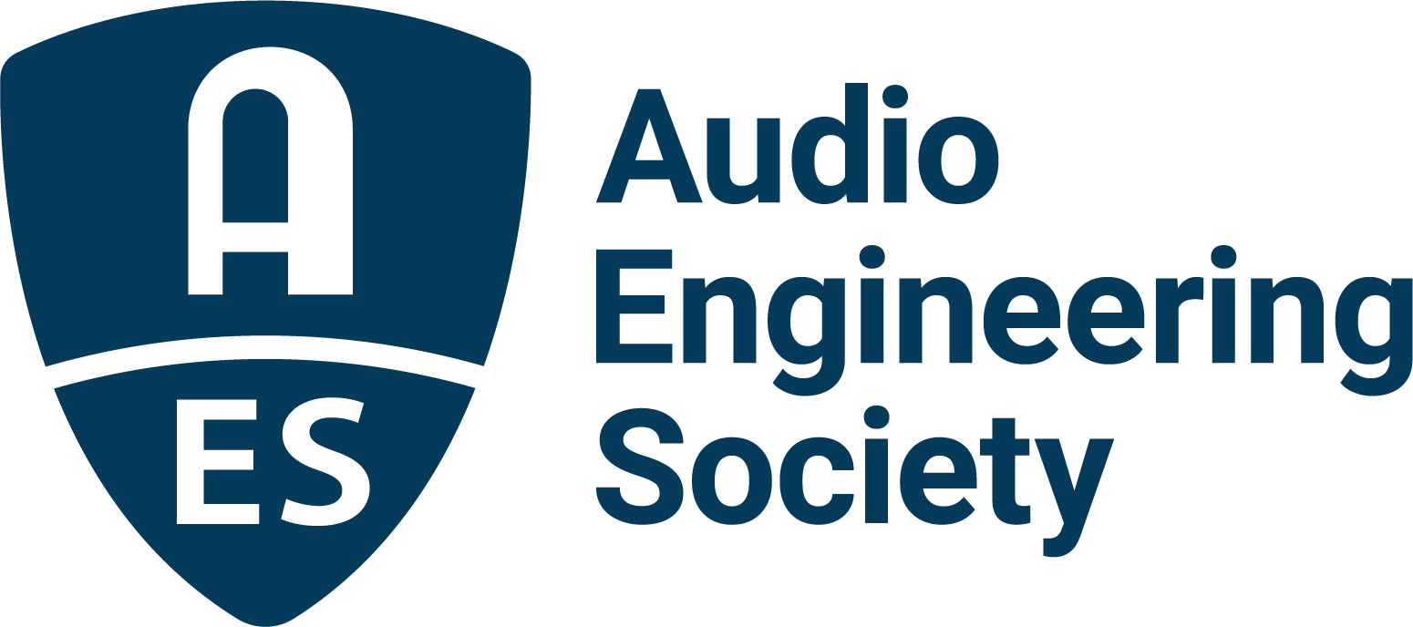

FOR IMMEDIATE RELEASE

New Sessions and Sponsors Announced for Upcoming AES Audio Archiving, Preservation and Restoration Conference

— World-leading audio professionals will present their latest archiving technologies and techniques at the U.S. Library of Congress National Audio-Visual Conservation Center in Culpeper, VA —

New York, NY, May 24, 2023 — Organizers of the upcoming AES 2023 Audio Archiving, Preservation and Restoration Conference (AAP&R), taking place June 1 – 3 at the U.S. Library of Congress National Audio-Visual Conservation Center in Culpeper, Virginia, have released the full technical program.

This year’s conference offers a wealth of new technological innovations, along with updates in practice, procedure and archival philosophies since 2018’s sold-out event, also held in Culpeper. The 2023 program features more than 45 Workshops, Papers presentations, onsite facilities tours and a Keynote by Leslie Ann Jones of Skywalker Sound, along with other networking and social opportunities.

Supporting the development and promotion of best practice methods and standards for preserving the world’s rich audio heritage are Platinum Sponsor Iron Mountain Entertainment Services (IMES); Gold Sponsors 360 Reality Audio and Planet Venus Audio Technologies; Silver Sponsor the Recording Academy® Producers & Engineers Wing®; Bronze Sponsors Prism Sound, NOA and CEDAR Audio; and Break Sponsors Merging Technologies and Independent Audio. The complete schedule of sessions, presenters and travel information is available online.

The Conference will begin on Thursday, June 1 with an in-depth tour of the National Audio-Visual Conservation Center facility, with stops to interact with professionals in the areas of recorded sound and moving image, the nitrate film vault, recorded sound vault, the data center, and the audio, video and film preservation laboratories. The Conference will then turn to the featured Keynote by Leslie Ann Jones, also co-chair of the Recording Academy P&E Wing, titled “Why It Matters: Reflections on Creating, Preserving and Valuing Music.”

Over the following three days an international slate of leading practitioners and pioneers in the industry will come together to educate and inspire with sessions addressing technological and practical questions. These include “Preserving Loudness Parameters,” “Democratizing Audio Preservation When Under-Resourced,” “Written in Their Soul: The Stax Songwriter Demos,” and local NPR radio station Engineering Supervisor Joyce Lieberman with the session “This is Fresh Air.” The panel, “What Amount of Audio Restoration is the Right Amount?” features guests Bryan Hoffa (Audio Preservation Specialist, Library of Congress), Jessica Thompson (Mastering & Restoration Engineer, JTA), and Nadja Wallaszkovits (Professor, State Academy of Fine Arts Stuttgart), with CEDAR Audio Managing Director Gordon Reid moderating.

An innovative, new archiving and preservation technology will be introduced in the Workshop “Automated Media Image Capture System at Iron Mountain Entertainment Services”, with IMES’s Robert Koszela, Alex Tomlin and Meg Travis, along with Nick Allen, Universal Music Group Vice President of Asset & Archive Management.

One of the strongest advocates for audio archiving, preservation and restoration – The Recording Academy Producers and Engineers Wing – will host a Workshop looking into its latest deliverables and archival recommendations, featuring engineers/producers Jeff Balding, George Massenburg, Michael Romanowski and Maureen Droney, Vice President of the Recording Academy Producers & Engineers Wing. Preservation issues will be discussed further in sessions including “Why Are Standards Important for Archiving Multi-track and Multi-channel Audio?” and “Best Practices for the Creation and Archiving of Immersive Audio Recordings”.

Additional sessions and events will offer exclusive opportunities for attendees to hear some of the Library’s rare and historic recordings, with in-depth analysis of its archiving, restoration and preservation lineage. Attendees can also register to take several guided Audio Lab tours covering areas of interest such as Disc Preservation, Cylinder Preservation, Open Reel / Workflow, Cassette Playback, Parallel Transfers, Multi-track and Immersive, IRENE and Optical Capture of Audio Discs, Historical Audio Equipment and the American Folklife Center Archive.

Rounding out the three-day program will be a buffet-style open-grill barbecue dinner where attendees can socialize and enjoy live music and a couple of glasses of wine in the bucolic farm setting of the Mountain Run Winery, located just five minutes from downtown Culpeper.

Registration, including discounts for AES Members and Student Members, along with the complete program and session information is available here.

…ends 631 words

Link:
2023 AES International Conference on Audio Archiving, Preservation and Restoration

Photo File 1: AES_AARP_Conference_2023.JPG
Photo Caption 1: Full program details are now available for the AES International Conference on Audio Archiving, Preservation and Restoration, taking place June 1 – 3 at the U.S. Library of Congress National Audio-Visual Conservation Center in Culpeper, Virginia.

About the Conference Committee
This year’s AES Audio Archiving, Preservation and Restoration Conference Committee is led by Chair and AES Past President John Krivit, along with Program Chairs, Konrad Strauss (Indiana University), Nadja Wallaszkovits (AES Past President) and Toby Seay (IASA Past President); Papers Chair Melissa Widzinski (U.S. Library of Congress): Conference Treasurer Yuri Shimoda (Disney); Jessica Thompson (NARAS), Marketing and Promotions Chair. Additional program organizers are Rob Friedrich (U.S. Library of Congress), George Massenburg (GML), Brad McCoy (US Library of Congress – Retired), Kaylie Ackerman (Harvard University), Mitch Peyser (Time/Life Music), and Samantha Winter, Intern.
About the Venue
The U.S. Library of Congress National Audio-Visual Conservation Center‘s Packard Campus of the National Audio-Visual Conservation Center, located in Culpeper, VA, provides underground storage for its entire collection on 90 miles of shelving, together with extensive modern facilities for the acquisition, cataloging and preservation of all formats. The facility holds the nation’s largest public collection of sound recordings containing music, spoken word and radio broadcasts, encompassing nearly 3.5 million recordings in all. Over 110 years of sound recordings history is represented in nearly every audio format, from cylinders to CDs, covering a wide range of subjects and genres in considerable depth and breadth.

About the Audio Engineering Society
The Audio Engineering Society celebrates 75 years of audio excellence in 2023. Serving as the pivotal force in fostering the development and dissemination of technical information for the audio community, its members are affiliated with 90 AES professional sections and more than 120 AES student sections around the world where activities include guest speakers, technical tours, demonstrations, online events and social functions. Through Conventions, Conferences, Training and Development, Member Events and peer-reviewed Publications, as well as the Society’s vast online technical document, Standards and video resources, members experience valuable opportunities for professional networking and personal growth. For additional information, visit AES.org.

Join the conversation and keep up with the latest AES News and Events:
Twitter: #AESorg (AES Official)
Facebook: facebook.com/AES.org
LinkedIn: https://www.linkedin.com/company/audio-engineering-society
Instagram: https://www.instagram.com/aes_org/

AES Marketing Communications:
Email: robert.clyne@aes.org
Tel: 615-662-1616
Clyne Media, Inc.,
169-B Belle Forest Circle, Nashville, TN 37221;
Web: http://www.clynemedia.com

