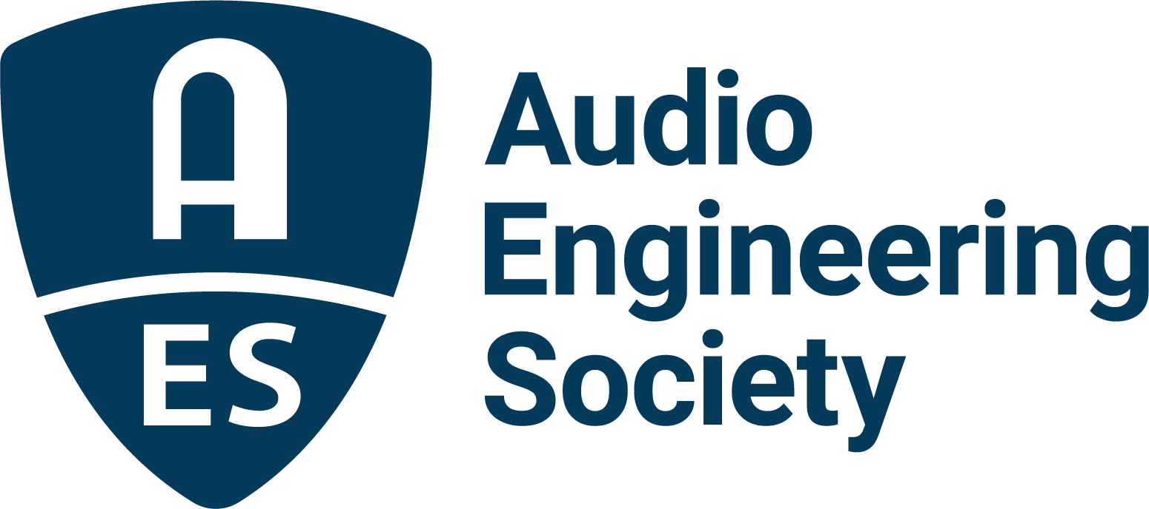

FOR IMMEDIATE RELEASE

Skywalker Sound’s Leslie Ann Jones to Keynote 2023 AES Audio Archiving, Preservation and Restoration Conference

— Event will host international slate of presenters and attendees at the U.S. Library of Congress National Audio-Visual Conservation Center in Culpeper, VA —

New York, NY, April 12, 2023 — The Audio Engineering Society has announced developing details of the next-in-series AES International Conference on Audio Archiving, Preservation and Restoration (AAPR), taking place June 1 – 3. Newly-announced Keynote presenter, Leslie Ann Jones of Skywalker Sound, will join a host of other top audio engineers and archiving professionals to present the latest technologies and address challenges in the field, offering strategies and insights to attendees on preserving the world’s rich audio heritage.

The Conference will return to the site of the highly successful 2018 AAPR conference – the U.S. Library of Congress National Audio-Visual Conservation Center in Culpeper, Virginia, one of the world’s premier active archives of audio-visual history – where researchers and practitioners will gather for three days to investigate the latest in archival science and its applications. Workshops, presentations and discussions will address critical preservation issues, including immersive audio assets, and focus on strategies to support and encourage collaboration and interoperability within the preservation, restoration and archiving community, and between that community and those holding intellectual property assets to preserve and monetize.

Registration at Early Bird rates through April 28, with even deeper discounts for AES Members and Student Members, is now open at the AAPR event page, along with a preliminary program and information on the venue and available accommodation.

Leslie Ann Jones’ Keynote speech is titled “Why It Matters: Reflections on Creating, Preserving and Valuing Music.” Reinforcing the mission and goals of the Conference, Jones states “Our recorded history is our future. Whether an indie artist's first record or the magnificent Star Wars soundtracks, audio assets are assets and all have value.”

To round off the three-day program the Conference will close with a buffet-style open-grill barbecue dinner where attendees can socialize and enjoy live music, outdoor projected silent movies and a couple of glasses of wine in the bucolic farm setting of the Mountain Run Winery, located just five minutes from downtown Culpeper.

…ends 315 words

Link:
2023 AES International Conference on Audio Archiving, Preservation and Restoration

Photo File 1: AES_AARP_Conference_2023.JPG
Photo Caption 1: Registration and preliminary details are now available for the AES International Conference on Audio Archiving, Preservation and Restoration, taking place June 1 – 3 at the U.S. Library of Congress National Audio-Visual Conservation Center in Culpeper, Virginia.

Photo File 2: Leslie_Ann_Jones.JPG
Photo Caption 2: Leslie Ann Jones of Skywalker Sound will give the Keynote at the AES 2023 Audio Archiving, Preservation and Restoration Conference taking place at the U.S. Library of Congress National Audio-Visual Conservation Center in Culpeper, Virginia.

Photo File 3: AES_Conference_Attendees.JPG
Photo Caption 3: A sold-out crowd of attendees gather during the 2018 AES International Conference on Audio Archiving, Preservation & Restoration at the U.S. Library of Congress National Audio-Visual Conservation Center in Culpeper, Virginia.

Photo File 4: AES_AAPR_IRENE.JPG
Photo Caption 4: Peter Alyea of the U.S. Library of Congress demonstrates their IRENE optical imaging system used to make high resolution 2D and 3D images of broken media that can’t otherwise be played back mechanically during the 2018 AES International Conference on Audio Archiving, Preservation & Restoration at the U.S. Library of Congress National Audio-Visual Conservation Center in Culpeper, VA.

About the Conference Committee
This year’s AES Audio Archiving, Preservation and Restoration Conference Committee is led by Chair and AES Past President John Krivit, along with Program Chair Nadja Wallaszkovits (AES Past President); Papers Co-chairs Konrad Strauss (Indiana University), Toby Seay (IASA Past President); Yuri Shimoda, Conference Treasurer (Disney) and Jessica Thompson, Marketing and Promotions Chair. Additional program organizers are Rob Friedrich (US Library of Congress), George Massenburg (GML), Brad McCoy (US Library of Congress – Retired), Kaylie Ackerman (Harvard University), Mitch Peyser (Time/Life Music), Melissa Widzinski (U.S. Library of Congress) and Samantha Winter, Intern.
About the Venue
The U.S. Library of Congress National Audio-Visual Conservation Center‘s Packard Campus of the National Audio-Visual Conservation Center, located in Culpeper, VA, provides underground storage for its entire collection on 90 miles of shelving, together with extensive modern facilities for the acquisition, cataloging and preservation of all formats. The facility holds the nation’s largest public collection of sound recordings containing music, spoken word and radio broadcasts, encompassing nearly 3.5 million recordings in all. Over 110 years of sound recordings history is represented in nearly every audio format, from cylinders to CDs, covering a wide range of subjects and genres in considerable depth and breadth.

About the Audio Engineering Society
The Audio Engineering Society celebrates 75 years of audio excellence in 2023. Serving as the pivotal force in fostering the development and dissemination of technical information for the audio community, its members are affiliated with 90 AES professional sections and more than 120 AES student sections around the world where activities include guest speakers, technical tours, demonstrations, online events and social functions. Through Conventions, Conferences, Training and Development, Member Events and peer-reviewed Publications, as well as the Society’s vast online technical document, Standards and video resources, members experience valuable opportunities for professional networking and personal growth. For additional information, visit AES.org.

Join the conversation and keep up with the latest AES News and Events:
Twitter: #AESorg (AES Official)
Facebook: facebook.com/AES.org
LinkedIn: https://www.linkedin.com/company/audio-engineering-society
Instagram: https://www.instagram.com/aes_org/

AES Marketing Communications:
Email: robert.clyne@aes.org
Tel: 615-662-1616
Clyne Media, Inc.,
169-B Belle Forest Circle, Nashville, TN 37221;
Web: http://www.clynemedia.com

