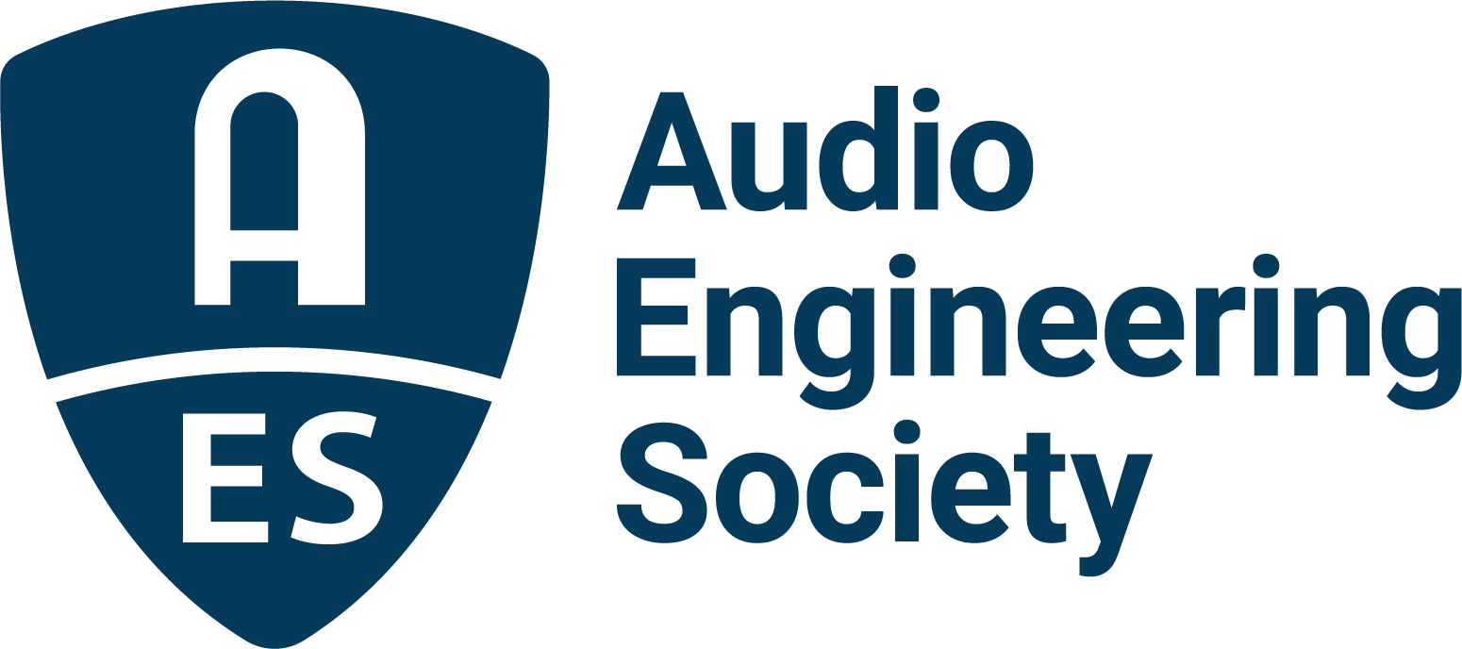

FOR IMMEDIATE RELEASE

Speaker and Special Event Updates Shared for AES Europe 2023

— The Audio Engineering Society has announced Jamie Angus-Whiteoak as Heyser Memorial Lecturer, plus student, social and pre-convention events —

New York, NY, February 28, 2023 — The Audio Engineering Society, celebrating its 75th Anniversary in 2023, has revealed details on highlights of the upcoming AES Europe 2023 Convention being held at Aalto University, Espoo, Helsinki, Finland, May 13 – 15.

AES’s world-renowned Technical Program for the 154th AES International Convention will cover a host of hot audio topics including immersive sound, microphone technology and use, recording, binaural listening and audio measurement, with full details online soon. Just announced is that AES Fellow and Silver Medal awardee Jamie Angus-Whiteoak, Emeritus Professor of Audio Technology, University of Salford, will deliver the Convention’s Richard C. Heyser Memorial Lecture. Titled “The Ear is Not a Fourier Transformer,” Jamie’s presentation will examine the operation of the ear, including its dynamic non-linear behavior, while exploring differences between the Fourier Transform and the human auditory system, and highlighting how they trade off time and frequency resolution differently. Further, the lecture will look at the unique ways the human auditory system allows us to hear the incredible complexity of an audio signal and how that might affect what we do in the future to improve audio.

Jamie joins the Convention’s special guest speaker roster alongside the previously announced 2023 Keynote speaker, Douglas Castro, CEO and Founder of Helsinki-based Neural DSP Technologies and an award-winning developer of AI-enabled state-of-the-art digital effects and associated hardware to emulate physical guitar and bass amplifiers.

Taking advantage of the Convention venue, attendees are being invited to a free (registration required) May 12 pre-convention workshop at the Aalto Acoustics Lab where Ville Pulkki, Vesa Välimäki, Tapio Lokki and Sebastian Schlecht will discuss trends in acoustics research, followed by jaw-dropping demonstrations in the Lab.

AES Conventions are also renowned for their unparalleled human networking opportunities with leading industry production, product development and research professionals. In addition to dialog in and around the Convention venue, on Saturday, May 13, Convention registrants can join friends and colleagues for an evening cruise to enjoy the beautiful scenery of the Helsinki archipelago. The registration price for the sightseeing boat trip includes a buffet. Space is limited so early registration is recommended.

Along with getting preferential registration rates, AES Student Members have Convention opportunities designed specifically for them. Student activities will include the always popular student party on May 14 and, within the Technical Program, the enlightening Student Mix Critiques where a panel of industry professionals offer feedback, suggestions and insights on student productions in a live, non-competitive setting,

Special Early Bird discount registration pricing for the AES Europe 2023 Convention is available for a limited time. Further details on registration; student activities; Convention Partners and Sponsors Genelec, IMES (Iron Mountain Entertainment Services), Nokia and Brandenburg Labs; and the host of ways the Convention will deliver to “Listen, Learn and Connect” with peers and pros from around the world are available at AESEurope.com.

…ends 467 words

Links:
AES Europe 2023 Convention
AES Europe 2023 Heyser Lecture – Jamie Angus-Whiteoak
AES Europe 2023 Keynote – Douglas Castro

Photo File 1: AES_Europe_2023.JPG
Photo Caption 1: Registration and preliminary details are now available for the AES Europe 2023 Convention in Espoo, Helsinki, Finland, May 13 – 15, at AESEurope.com.

Photo File 2: Jamie_Angus_Whiteoak.JPG
Photo Caption 2: AES Fellow Jamie Angus-Whiteoak, Emeritus Professor of Audio Technology, University of Salford, will deliver the Richard C. Heyser Memorial Lecture, titled “The Ear is Not a Fourier Transformer,” at the AES Europe 2023 Convention in Espoo, Helsinki, Finland.

Photo File 3: Douglas_Castro.JPG
Photo Caption 3: Douglas Castro, CEO and Founder of Helsinki-based Neural DSP Technologies, has been announced as the Keynote speaker for the AES Europe 2023 Convention in Helsinki, Finland.

Photo File 4: Archipelago_Cruise.JPG
Photo Caption 4: On Saturday, May 13, AES Europe 2023 Convention registrants can join friends and colleagues for an evening cruise to enjoy the beautiful scenery of the Helsinki archipelago.

About the Audio Engineering Society
The Audio Engineering Society celebrates 75 years of audio excellence in 2023. Serving as the pivotal force in fostering the development and dissemination of technical information for the audio community, its members are affiliated with 90 AES professional sections and more than 120 AES student sections around the world where activities include guest speakers, technical tours, demonstrations, online events and social functions. Through Conventions, Conferences, Training and Development, Member Events and peer-reviewed Publications, as well as the Society’s vast online technical document, Standards and video resources, members experience valuable opportunities for professional networking and personal growth. For additional information, visit AES.org.

Join the conversation and keep up with the latest AES News and Events:
Twitter: #AESorg (AES Official)
Facebook: facebook.com/AES.org
LinkedIn: https://www.linkedin.com/company/audio-engineering-society
Instagram: https://www.instagram.com/aes_org/

AES Marketing Communications:
Email: robert.clyne@aes.org
Tel: 615-662-1616
Clyne Media, Inc.,
169-B Belle Forest Circle, Nashville, TN 37221;
Web: http://www.clynemedia.com

