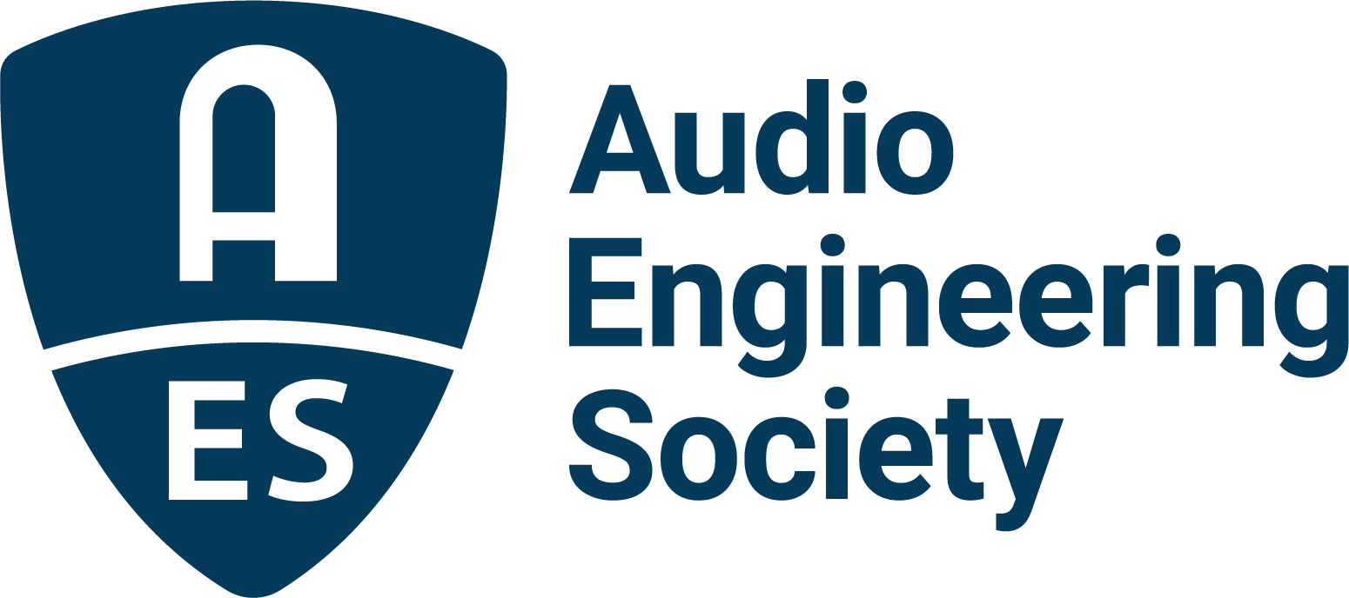

FOR IMMEDIATE RELEASE

AES Europe 2023 Convention Releases Preliminary Program Details for Papers and Workshops Presentations; Early Bird Rates End March 20

— Highly anticipated AES Europe Convention to highlight prevalent audio topics through a variety of formats including a series of immersive audio Workshops and a sweeping cross-section of audio technology and production sessions —

New York, NY, March 16, 2023 — The AES has announced its preliminary listings of Papers and Workshops presentations for the upcoming AES Europe 2023 Convention, being held at Aalto University, Espoo, Helsinki, Finland, May 13 – 15, with pre-convention events on May 12.

As well as 40 topical Workshops and over 100 Papers sessions covering the full spectrum of audio topics and audio research from a worldwide roster of presenters, Convention highlights include a Keynote by Douglas Castro of Neural DSP Technologies; the Heyser Memorial Lecture by AES Fellow and Silver Medal awardee Jamie Angus-Whiteoak; a pre-Convention Tech Tour of Finnish broadcaster YLE’s radio studios; a pre-Convention tour, demonstrations and discussion of trends in acoustics research at the Aalto Acoustics Lab; and an Archipelago Sightseeing Cruise open to all attendees (additional registration required). Immediate registration is recommended to take advantage of discounted Early Bird rates, available through Monday, March 20.

Prominent in the list of Workshops list is a series of “Enveloping Masterclass” sessions hosted by the perennially popular presenter Thomas Lund and featuring experts Hyunkook Lee, Morten Lindberg, Florian Camerer, Ulrike Schwarz, Kimio Hamasaki and Li Dakang. Binaural mixes, managing low frequencies, AoIP, career guidance, recording studio collaboration, acoustics, microphones, hearing and a host of additional immersive topics are also on the Workshops slate, with an elite cast of presenters including Tom Ammerman, Bruce Black, Ian Corbett, Rafael Kassier, Richard King, Brad McCoy, Maryam Safi, Nadya Wallaszkovits and John Willett. Additional technology workshops will be hosted by AES Europe Convention Partners Genelec, IMES (Iron Mountain Entertainment Services) and Nokia, with additional Partner support from Brandenburg Labs.

An equally robust Papers program will offer the latest research in an array of audio topics, from loudspeakers and headphones to spatial audio and synthesis, recording and perception, and other cutting-edge areas of audio research. These sessions present a unique opportunity for attendees to gather in-depth knowledge and insights into the inner workings of the latest technologies and techniques in audio. A preliminary list of Papers topics and presenters is currently available on the AES Europe 2023 Convention website: AESEurope.com.

Additionally, the AES Europe 2023 Convention will offer a slate of student-focused sessions and activities, including a student party co-organized with Entropy – the electronic music cultural association of Student Union of Aalto University – to feature a rave room, a jazz lounge, and a sauna with a subwoofer!

Registration and information on travel recommendations and Convention offerings including student activities, networking opportunities and program updates are at AESEurope.com.

…ends 413 words

Links:
AES Europe 2023 Convention
AES Europe 2023 Preliminary Tech Program Details
AES Europe 2023 Social Events

Photo File 1: AES_Europe_2023.JPG
Photo Caption 1: Registration and preliminary details are now available for the AES Europe 2023 Convention in Espoo, Helsinki, Finland, May 13 – 15, at AESEurope.com.

Photo File 2: Aalto-University.jpg
Photo Caption 2: AES Europe 2023 is being held at Aalto University, Espoo, Helsinki, Finland.

Photo File 3: Aalto_University_Anechoic_Chambers_at_Acoustics_Labs.jpg
Photo Caption 3: A pre-convention tour, demonstrations and discussion of trends in acoustics research will take place in the Aalto Acoustics Lab onsite at the AES Europe 2023 Venue.

About the Audio Engineering Society
The Audio Engineering Society celebrates 75 years of audio excellence in 2023. Serving as the pivotal force in fostering the development and dissemination of technical information for the audio community, its members are affiliated with 90 AES professional sections and more than 120 AES student sections around the world where activities include guest speakers, technical tours, demonstrations, online events and social functions. Through Conventions, Conferences, Training and Development, Member Events and peer-reviewed Publications, as well as the Society’s vast online technical document, Standards and video resources, members experience valuable opportunities for professional networking and personal growth. For additional information, visit AES.org.

Join the conversation and keep up with the latest AES News and Events:
Twitter: #AESorg (AES Official)
Facebook: facebook.com/AES.org
LinkedIn: https://www.linkedin.com/company/audio-engineering-society
Instagram: https://www.instagram.com/aes_org/

AES Marketing Communications:
Email: robert.clyne@aes.org
Tel: 615-662-1616
Clyne Media, Inc.,
169-B Belle Forest Circle, Nashville, TN 37221;
Web: http://www.clynemedia.com

