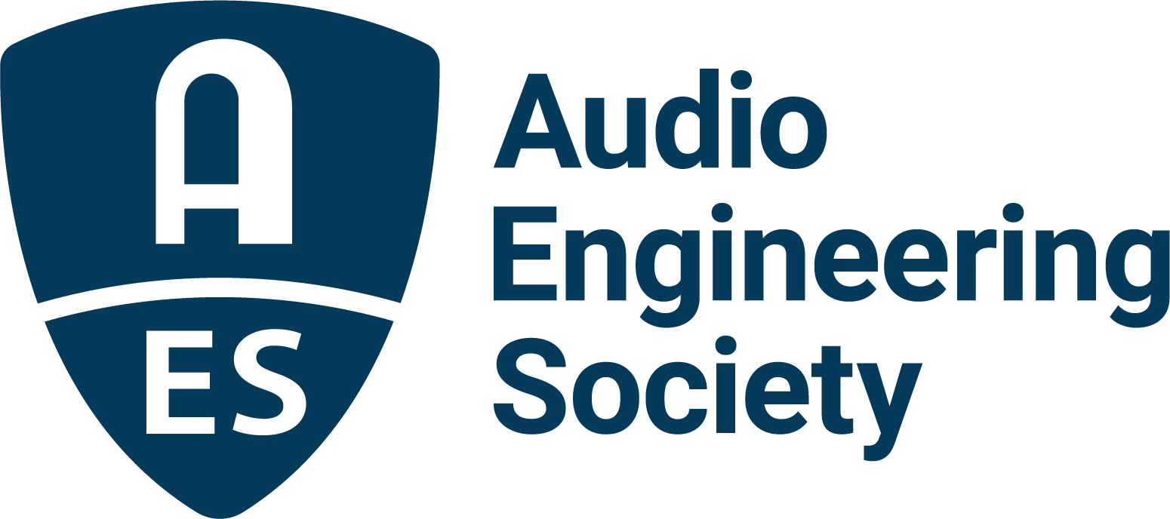

FOR IMMEDIATE RELEASE

AES Europe 2023 Delivers Immersive Experience to Sold-Out Audience in Finland

— Audio engineering professionals and students from over 30 countries gathered for annual European AES Convention highlighting the latest in audio science and application —

New York, NY, May 26, 2023 — The Audio Engineering Society, celebrating its 75th anniversary in 2023, maxed out the capacity of the venue for the recent 154th AES International Convention, held at Aalto University, Espoo, Helsinki, Finland, May 13-15. AES Europe 2023 delivered over 140 sessions to near 450 participants, who came from over 30 countries to learn from world-leading audio experts and experience the latest audio technologies and techniques. The breadth of audio topics included extensive forays into cutting-edge innovations in Spatial and Immersive Audio, as well as audio for Augmented and Virtual Reality, demonstrating the leadership of the AES in developing and shaping emerging technologies. Other highlights included a Keynote by Neural DSP’s Douglas Castro and the Heyser Memorial Lecture by Jamie Angus-Whiteoak, Emeritus Professor of Audio Technology at Salford University.

Commenting on the Convention’s positive feedback and integral participation by attendees and presenters, Convention Chair Ville Pulkki commented, “There would not be a convention without professionals submitting their work, and the Chairs are thankful for the broad collection of high-quality works received. The organizers garnered a lot of positive feedback for hosting well-attended tours of the Aalto Acoustics Lab, and the Dipoli event venue and its timeless design, as well as for the program in general. The success of the event proved that our Society needs conventions as general gatherings of professionals and researchers in the field of audio, even without large exhibitions.”

AES Europe 2023’s attendees – nearly a third being a strong contingent of students from around the world – shared in educational experiences designed to bolster collaboration and experimentation amongst audio professionals. Workshops Chair Aki Mäkivirta recounts, “The AES 154th Convention in Espoo provided a captivating array of informative workshops conducted by prominent experts. These encompassed a wide range of topics, including comprehensive tutorials and case studies on creating top-notch immersive recordings, updates on the latest advancements in audio synthesis, modelling, coding, applications of machine learning and artificial intelligence, and other vital subjects within the realm of audio engineering. These workshops aimed to equip and support the career development of individuals studying or actively engaged in audio engineering, while also serving as a source of inspiration to continually push the boundaries of what is achievable. By fostering communication and facilitating the exchange of knowledge, these workshops offered an exceptional opportunity to discover and learn about exciting new developments in the field of audio engineering.”

In addition to the extensive Technical Program offerings, attendees also enjoyed networking events including an Archipelago Sightseeing Cruise and a Student Party co-organized with Entropy, the electronic music cultural association of the Student Union of Aalto University. Industry support for the AES Europe 2023 Convention came from sponsors Genelec, Iron Mountain Entertainment Services, Nokia, Brandenburg Labs, Microtech Gefell and Oeksound.

The AES continues to celebrate 75 years of Audio Innovation in 2023 with upcoming AES Section events, Conferences and more, culminating in the AES New York 155th International Convention taking place October 25 – 27.

…ends 486 words

Links:
AES Europe 2023 Convention
AES New York 2023 Convention

Photo File 1: AES_Europe_Crowd.JPG
Photo Caption 1: Attendees gather for one of over 140 sessions held during the sold-out AES Europe 2023 Convention held at Aalto University, Espoo, Helsinki, Finland, May 13-15.
Photo File 2: AES_Europe_Keynote.JPG
Photo Caption 2: Neural DSP’s Douglas Castro delivers the Keynote address during the AES Europe 2023 Convention.
Photo File 3: AES_Europe_Heyser.JPG
Photo Caption 3: AES Europe 2023 Heyser Memorial Lecturer Jamie Angus-Whiteoak (right) accepts an AES Gold Medal Award from AES President Bruce Olson during the Convention’s opening ceremony
Photo File 4: Ville_Pulkki.JPG
Photo Caption 4: Ville Pulkki, AES Europe 2023 Convention Chair.
Photo File 5: Aki_ Makivirta.JPG
Photo Caption 5: Aki Mäkivirta, AES Europe 2023 Convention Workshops Chair.

About the Audio Engineering Society
The Audio Engineering Society celebrates 75 years of audio excellence in 2023. Serving as the pivotal force in fostering the development and dissemination of technical information for the audio community, its members are affiliated with 90 AES professional sections and more than 120 AES student sections around the world where activities include guest speakers, technical tours, demonstrations, online events and social functions. Through Conventions, Conferences, Training and Development, Member Events and peer-reviewed Publications, as well as the Society’s vast online technical document, Standards and video resources, members experience valuable opportunities for professional networking and personal growth. For additional information, visit AES.org.

Join the conversation and keep up with the latest AES News and Events:
Twitter: #AESorg (AES Official)
Facebook: facebook.com/AES.org
LinkedIn: https://www.linkedin.com/company/audio-engineering-society
Instagram: https://www.instagram.com/aes_org/

AES Marketing Communications:
Email: robert.clyne@aes.org
Tel: 615-662-1616
Clyne Media, Inc.,
169-B Belle Forest Circle, Nashville, TN 37221;
Web: http://www.clynemedia.com

