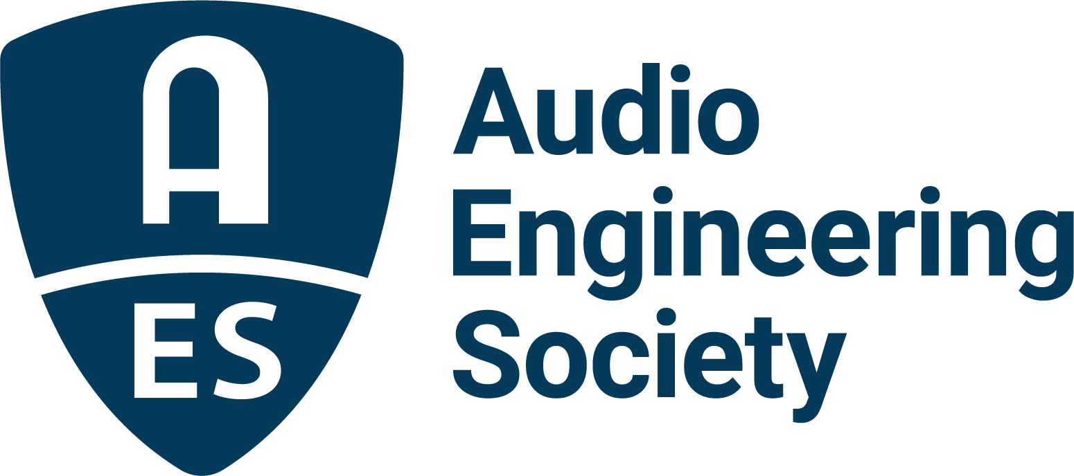

FOR IMMEDIATE RELEASE

Detailed Program Schedule Announced for AES Europe 2023 Convention – Early Bird Rates End April 3

— Full details of the 154th Technical Program schedule, session content and presenters reveal extensive insights into the latest audio technologies and techniques —

New York, NY, March 31, 2023 — The AES has released Technical Program details for the upcoming AES Europe 2023 Convention, being held at Aalto University, Espoo, Helsinki, Finland, May 13 – 15. To ensure attendees have the opportunity to review the full schedule to appreciate the breadth and scope of the Program, and secure the best value on all that the Convention has to offer, Early Bird pricing has been extended through April 3.

Contained in the Convention’s schedule of Tech Program sessions and events are newly announced details on the full slate of research paper presentations, along with additional workshop details. The interactive online schedule also includes abstracts for all sessions.

A sampling of the audio research being presented during the 3-day program includes a look at “Advances in Perceptual Bass Extension for Music and Cinematic Content” (authors: Sunil G. Bharitkar, Ema Souza Blanes, Glenn Kubota and Ashish Rawat); an exploration of an acoustic navigation experiment in virtual reality in “Navigation of Virtual Mazes Using Acoustic Cues” (authors: Sebastia Vicenc Amengual Gari, Paul Calamia and Philip Robinson); discovery of innovations in aural training exercises in “Generating Melodic Dictations Using Markov Chains and LSTM Neural Networks” (authors: Emilia Stefanowska, Stanisław Kacprzak and Piotr Książek); learning about challenges and technologies in working with compact electronic devices in the session “Audio Capture Using Structural Sensors on Vibrating Panel Surfaces” (authors: Tre DiPassio, Michael Heilemann and Mark Bocko); and hearing about recreating inner auditory experiences in “Representing Inner Voices in Virtual Reality Environments” (authors: Kuura Parkkola, Thomas McKenzie, Jukka Häkkinen and Ville Pulkki).

38 of the 100+ Papers and Posters presentations are authored or co-authored by students representing many top universities and institutes. These include a diverse range of topics such as “Open-access 3D-printed adjustable microphone turntable” (Bogdan Ioan Bacila, University of Huddersfield, UK); “A New Method for HRTFs Interpolation based on Inverse Distance Weighting” (Valeria Bruschi, Università Politecnica delle Marche, Italy); “A Review of Literature in Critical Listening Education” (Stephane Elmosnino, University of Technology Sydney, Australia); “Plasma Organ – Improvement of Prototype” (Miłosz Derżko, AGH University of Science & Technology, Poland); “Optimal Spatial Sampling of Plant Transfer Functions for Head-Tracked Personal Sound Zones” (Yue Qiao, Princeton University, USA); and “Inside The Quartet – A first-person virtual reality string quartet production” (Nils Meyer-Kahlen, Aalto University, Finland).

The AES Europe 2023 Convention also offers a robust program of student-focused sessions offering practical and career-oriented advice including “What I Wish I Knew (When Starting My Career)” and “What Does it Take to Become a Successful Audio Engineer?,” while student attendees are also encouraged to participate in Student Mix Critique sessions and the Sunday evening Student Party co-organized with Entropy – the electronic music cultural association of Student Union of Aalto University – to feature a rave room, jazz lounge and more.

The complete Tech Program details, venue and travel info, and how to register can be found at AESEurope.com.

…ends 473 words

Links:
AES Europe 2023 Convention
AES Europe 2023 – Tech Program
AES Europe 2023 Social Events

Photo File 1: AES_Europe_2023.JPG
Photo Caption 1: The AES has released Tech Program details for the upcoming AES Europe 2023 Convention, being held at Aalto University, Espoo, Helsinki, Finland, May 13 – 15. Early Bird registration pricing has been extended through April 3 at AESEurope.com.

About AES Europe 2023
Marking the first international convention of the AES’s 75th anniversary year, AES Europe 2023 will bring together leaders in audio research, technology and education for three days of audio immersion, featuring over 140 topical workshops, research paper presentations, a strong showing of student-led sessions, opportunities to network with peers and mentors, and more. Plus, this year’s featured Keynote by Douglas Castro, CEO and Founder, Neural DSP Technologies and the Heyser Memorial Lecture by AES Fellow and Silver Medal awardee Jamie Angus-Whiteoak, Emeritus Professor of Audio Technology, University of Salford. Additional technology workshops will be presented by AES Europe Convention Partners Genelec, IMES (Iron Mountain Entertainment Services) and Nokia, with additional Partner support from Brandenburg Labs.

This year’s AES Europe Convention also offers two pre-Convention Tech Tour events including a tour, demonstrations and discussion of trends in acoustics research in the Aalto Acoustics lab and a tour of Finnish broadcaster YLE. Saturday evening, the AES will host an Archipelago Sightseeing Cruise open to all attendees (additional registration required).

The complete Tech Program details, venue and travel info and registration can be found at AESEurope.com.

About the Audio Engineering Society
The Audio Engineering Society celebrates 75 years of audio excellence in 2023. Serving as the pivotal force in fostering the development and dissemination of technical information for the audio community, its members are affiliated with 90 AES professional sections and more than 120 AES student sections around the world where activities include guest speakers, technical tours, demonstrations, online events and social functions. Through Conventions, Conferences, Training and Development, Member Events and peer-reviewed Publications, as well as the Society’s vast online technical document, Standards and video resources, members experience valuable opportunities for professional networking and personal growth. For additional information, visit AES.org.

Join the conversation and keep up with the latest AES News and Events:
Twitter: #AESorg (AES Official)
Facebook: facebook.com/AES.org
LinkedIn: https://www.linkedin.com/company/audio-engineering-society
Instagram: https://www.instagram.com/aes_org/

AES Marketing Communications:
Email: robert.clyne@aes.org
Tel: 615-662-1616
Clyne Media, Inc.,
169-B Belle Forest Circle, Nashville, TN 37221;
Web: http://www.clynemedia.com

