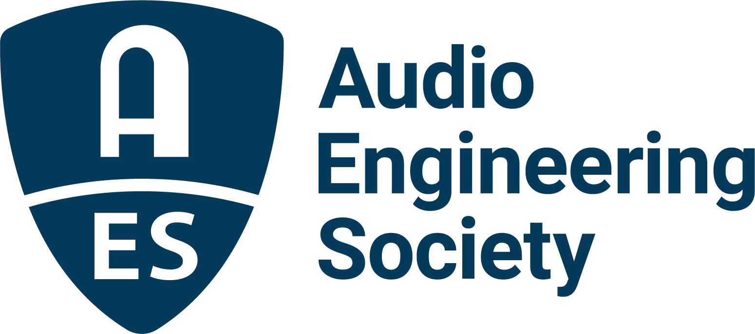

FOR IMMEDIATE RELEASE

AES Europe Convention Workshops Program Offers Insights on Audio Production and Technologies

— Educational sessions throughout the AES Europe 2023 Technical Program present exclusive opportunities to learn from some of the top researchers in audio science —

New York, NY, April 28, 2023 — The run-up to this year’s AES Europe 2023 Convention, being held at Aalto University, Espoo, Helsinki, Finland, May 13-15, continues to build momentum with a strong Technical Program featuring over 40 topical Workshops in addition to research papers presentations, technology demonstrations and networking events. Whether attending as a first-time student or seasoned veteran of AES events, AES Europe 2023 will offer an inclusive and diverse industry gathering of top-tier professionals in a state-of-the-art host venue that is sure to illuminate, educate and inspire further innovation in the art and science of audio engineering. View the full schedule of over 140 Technical Program sessions, student activities and special events, and register at AESEurope.com.

The myriad of topical workshops highlight breaking technologies as well as audio standards and insights into audio engineering fundamentals. Day one’s immersive audio workshops sessions include two heavily bookmarked by Convention registrants: “The Why and How Behind Immersive and Surround Recordings,” which will examine the interaction between composers, musicians, producers, engineers and labels in immersive audio production, and a look at the plethora of target playback environments for immersive audio in “Immersive Staging Targets for Various Playback Scenarios.” The highlight acoustics session, “Secrets of the Low Frequencies – Navigating the Quicksand,” joins additional first day workshop topics including “The Future of Wireless Audio / Headphone 3.0,” “Towards an Objective Understanding of High-End Audio,” and a “Primer to the Temporal Auditory Imaging Theory.”

Day two continues with sessions focused on the 100+ pre-registered student attendees such as “What Does it Take to Become a Successful Audio Engineer?,” “What I Wish I Knew (When Starting My Career)” and the first of two of the always popular Student Mix Critiques. Further sessions include a four-part Enveloping Masterclass series with immersive listening opportunities and Q&As, explorations of modeling and emulation including “Machine Learning for Guitar Amplifier Modeling,” while important sound reinforcement issues are covered in “Essential Elements for Building Acoustically High Performance Spaces” and “Maximum Sound Pressure Level Prediction and Measurement for Live Event Applications.”

Workshops on the third day of AES Europe include vital information on hearing preservation in “Safe Listening – Clinical Review, EU Requirements, Tinnitus and Treatment,” while “The Anatomy of a Recording Session: Where Musical Creativity and Technology Intersect,” features a discussion on using recording studio sessions to study creativity as a collaborative practice. A DIY software engineering educational session on “Creating Audio Plug-ins with MATLAB” is complemented by a detailed look at the now free-to-all web edition of the “AES Perceptual Audio Coders – What to Listen For” interactive online tutorial, which offers a set of valuable listening evaluation tools to the audio community.

AES Europe 2023 Workshops Chair, Aki Mäkivirta states: “I am very excited about the line-up of excellent workshops in the upcoming AES154 Convention. These will cover the core areas of current developments in audio engineering, ranging from immersive recording and mixing techniques and sound design, to improving personal rendering of audio for headphone presentation, machine learning in the area of audio, virtual and augmented audio, creating plugins with MATLAB, and the design of acoustically high performance spaces. I am confident the AES Convention in Espoo will offer an excellent view of what is important in audio engineering at the moment, and do this at the highest possible scientific level.”

Rounding out the AES Europe 2023 program will be a Friday pre-convention Technical Tour and Workshop, and a Saturday evening Archipelago Sightseeing Cruise, now in a larger vessel with added capacity (additional registration required for these events). Sunday evening’s Student Party, co-organized with Entropy, the electronic music cultural association of the Student Union of Aalto University, will feature the unique Ambient Sauna (Convention badge required for entrance).

Complete AES Europe 2023 details, including AES Member and Student Member registration discounts, are available online at AESEurope.com.

…ends 628 words

Links:
AES Europe 2023 Convention
AES Europe 2023 Convention – Tech Program

Photo File 1: AES_Europe_2023_Convention.JPG
Photo Caption 1: The AES Europe 2023 Convention, being held at Aalto University, Espoo, Helsinki, Finland, May 13-15, will feature over 40 topical Workshops in addition to research papers presentations, technology demonstrations and networking events.
Photo File 2: Aki_Makivirta.JPG
Photo Caption 2: AES Europe 2023 Convention Workshops Chair, Aki Mäkivirta

About AES Europe 2023
Marking the first international convention of the AES’s 75th anniversary year, AES Europe 2023 will bring together leaders in audio research, technology and education for three days of audio immersion, featuring over 140 topical workshops, research paper presentations, a strong showing of student-led sessions, opportunities to network with peers and mentors, and more. Plus, this year’s featured Keynote by Douglas Castro, CEO and Founder, Neural DSP Technologies and the Heyser Memorial Lecture by AES Fellow and Silver Medal awardee Jamie Angus-Whiteoak, Emeritus Professor of Audio Technology, University of Salford. Additional technology workshops will be presented by AES Europe Convention Partners Genelec, IMES (Iron Mountain Entertainment Services) and Nokia, with additional Partner support from Brandenburg Labs, Microtech Gefell and Oeksound.

This year’s AES Europe Convention also offers two pre-Convention events including a tour, demonstrations and discussion of trends in acoustics research in the Aalto Acoustics lab and a tour of Finnish broadcaster YLE. Saturday evening, the AES will host an Archipelago Sightseeing Cruise open to all attendees (additional registration required).

The complete Tech Program details, venue and travel info and registration can be found at AESEurope.com.

About the Audio Engineering Society
The Audio Engineering Society celebrates 75 years of audio excellence in 2023. Serving as the pivotal force in fostering the development and dissemination of technical information for the audio community, its members are affiliated with 90 AES professional sections and more than 120 AES student sections around the world where activities include guest speakers, technical tours, demonstrations, online events and social functions. Through Conventions, Conferences, Training and Development, Member Events and peer-reviewed Publications, as well as the Society’s vast online technical document, Standards and video resources, members experience valuable opportunities for professional networking and personal growth. For additional information, visit AES.org.

Join the conversation and keep up with the latest AES News and Events:
Twitter: #AESorg (AES Official)
Facebook: facebook.com/AES.org
LinkedIn: https://www.linkedin.com/company/audio-engineering-society
Instagram: https://www.instagram.com/aes_org/

AES Marketing Communications:
Email: robert.clyne@aes.org
Tel: 615-662-1616
Clyne Media, Inc.,
169-B Belle Forest Circle, Nashville, TN 37221;
Web: http://www.clynemedia.com

