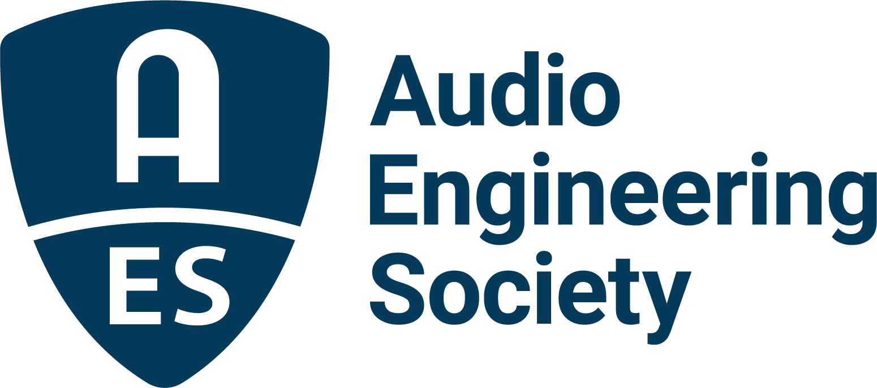

FOR IMMEDIATE RELEASE

Audio Engineering Society Receives Technical GRAMMY® Award

— AES acknowledged for its contributions of outstanding technical significance to the recording field —

New York, NY, February 7, 2023 — The Audio Engineering Society (AES) was presented with a prestigious Technical GRAMMY® Award during GRAMMY® Week 2023. AES President Bruce Olson and AES President-Elect Leslie Gaston-Bird accepted the Special Merit Award on behalf of the Society during a ceremony held by the Recording Academy® on Saturday, February 4, 2023, at the Wilshire Ebell Theatre in Los Angeles.

“The Audio Engineering Society is celebrating its 75th year at the heart of audio innovation,” noted Olson in his acceptance comments. “From such milestones as the AES Convention introductions of the 45 rpm single, the Compact Disc, the MP3 format, and now streaming audio technology, AES brings together the leading minds in audio innovation and has guided the music industry with standards and best practices that continuously refine the state of the art of audio recording, playback, broadcast, and streaming. The AES is honored by this recognition of its ongoing contributions and on behalf of its more than 10,000 members worldwide, the Society proudly accepts this Technical GRAMMY Award and thanks the Recording Academy and its Producers & Engineers Wing®.”

Gaston-Bird added to Olson’s comments, saying, “And our work is just beginning. We listen to our members and glean inspiration from women and underrepresented groups in audio who work tirelessly to create a more inclusive industry. We understand the power of networking, role models, and mentorship, and we’ll work within the industry to help create lasting, sustainable change. The next 75 years of the AES is already starting to look different from the first 75, and we are so excited about the future.”
This Special Merit Award is presented by vote of the Producers & Engineers Wing Advisory Council and Chapter Committees, and ratification by the Recording Academy’s National Trustees to individuals and/or companies/organizations/institutions who have made contributions of outstanding technical significance to the recording field.

In addition to the Society’s Technical GRAMMY Award, current AES members on the Recording Academy’s 2023 GRAMMY Awards recipients list are mastering engineer Bob Ludwig for his contribution to the Best Historical Album winner, Yankee Hotel Foxtrot (20th Anniversary Super Deluxe Edition) (Wilco); immersive mix engineer Eric Schilling and immersive producer Herbert Waltl for their roles on the Best Immersive Audio Album winner, Divine Tides (Stewart Copeland & Ricky Kej); and engineers Shawn Murphy and Charlie Post and mastering engineer Michael Romanowski for their work on the Best Engineered Album Classical winner, Bates: Philharmonia Fantastique – The Making Of The Orchestra (Edwin Outwater & Chicago Symphony Orchestra).

The Society also acknowledges the many AES members who contributed to and were credited on Award-winning recordings in GRAMMY® artist-focused nomination categories. Their contributions to the audio arts are appreciated by their fellow members and music lovers worldwide.

For the latest AES news, events and membership opportunities, visit AES.org.

…ends 458 words

Photo File 1: LeslieGB_BruceO.JPG
Photo Caption 1: AES President-Elect Leslie Gaston-Bird (left) and President Bruce Olson accepted a Technical GRAMMY® Award on behalf of the Audio Engineering Society during the GRAMMY® Week celebration in February 2023.
Photo Credit 1: Photo by Getty Images for the Recording Academy.

About the Audio Engineering Society
The Audio Engineering Society celebrates 75 years of audio excellence in 2023. Serving as the pivotal force in fostering the development and dissemination of technical information for the audio community, its members are affiliated with 90 AES professional sections and more than 120 AES student sections around the world where activities include guest speakers, technical tours, demonstrations, online events and social functions. Through Conventions, Conferences, Training and Development, Member Events and peer-reviewed Publications, as well as the Society’s vast online technical document, Standards and video resources, members experience valuable opportunities for professional networking and personal growth. For additional information, visit AES.org.

Join the conversation and keep up with the latest AES News and Events:
Twitter: #AESorg (AES Official)
Facebook: facebook.com/AES.org
LinkedIn: https://www.linkedin.com/company/audio-engineering-society
Instagram: https://www.instagram.com/aes_org/

AES Marketing Communications:
Email: robert.clyne@aes.org
Tel: 615-662-1616
Clyne Media, Inc.,
169-B Belle Forest Circle, Nashville, TN 37221
Web: http://www.clynemedia.com

