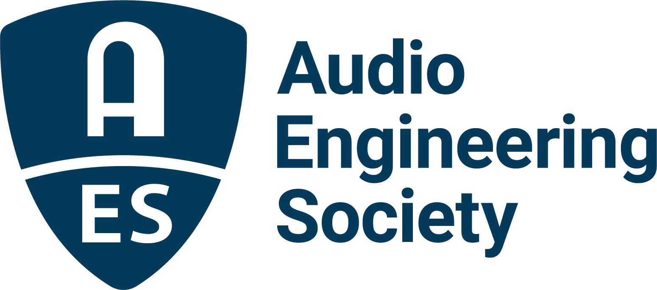

FOR IMMEDIATE RELEASE

The Audio Engineering Society Welcomes Bruce Olson as President

New York, NY, January 17, 2023 — The AES welcomes Bruce Olson as President for 2023, the Society’s 75th anniversary year. Olson, whose term of service began on January 1, is an AES Fellow whose decades of active service to the Society have helped shape international audio standards and practices, while he has further contributed to the Society as a Governor and Chair, Treasurer, and committee member of his local AES section.

“Bruce is perennially an invaluable driving force in the AES and to the industry as a whole,” states immediate Past President Josh Reiss. “His depth of experience within AES leadership and his industry acumen, as well as his acute technical insight, position him as a strong leader for continued growth as the AES enters its 75th year as the hub of audio technology and innovation.”

As the Chair of the Audio Engineering Society Standards Committee (AESSC), and having served as the Chair of the AES Working Group on Grounding and EMC Practices (SC-05-05), Vice-Chair of the AES Technical Committee for EMC (AESTC-EMC), and as a member of various AES standards groups, Olson received the AES Fellowship Award in 2018 “for outstanding contributions to AES Standards and to sound reinforcement system design and practices.” In addition to Standards, He has served on numerous AES Committees including Awards and Education, the 144th Convention, and a decade on the Laws & Resolutions Committee.

“It is an honor to serve as President of the Audio Engineering Society. I am pleased by the confidence and trust of our membership,” states Olson. “Through our international team of dedicated industry professionals, the AES continues to bring together the greatest minds with the latest technologies, both through our wide array of events – ranging from those that are industry-wide, such as our highly successful AES New York 2022 Convention, down to local section meetings – and through the standard-setting work that helps align the industry as a whole. I ask that you join us this year in celebrating audio innovation in all its forms and become a part of this worldwide audio community as we face and shape the future together.”

Olson is the founding member of Olson Sound Design, a consulting firm he started in 1991 specializing in acoustical and technical systems design for Performing Arts Centers, Recording Studios, and Houses of Worship. Prior to this, he worked for 13 years in audio and acoustical systems design, installation, testing and project management for Minneapolis, MN-based AVC Systems. He is also active in live sound system design and mixing.

Olson has been an invited speaker for sessions, workshops, classes and seminars organized by the AES, The American Institute of Architects (AIA), Acoustical Society of America (ASA), InfoComm, International Commission for Acoustics (ICA), Minnesota Music Educators Association (MMEA), National Association of Music Merchants (NAMM), National Systems Contractors Association (NSCA), Synergetic Audio Concepts (Syn-Aud-Con), and United States Institute for Theatre Technology (USITT). He has taught college courses on the use of sound reinforcement, recording, lighting and acoustic facilities. In 2017, Olson was presented with the ASA Fellowship Award for contributions to design and modeling of electro-acoustic systems for architectural spaces, and is also a member of IEEE, SMPTE, Syn-Aud-Con and USITT. He continues as an active musician and is a member of the Ria Saxophone Quintet and The Bend in the River Big Band.

Learn more about the Audio Engineering Society and membership at AES.org.
…ends 558 words

Photo File 1: Bruce_Olson.JPG
Photo Caption 1: The AES welcomes Bruce Olson as AES President in 2023.

About the Audio Engineering Society
The Audio Engineering Society celebrates 75 years of audio excellence in 2023. Serving as the pivotal force in fostering the development and dissemination of technical information for the audio community, its members are affiliated with 90 AES professional sections and more than 120 AES student sections around the world where activities include guest speakers, technical tours, demonstrations, online events and social functions. Through Conventions, Conferences, Training and Development, Member Events and peer-reviewed Publications, as well as the Society’s vast online technical document, Standards and video resources, members experience valuable opportunities for professional networking and personal growth. For additional information, visit AES.org.

Join the conversation and keep up with the latest AES News and Events:
Twitter: #AESorg (AES Official)
Facebook: facebook.com/AES.org
LinkedIn: https://www.linkedin.com/company/audio-engineering-society
Instagram: https://www.instagram.com/aes_org/

AES Marketing Communications:
Email: robert.clyne@aes.org
Tel: 615-662-1616
Clyne Media, Inc.,
169-B Belle Forest Circle, Nashville, TN 37221;
Web: http://www.clynemedia.com

