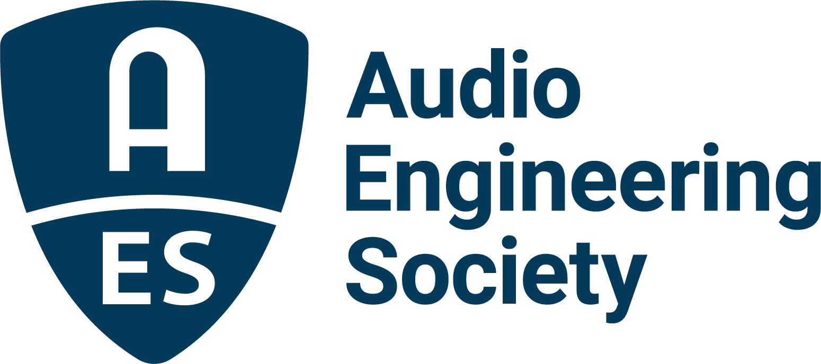

FOR IMMEDIATE RELEASE

Audio Engineering Society to Receive Technical GRAMMY® Award

— Organization acknowledged for its contribution of outstanding technical excellence to the recording field —

New York, NY, January 5, 2023 — The Audio Engineering Society (AES) has been informed that it will be presented with a prestigious Technical GRAMMY® Award during the GRAMMY Week celebration in February 2023. The news was made public as part of the Recording Academy® announcing its Special Merit Awards recipients. A special invitation-only ceremony will be held on Saturday, Feb. 4, 2023, at the Wilshire Ebell Theatre in Los Angeles. With the presentation of this Technical GRAMMY, AES joins an elite list of previous recipients which includes such well-known names as Apple Computer, Inc., AMS Neve plc, JBL Professional, Royer Labs, Shure Incorporated, Sony/Philips, Solid State Logic, Universal Audio, WAVES Audio, Ltd., and Yamaha Corporation.

This Special Merit Award is presented by vote of the Producers & Engineers Wing® Advisory Council and Chapter Committees, and ratification by the Recording Academy’s National Trustees to individuals and/or companies/organizations/institutions who have made contributions of outstanding technical significance to the recording field.

The Recording Academy’s Special Merit Awards recipients press release stated, “The Audio Engineering Society (AES) is the only professional society devoted exclusively to advancing audio technology. Founded in 1948 with the key goals of collecting, collating and disseminating knowledge of audio science and its application, AES facilitates communication and collaboration that unites audio engineers, creative artists, scientists, and students, with hundreds of local sections worldwide. 75 years on, AES’s members continue to set precedents and standards wherever sound and technology meet, from recording and entertainment to scientific research in emerging fields such as Spatial and Game Audio, Networking and Streaming, and Audio for Virtual and Augmented Reality.”

As it enters its 75th Anniversary year, the Society is deeply grateful to the Recording Academy, the Producers & Engineers Wing Advisory Council and Chapter Committees for this exceptional recognition of its ongoing contributions to the science and art of audio. “Receiving this Technical GRAMMY Award is a tremendous honor for the Audio Engineering Society,” remarked AES President Bruce Olson. “I could not think of a better present to kick off 2023 as AES begins to celebrate its 75th Anniversary.”

For the latest AES news, events and membership opportunities, visit AES.org.

…ends 350 words

Photo File 1: AES_75_logo.PNG
Photo Caption 1: The Audio Engineering Society (AES) will be presented with a prestigious Technical GRAMMY® Award during the GRAMMY Week celebration in February 2023.

About the Audio Engineering Society
The Audio Engineering Society celebrates 75 years of audio excellence in 2023. Serving as the pivotal force in fostering the development and dissemination of technical information for the audio community, its members are affiliated with 90 AES professional sections and more than 120 AES student sections around the world where activities include guest speakers, technical tours, demonstrations, online events and social functions. Through Conventions, Conferences, Training and Development, Member Events and peer-reviewed Publications, as well as the Society’s vast online technical document, Standards and video resources, members experience valuable opportunities for professional networking and personal growth. For additional information, visit AES.org.

Join the conversation and keep up with the latest AES News and Events:
Twitter: #AESorg (AES Official)
Facebook: facebook.com/AES.org
LinkedIn: https://www.linkedin.com/company/audio-engineering-society
Instagram: https://www.instagram.com/aes_org/

AES Marketing Communications:
Email: robert.clyne@aes.org
Tel: 615-662-1616
Clyne Media, Inc.,
169-B Belle Forest Circle, Nashville, TN 37221;
Web: http://www.clynemedia.com

