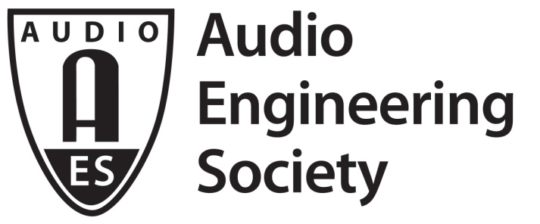

FOR IMMEDIATE RELEASE

“Ambisonics Tools for Immersive Audio” and “Audio Repair and Restoration” Special Hands-On Events Set for AES New York 2019

— Attendees will have the opportunity to experiment with dedicated hardware and software tools during these limited-seating All Access workshops —

New York, NY, October 8, 2019 — The AES New York 2019 Pro Audio Convention has slated two hands-on training workshops on the final day of the Convention, October 19.

Covering the latest cutting-edge tools and technologies in immersive audio production, the Convention will host an “Ambisonics Tools for Immersive Audio Capture and Post-Production” workshop from 9:00 am – 12:00 noon. Presenters will be Ianina Canalis (National University of Lanus), Brian Glasscock (Sennheiser), Andres A. Mayo (@360MusicLab) and Martin Muscatello (@360MusicLab).

“Over the past three years, immersive audio production tools have evolved considerably, allowing producers to combine them in a million creative ways.” shares AES Past President and “Ambisonics Tools for Immersive Audio Capture and Post-Production” workshop co-presenter Mayo. “This workshop will provide an in-depth explanation of how Ambisonics works, and how it can be a central element in an immersive audio production workflow.” Attendees will be able to experiment with dedicated hardware and software tools during the workshop and be guided through the entire process of capturing, processing, mixing and multiplexing audio and video in 360 degrees for multiple purposes, such as YouTube and Facebook music videos, Virtual Reality, and 360° documentaries.

Additionally, focusing on essential skills that let the modern engineer deal with a broad range of audio challenges, the workshop “Audio Repair and Restoration for Music and Post: Build Your Skills” will follow from 1:30 pm – 4:30 pm. Leading the workshop will be David Barber (Juniper Post – Burbank), Alexey Lukin,(iZotope), Jessica Thompson (Jessica Thompson Audio - Berkeley, CA) and Jonathan Wyner (M Works Mastering/iZotope/Berklee College of Music).
AES’s next President-Elect Wyner, co-presenter for the workshop “Audio Repair and Restoration for Music and Post: Build Your Skills” notes that “Single-ended noise reduction and audio repair tools have evolved during the past 35 years to the point that they have become an integral part of the work and workflows across audio disciplines. Workshop attendees will be led through an overview of the various sorts of technologies, techniques, and strategies used to solve audio challenges in music and audio post.” The workshop will include exercises designed to help participants develop their skills in audio repair and restoration for post and music applications. Among other topics, the workshop will address how to manipulate an audio spectrogram to problem solve more quickly and effectively, choosing noise reduction and repair technology to achieve the best results, best practices for repair sequencing, pre-treating signals to achieve best noise removal and aesthetic considerations in music and dialogue editing examples.

Preregistration is required for these events, as is Convention All Access registration (either four-, two- or one-day All Access registration, valid for October 19). Tickets for each workshop are $75 (member) and $125 (non-member) and can be purchased on-line through the Convention registration portal. Attendees must supply their own laptop and headphones for these unique learning experiences and must download and preload session resources. Seating is limited. All Access Advance Registration pricing and options and workshop registration is available through 11:00 pm EDT, October 14, with AES Members and Students receiving significant savings on badge registration. Find out more about the AES New York and register now at aesshow.com.

Further detail on the “Ambisonics Tools for Immersive Audio Capture and Post-Production” workshop, including computer requirements and asset download information, can be found at http://www.aes.org/events/147/ambisonics/.
Further detail on the “Audio Repair and Restoration for Music and Post: Build Your Skills” workshop, including computer requirements and asset download information, can be found at http://www.aes.org/events/147/restoration/.

...ends 568 words

Photo File: Ambisonics_Events.JPG
Photo Caption: AES New York attendees will have the opportunity to experiment with dedicated hardware and software tools during limited-seating All Access workshops on Saturday, October 19

Photo File: AESNY.JPG
Photo Caption: The AES New York 2019 Pro Audio Convention take place October 16 – 19 at the Javits Center

About the Audio Engineering Society
The Audio Engineering Society, celebrating over 70 years of audio excellence, now counts over 12,000 members throughout the U.S., Latin America, Europe, Japan and the Far East. The organization serves as the pivotal force in the exchange and dissemination of technical information for the industry. Currently, its members are affiliated with 90 AES professional sections and more than 120 AES student sections around the world. Section activities include guest speakers, technical tours, demonstrations and social functions. Through local AES section events members experience valuable opportunities for professional networking and personal growth. For additional information, visit aes.org.

Join the conversation and keep up with the latest AES News and Events:
Twitter: #AESorg (AES Official)
Facebook: facebook.com/AES.org

AES Marketing Communications:
Email: robert.clyne@aes.org
Tel: 615-662-1616, Fax: 615-662-1636,
Clyne Media, Inc.,
169-B Belle Forest Circle, Nashville, TN 37221;
Web: http://www.clynemedia.com

