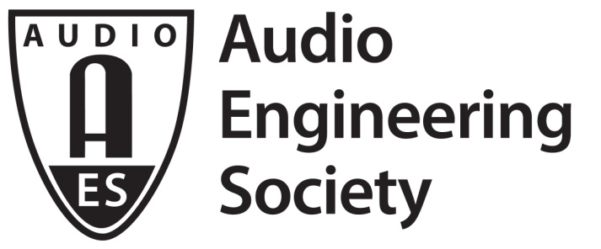

FOR IMMEDIATE RELEASE

Early-Bird Registration for AES New York Convention Ending Soon – Best Pricing and Options Available Through August 1

— AES New York attendees can save valuable time and money by registering now for the pro audio event of the year —

New York, NY, July 26, 2019 — Early-Bird pricing and options for AES New York 2019 Pro Audio Convention ends on August 1. All Access registration is the ticket to everything the largest dedicated pro audio event and exhibition of the year has to offer – four full days of the best in pro audio education, gear, networking opportunities, and much more. Offering the latest in science and technology in the fields of Studio Recording, Home Recording, Music Production, Electronic Dance Music, DJ, Live Sound, Theater Sound, Broadcast and Streaming, Networked Audio, Audio for Virtual and Augmented Reality, Game Audio, Sound for Picture, Product Development, and other related areas of the industry, AES New York is the place to be for pro audio inspiration and education.

Taking place October 16 – 19 (Exhibition and Inspiration Stage open October 16 – 18), the AES New York Convention will once again host the biggest names in professional audio, offering exclusive insights and presentations on the latest technologies and techniques for improving your sound and workflow. This year’s AES New York Convention will host over 330 Technical Program sessions (requires All Access badge) in addition to over 300 brands represented on the exhibition floor, three floors of demo rooms, over 100 Inspiration Stage presentations, and other opportunities to make the most of your convention experience.

Early Bird registration will end August 1. Information and registration are available at aesshow.com.

...ends 226 words

Photo File: AESNY.JPG
Photo Caption: Early-Bird Registration for AES New York Convention Ends August 1st

About the Audio Engineering Society
The Audio Engineering Society, celebrating over 70 years of audio excellence, now counts over 12,000 members throughout the U.S., Latin America, Europe, Japan and the Far East. The organization serves as the pivotal force in the exchange and dissemination of technical information for the industry. Currently, its members are affiliated with 90 AES professional sections and more than 120 AES student sections around the world. Section activities include guest speakers, technical tours, demonstrations and social functions. Through local AES section events members experience valuable opportunities for professional networking and personal growth. For additional information, visit aes.org.

Join the conversation and keep up with the latest AES News and Events:
Twitter: #AESorg (AES Official)
Facebook: facebook.com/AES.org

AES Marketing Communications:
Email: robert.clyne@aes.org
Tel: 615-662-1616, Fax: 615-662-1636,
Clyne Media, Inc.,
169-B Belle Forest Circle, Nashville, TN 37221;
Web: http://www.clynemedia.com

