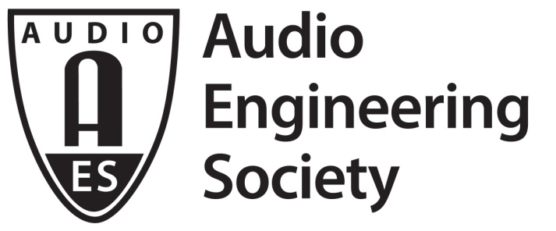

PRESS RELEASE
Contact: Robert Clyne
robert.clyne@aes.org
Tel: (615) 662-1616 x17

FOR IMMEDIATE RELEASE

AES Berlin 2017 Opens Tomorrow; Award Recipients Announced

Berlin, May 19, 2017 — AES Berlin 2017, the 142nd International AES Convention, begins Saturday, May 20, running through May 23. The Convention is being held at the Maritim Hotel Berlin (Stauffenbergstrasse). As part of the Convention’s special events program, the opening ceremonies will include the traditional presentation of AES Awards, recognizing individuals who have made significant contributions to the Society and/or to the field of audio engineering.

The Fellowship Award is given to a member who has rendered conspicuous service or is recognized to have made a valuable contribution to the advancement in or dissemination of knowledge of audio engineering or in the promotion of its application in practice. At AES Berlin, 2017, this award is being presented to Tapio Lokki, for bringing sensory evaluation to research of concert hall acoustics.

The Board Of Governors Award is given for outstanding contributions to the Audio Engineering Society. The Berlin recipients of the BOG Awards are Philip Jackson, in recognition of co-chairing the 2016 AES International Conference on Sound Field Control; and Michael Williams, in recognition of chairing the 140th AES Convention in Paris, France, June 4–7, 2016.

The Distinguished Service Award is given in recognition of extraordinary service to the Society over a period of years. This award will be presented to Mark Yonge, in recognition of exceptional contributions to, and management of, AES standards.

The Silver Medal is given in recognition of outstanding development or achievement in the field of audio engineering. Being recognized with a Silver Medal is Wolfgang Klippel, in recognition of outstanding achievements in the understanding, modeling and control of the behavior of loudspeaker and headphone transducers.

In addition to the awards above, outstanding Papers from those submitted for a given convention are recognized during Convention opening ceremonies. Papers Co-Chairs for the 142nd Convention, Jamie Angus and Thomas Sporer, have announced that Florian Straube, Frank Schultz, David Albanés Bonillo, and Stefan Weinzierl will be presented with the 142nd AES International Convention Paper Award. The winning paper is titled “An Analytical Approach for Optimizing the Curving of Line Source Arrays.”

Additionally, AES Student Technical Paper Award Coordinator Dr. Rob Maher has announced the paper titled “Joint Parameter Optimization of Differentiated Discretization Scheme for Audio Circuits” as the winner of the AES Berlin 2017 Student Technical Paper Award. The award will be presented to co-authors François Germain and Kurt James Werner.

Winning papers are eligible for publication in the Journal of the Audio Engineering Society, subject to standard submission and review guidelines.

Awards presentations for AES Berlin 2017 will take place during the opening ceremonies, Saturday, May 20, 13:00 – 14:30. Also during the opening ceremonies, Dr. Alex Arteaga will give the keynote address “Auditory Architecture: Environment, Sense, and Aurality.” Dr. Arteaga’s presentation will delve into areas of aesthetics and the perception by the senses as they pertain to audio, especially in regards to the research and design of “Klangumwelten,” the “surrounding-aural-worlds.”

Onsite registration is available for anyone wishing to attend AES Berlin. For more details, visit www.aeseurope.com.

...ends 498 words

Photo File: AES_Berlin.JPG
Photo Caption: AES Berlin opens 20 May 2017

About the Audio Engineering Society
The Audio Engineering Society was formed in 1948 and now counts over 12,000 members throughout the U.S., Latin America, Europe, Japan and the Far East. The organization serves as the pivotal force in the exchange and dissemination of technical information for the industry. Currently, its members are affiliated with more than 75 AES professional sections and more than 95 AES student sections around the world. Section activities may include guest speakers, technical tours, demonstrations and social functions. Through local AES section events, members experience valuable opportunities for professional networking and personal growth. For additional information visit http://www.aes.org.

Join the conversation and keep up with the latest AES News and Events:
Facebook: http://facebook.com/AES.org
Twitter: #AESorg (AES Official)

AES Marketing Communications:
Email: robert.clyne@aes.org
Tel: 615-662-1616, Fax: 615-662-1636,
Clyne Media, Inc.,
169-B Belle Forest Circle, Nashville, TN 37221;
Web: http://www.clynemedia.com

