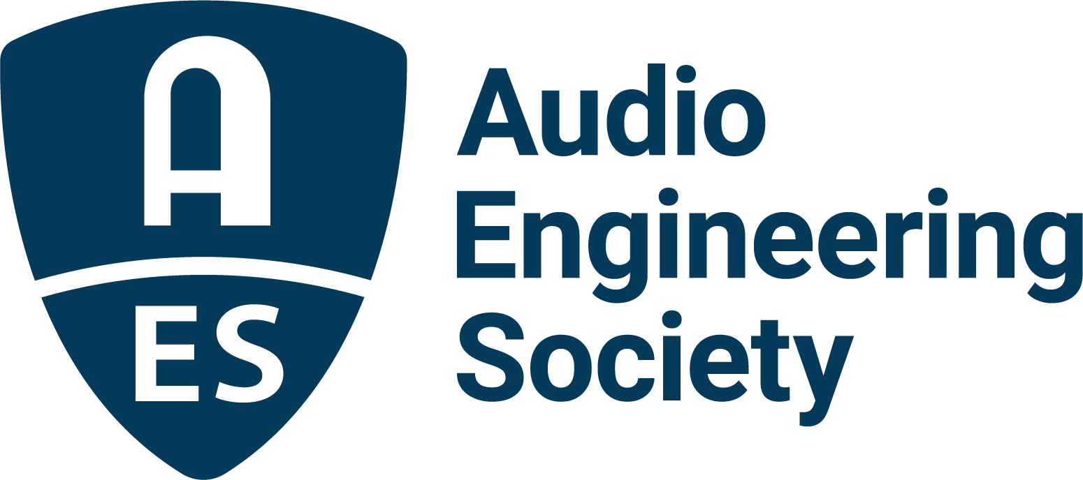

FOR IMMEDIATE RELEASE

AES announces International Conference on Breaking Barriers in Audio

— The Audio Engineering Society will bring together a diverse community of academics, audio professionals, industry veterans and advocates committed to fostering equity and inclusivity in audio engineering —

New York, NY, February 14, 2025 — The Audio Engineering Society (AES) has announced its inaugural AES International Conference on Breaking Barriers in Audio, taking place April 3 – 5, 2025. Aimed at furthering the Society’s extensive efforts in opening up opportunities for everyone in the audio industry and related fields, the Conference will offer a unique platform for exploring and elevating critical discussions on equity, access, representation, and the participation of underrepresented and marginalized groups in the audio community. Originally scheduled as a live event, to provide true inclusivity and accessibility to the broadest range of participants within our community, regardless of physical, geographic or financial status, the dialogue, Papers, and Workshops of this Conference will now be offered in a virtual format only.

A featured highlight of the event will be a Keynote from AES Past President and founder of Immersive and Inclusive Audio (IIA), Dr. Leslie Gaston-Bird, titled “Immersive and Inclusive: Advancing Equity in Education and Practice,” which will focus on creating lasting frameworks for equity in professional audio and to build an industry culture that values diverse perspectives and experiences. Key themes of the address will include safe spaces, mentorship, international impact, support networks, and role models. Dr. Gaston-Bird will present actionable recommendations for educators, industry leaders, and policymakers to build an equitable future for audio education and practice. A second keynote address has just been added, to be delivered by Joey Stuckey, an award-winning musician, composer, producer and sound engineer who lost his sight as a child.

The Breaking Barriers in Audio Conference is the culmination of years of research, outreach, and feedback from audio professionals seeking to provide more equitable entryways for those looking to contribute to the craft. Conference co-chairs are Dr. Jiayue Cecilia Wu (University of Colorado College of Arts and Media) and Dr. Mary Mazurek (University of Lethbridge), who will each offer their own unique insights and experiences in leading this important event, along with Papers chair Dr. Zeynep Ozcan (University of Michigan) and Workshops chair Dr. Alexandria Smith (Georgia Tech).

“We are eager to share our collective experiences within the AES community in a meaningful, engaging, and inclusive way,” says Cecilia Wu, Conference co-chair. “Both the challenges and opportunities that we have encountered through our diverse backgrounds and research demonstrate the goals we can achieve together. Our collaboration during the Conference is intended to define a clear path towards those shared goals, uniting us in a way that values all perspectives.”

“Our industry is based on people and the connections which we all help create,” adds Wu’s co-chair, Mary Mazurek. “A more diverse industry means that more voices and ideas can be heard, not unlike the wide variety of conventional and unconventional methods we use to create and capture audio where each voice, each sound, has its place. We want the world to know that these barriers are surmountable with proper equity and support for all.”

Registration and preliminary details for the 2025 AES International Conference on Breaking Barriers in Audio are available here.

…ends 496 words

Photo File 1: AES_BBIA.JPG
Photo Caption 1: The Audio Engineering Society announces the 2025 AES International Conference on Breaking Barriers in Audio, taking place online April 3 – 5.

Photo File 2: LeslieGaston_Bird.jpg
Photo Caption 2: Dr. Leslie Gaston-Bird will present a keynote address during the 2025 AES International Conference on Breaking Barriers in Audio. Titled “Immersive and Inclusive: Advancing Equity in Education and Practice,” the presentation will focus on creating lasting frameworks for equity in professional audio and to build an industry culture that values diverse perspectives and experiences.

Photo File 3: Joey_Stuckey.jpg
Photo Caption 3: A second keynote address during the 2025 AES International Conference on Breaking Barriers in Audio will be delivered by Joey Stuckey, an award-winning musician, composer, producer and sound engineer. Stuckey, who lost his sight as a child, is passionate about address accessibility within the audio industry for those who are differently able.

About the Audio Engineering Society
For more than 75 years, the Audio Engineering Society has served as the pivotal force in fostering the advancement in audio technologies and application and the dissemination of technical information for the audio community. Its members are affiliated with 90 AES professional sections and more than 120 AES student sections around the world where activities include guest speakers, technical tours, demonstrations, online events and social functions. Through Conventions, Conferences, Training and Development events and peer-reviewed publications, as well as the Society’s vast online technical documents, Standards and video resources, members experience valuable opportunities for professional networking and personal growth. For additional information, visit AES.org.

Join the conversation and keep up with the latest AES News and Events:
X: #AESorg (AES Official)
Facebook: facebook.com/AES.org
LinkedIn: https://www.linkedin.com/company/audio-engineering-society
Instagram: https://www.instagram.com/aes_org/

AES Marketing Communications:
Email: robert@clynemedia.com
Tel: 615-662-1616
Clyne Media, Inc.,
169-B Belle Forest Circle, Nashville, TN 37221;
Web: http://www.clynemedia.com

