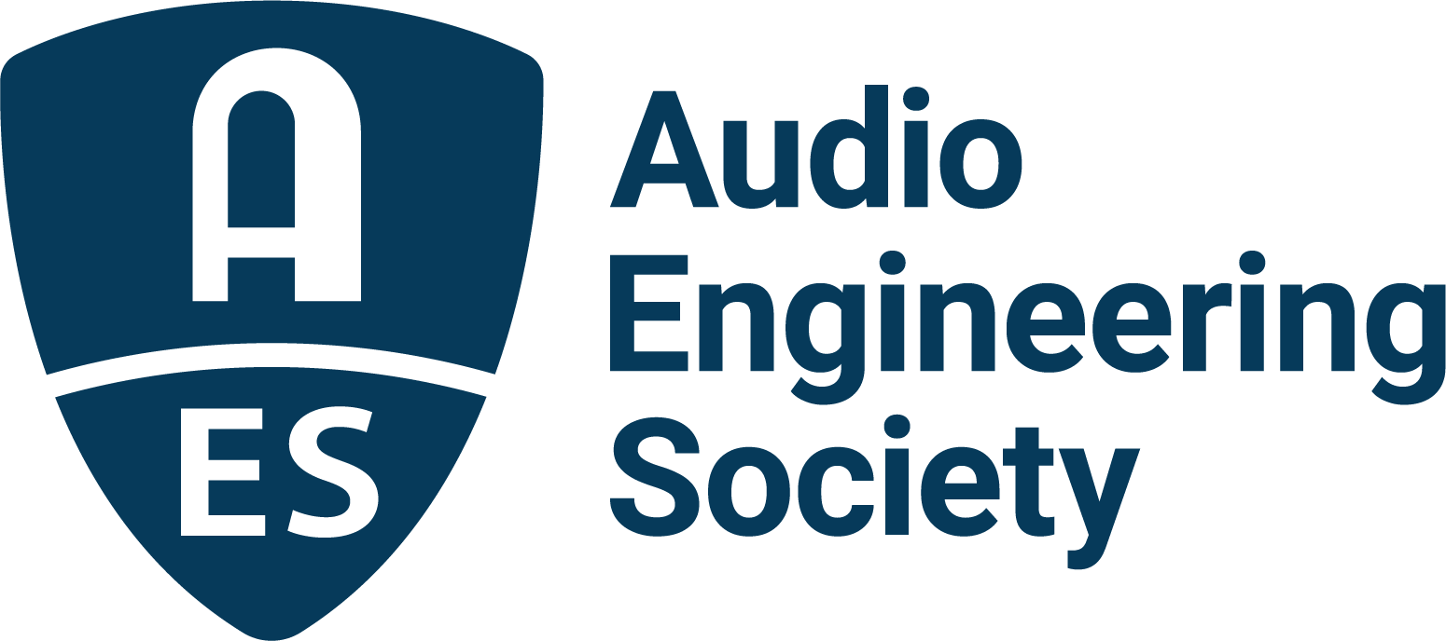

FOR IMMEDIATE RELEASE

Audio Engineering Society announces results of 2026 elections

— David v.R. Bowles will join the Board of Directors as President-Elect in 2027; new Governors and Regional Vice Presidents were also elected —

New York, NY, August 7, 2026 — The Audio Engineering Society has announced the results of its 2026 Board of Directors and Board of Governors elections. The Society’s Membership has elected David v.R. Bowles as President-Elect, as well as several new Governors and Regional Vice Presidents.
In the AES Elections for the Board of Governors (BoG), the following have been elected as regional Vice Presidents: Malik Williams, Vice President: Eastern Region, USA/Canada; Jess Berg, Vice President: Western Region, USA/Canada; and Merlijn van Veen, Vice President: Northern Region, Europe. Additionally, newly elected as at-large Governors are Helen Caddes, Ivo Marković and Angela Piva. Valerie Tyler has been re-elected as Secretary.

“As a volunteer-driven professional membership society, the AES board elections are a critical part of our operations,” says AES President Brecht De Man. “I want to congratulate the elected leaders for 2027 and look forward to working with each of them. I am also very grateful to each and every potential candidate, whether nominated to be on the ballot or not, and hope the Society is always supported by this level of volunteer energy and commitment. I also appreciate the hard work by the Tellers Committee and its longtime chair Gary Louie for taking care of the election process, as well as the Nominations Committee with its revolving leadership, and the staff support that goes into the organization of each election.”

Save for the President-Elect, each newly elected individual will serve a two-year term. David v.R. Bowles will serve on the AES Board of Directors as President-Elect in 2027, in 2028 as President, in 2029 as Past-President, followed by two years as a Governor. All those newly elected will begin their terms on January 1, 2027.

Also on January 1, 2027, current Past-President Gary Gottlieb will transition to Governor for the first year of a two-year term. Beginning one-year terms will be President Brecht De Man, who will transition to Past-President, and President-Elect Cesar Lamschtein, who will become President. Exiting the Board of Governors at that time will be Glenn Lorbiecki, Treasurer; Marcela Zorro, Director; Jamie Angus-Whiteoak, VP Northern Europe; and Governors Brett Leonard and Bruce Olson.

The 2027 Audio Engineering Society Board of Directors will be:
- Cesar Lamschtein: President
- Brecht De Man: Past-President
- David v.R. Bowles: President-Elect
- Valerie Tyler: Secretary
- Jayant Datta: Treasurer
- Agnieszka Roginska: Director
- One additional Director will be elected by the Board of Governors within the next 60 days.

The AES 2027 Board of Governors (in addition to the Directors above) will be:
- Masataka Nakahara: VP Asia-Pacific Region
- Merlijn van Veen: VP Northern Region, Europe
- Piotr Majdak: VP Central Region, Europe
- Huseyin Hacihabiboglu: VP Southern Europe/Middle East/Africa Region
- Ezequiel Morfi: VP Latin American Region
- Malik Williams: VP Eastern Region, USA/Canada
- Kelvin Grimble: VP Central Region, USA/Canada
- Jess Berg: VP Western Region, USA/Canada
- Jamie Baker: Governor
- Fariuska Lira Barully: Governor
- Leslie Gaston-Bird: Governor
- Helen Caddes: Governor
- Gary Gottlieb: Governor
- Ivo Marković: Governor
- Angela Piva: Governor
- Bernarda Ubidia: Governor

…ends 483 words

Photo File 1: David_vR_Bowles.JPG
Photo Caption 1: David v.R. Bowles, incoming Audio Engineering Society President-Elect in 2027.

About the Audio Engineering Society
For more than 75 years, the Audio Engineering Society has served as the pivotal force in fostering the advancement in audio technologies and application and the dissemination of technical information for the audio community. Its members are affiliated with 90 AES professional sections and more than 120 AES student sections around the world where activities include guest speakers, technical tours, demonstrations, online events and social functions. Through Conventions, Conferences, Training and Development events and peer-reviewed publications, as well as the Society’s vast online technical documents, Standards and video resources, members experience valuable opportunities for professional networking and personal growth. For additional information, visit AES.org.

Join the conversation and keep up with the latest AES News and Events:
X: #AESorg (AES Official)
Facebook: facebook.com/AES.org
LinkedIn: https://www.linkedin.com/company/audio-engineering-society
Instagram: https://www.instagram.com/aes_org/

AES Marketing Communications:
Email: robert@clynemedia.com
Tel: 615-662-1616
Clyne Media, Inc.,
169-B Belle Forest Circle, Nashville, TN 37221;
Web: http://www.clynemedia.com

