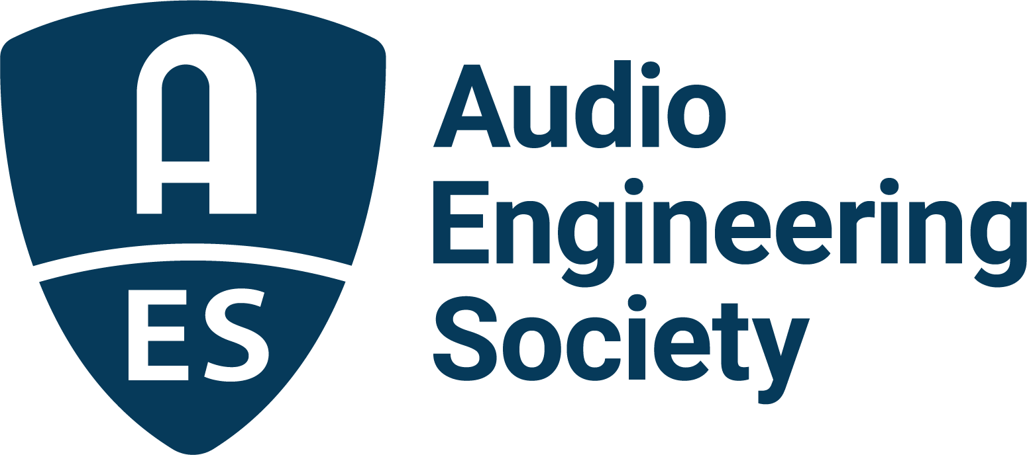

FOR IMMEDIATE RELEASE

AES Europe 2026 Early Bird Registration Ends April 15 – Keynote, Heyser Lecture and Preliminary Program Highlights Announced

— Program to feature Keynote by Geoff Martin, Heyser Lecture by Dorte Hammershøi, professional-led Workshops, and 3D Masterclass sessions —

New York, NY, April 13, 2026 — The Audio Engineering Society (AES) has announced that Early Bird registration for AES Europe 2026 will close on April 15, 2026. Through April 15, attendees have a limited-time opportunity to secure reduced rates for Europe’s largest dedicated gathering of audio professionals, researchers, and innovators. In addition, Keynote presentation and Heyser Lecture details are now online with highlights from the Convention’s Technical Program. AES Europe will take place May 28 – 30 at the Technical University of Denmark in Copenhagen.

Keynote and Heyser Memorial Lecture
AES Europe 2026 will feature a headline keynote address by Geoff Martin, Director Specialist for Audio Quality at Bang & Olufsen in Struer, Denmark, titled “The Perceptual Irrelevance of Physical Measurements.“ In his presentation, Martin will challenge the audio industry’s reliance on convenient measurements, reminding us that specifications we use exist because the measurements are easy to perform, and not because the resulting values are perceptually relevant or useful. This, he says, serves as a small reminder that the values shown in datasheets should never be trusted without interpretation, that precision should not be mistaken for accuracy, and that personal preference should not be confused with quality. For this presentation, Martin says that audio examples will be played, associated plots will be displayed, and with a little luck, at least a modicum of doubt will be instilled.

This year’s Richard Heyser Memorial Lecture will be given by Dorte Hammershøi, Professor at Aalborg University in Denmark, and is titled “From head-related transfer functions to risk of damage and hearing rehabilitation.” Hammershøi works in the field of human sound perception with special reference to electro-acoustic applications, including audiometric calibration, oto-acoustic emissions, hearing damage, hearing rehabilitation, spatial hearing, and measurement of noise sources close to the ear. This talk will give highlights from her 36 years of work in the field and will discuss what the presenter considers to be the contemporary challenges when earphones become hearing aids and vice versa.

Workshop Highlights
The AES Europe 2026 Workshop program is designed to bridge theory and application, covering a wide range of topics. Announced Workshop sessions include “Innovative Measurement of Speech Intelligibility – Applications of Listening Effort in Research & Practice” featuring Hannah Baumgartner and Jan Rennies-Hochmuth, “Audio Engineering Music for Listeners with Hearing Loss” presented by Trevor Cox, and “Studio Flunky to Audio Professional” with Gary Gottlieb and John Krivit.

Masterclass Highlights
In this series of one-hour masterclasses featuring a moderator-led listening experience, attendees are given a unique chance to hear 3D audio at its best, as we discuss the qualities that make it truly worth the effort. 3D Masterclass sessions will be led by a rotating roster including Kimio Hamasaki who will play a selection of high-resolution 3D recordings from glorious Japanese concert halls as well as share selections from his recent live and studio recording and mixing projects. Li Dakang will offer selections of unique 3D recordings, including a glorious, new version of China’s National Anthem, while Richard King will play a selection of his immersive recordings, accompanied by a discussion of the microphone configurations and mixing decisions employed in each example. Further, George Massenburg will play high resolution stereo, 5.1 and 3D recordings from his fabulous back catalogue, commenting on production tools and techniques, including his own well-regarded dynamics processor.

Tech Tour
On May 27, the day prior to the Convention’s open, DPA Microphones will host a factory tour of its production facility in Asnaes (1 hour from Copenhagen). Departure will be at 9:00 AM from Lyngby Station, with a 2:00 PM return. The bus transportation, tour and lunch are free. A maximum of 30 individuals may participate. Registration details will be available soon at https://aeseurope.com/tech-tours.

With Early Bird pricing ending April 15, prospective attendees are encouraged to register now to secure the best available rates and secure their spot for this year’s event.

For full AES Europe 2026 details, program updates, and registration information, visit https://aeseurope.com/

Photo File 1: AES_Europe_2026.JPG
Photo Caption 1: AES Europe 2026 will take place May 28 – 30 at the Technical University of Denmark in Copenhagen, Denmark.

Photo File 2: Geoff_Martin.JPG
Photo Caption 2: AES Europe 2026 will feature a headline keynote address by Geoff Martin, Director Specialist for Audio Quality at Bang & Olufsen in Struer, Denmark, titled “The Perceptual Irrelevance of Physical Measurements.“

Photo File 3: Dorte_Hammershoi.JPG
Photo Caption 3: The AES Europe 2026 Richard Heyser Memorial Lecture will be given by Dorte Hammershøi, Professor at Aalborg University in Denmark, titled “From head-related transfer functions to risk of damage and hearing rehabilitation.”

About the Audio Engineering Society
For more than 75 years, the Audio Engineering Society has served as the pivotal force in fostering the advancement in audio technologies and application and the dissemination of technical information for the audio community. Its members are affiliated with 90 AES professional sections and more than 120 AES student sections around the world where activities include guest speakers, technical tours, demonstrations, online events and social functions. Through Conventions, Conferences, Training and Development events and peer-reviewed publications, as well as the Society’s vast online technical documents, Standards and video resources, members experience valuable opportunities for professional networking and personal growth. For additional information, visit AES.org.

Join the conversation and keep up with the latest AES News and Events:
X: #AESorg (AES Official)
Facebook: facebook.com/AES.org
LinkedIn: https://www.linkedin.com/company/audio-engineering-society
Instagram: https://www.instagram.com/aes_org/

AES Marketing Communications:
Email: robert@clynemedia.com
Tel: 615-300-4666
Clyne Media, Inc.,
169-B Belle Forest Circle, Nashville, TN 37221;
Web: http://www.clynemedia.com

