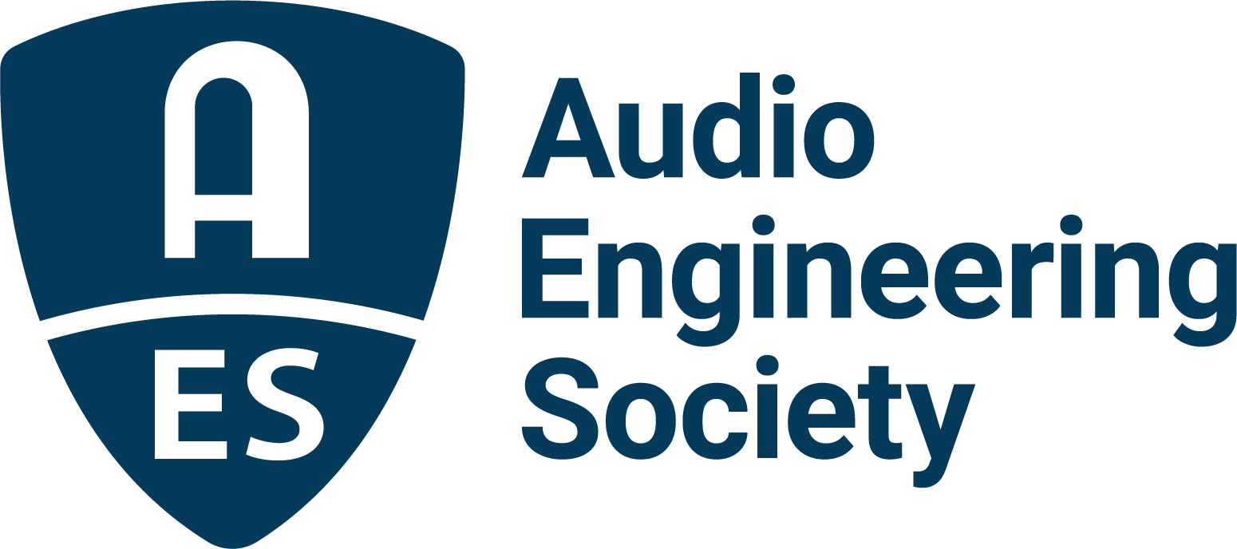

FOR IMMEDIATE RELEASE

Audio Engineering Society Educational Foundation announces awardees for the 2025/2026 academic year

— Annual grants and scholarships empower audio students worldwide to reach their full potential in top educational programs —

New York, NY, July 9, 2025 — The Audio Engineering Society Educational Foundation has
announced the recipients of AES Scholarships and Grants for Graduate and Undergraduate
Studies in Audio Engineering for the 2025/2026 academic year. These awards are funded
through generous contributions from benefactors – including EAW, Eventide, Genelec,
L-Acoustics, Sean Olive and WSDG - and from the estates of John Eargle, Emil Torick, and in
memory of Garry Margolis and Mary Lea Simpson. Other donations come from in-memoriam donors and individuals and companies that support education in audio.

Since its establishment in 1984, the Foundation has awarded grants for graduate studies to hundreds of exceptional applicants, many of whom have gone on to prominent and successful careers in the audio engineering industry.

“The AES Educational Foundation proudly recognizes the drive and ingenuity of the world’s leading audio engineering students with awards that pay tribute to our industry’s pioneers,” said Jim Anderson, President of the AES Educational Foundation. “We’re privileged to support these talented scholars as they advance their studies and research. We congratulate this year’s awardees and encourage all audio students to continue on their path as we strive together to make the industry stronger.”
The distinguished recipients of the AES Educational Foundation awards for the 2025/2026 academic year are as follows:

The Garry Margolis Scholarship, which celebrates the life and career of longtime AES member Garry Margolis, was awarded to Ryan Baker, Georgia Institute of Technology.

The L-Acoustics Dr. Christian Heil Future of Sound Scholarship, presented to students demonstrating curiosity about and dedication to shaping the future of sound, was awarded this year to Devon Green, Georgia Institute of Technology.

The Genelec Ilpo Martikainen Audio Visionary Scholarship, offered to U.S. graduate students with a passion for advancing audio through innovation and technology development, was given to Franco Galetto, Middle Tennessee State University.

The Genelec Mike Chafee Audio Pioneering Scholarship, offered to passionate and outstanding women to continue their audio education was awarded to Nancy Rico-Mineros, Stanford University (CCRMA).

The AES Educational Foundation John Eargle Award, given to a student who excels in both technology and music, was presented to Aoqi Deng, McGill University, Schulich School of Music.

The Olive Award for Excellence in Audio is granted annually to the student who demonstrates excellence in their scientific research and engineering of audio recording and reproduction is presented to Justin Kang, McGill University, Schulich School of Music.

The AES Educational Foundation Emil Torick Award, honoring former AES Foundation President and founding member Emil Torick, is presented to an outstanding student with exceptional career goals. This year’s award was given to Summer Krinsky, Stanford University (CCRMA).

The WSDG Nancy Flannery Memorial Scholarship provides opportunities to women pursuing graduate-level studies in architectural acoustics and is presented to Natasha Winge, University of Surrey, UK.

AES Educational Foundation Scholarship Grants were bestowed upon the following deserving individual students:
- Kayla Lee, Trinity College Dublin
- Calvin McCormack, Stanford University (CCRMA)
- Marcela Rada, University of Surrey
- Kyosuke Sato, Tokyo University of the Arts
- Nelly Victoria Alexandra Garcia-Sihuay, Queen Mary University of London

In addition, the Mary Lea Simpson Memorial Scholarship was given to William Heilbraun, Indiana University's Jacobs School of Music. The award provides tuition assistance for the final year of studies to an undergraduate student entering senior year at a North American college or university audio engineering/recording arts program.

Links:
AES Educational Foundation 2025 Scholarships and Grants

…ends 584 words

Photo File 1: AES_Scholarships_and_Grants.JPG
Photo Caption 1: The Audio Engineering Society Educational Foundation has announced the recipients of the AES Educational Scholarships and Grants for Graduate and Undergraduate Studies in Audio Engineering for the 2025/2026 academic year.

About the Audio Engineering Society
For more than 75 years, the Audio Engineering Society has served as the pivotal force in fostering the advancement in audio technologies and application and the dissemination of technical information for the audio community. Its members are affiliated with 90 AES professional sections and more than 120 AES student sections around the world where activities include guest speakers, technical tours, demonstrations, online events and social functions. Through Conventions, Conferences, Training and Development events and peer-reviewed publications, as well as the Society’s vast online technical documents, Standards and video resources, members experience valuable opportunities for professional networking and personal growth. For additional information, visit AES.org.

Join the conversation and keep up with the latest AES News and Events:
X: #AESorg (AES Official)
Facebook: facebook.com/AES.org
LinkedIn: https://www.linkedin.com/company/audio-engineering-society
Instagram: https://www.instagram.com/aes_org/

AES Marketing Communications:
Email: robert@clynemedia.com
Tel: 615-662-1616
Clyne Media, Inc.,
169-B Belle Forest Circle, Nashville, TN 37221;
Web: http://www.clynemedia.com

