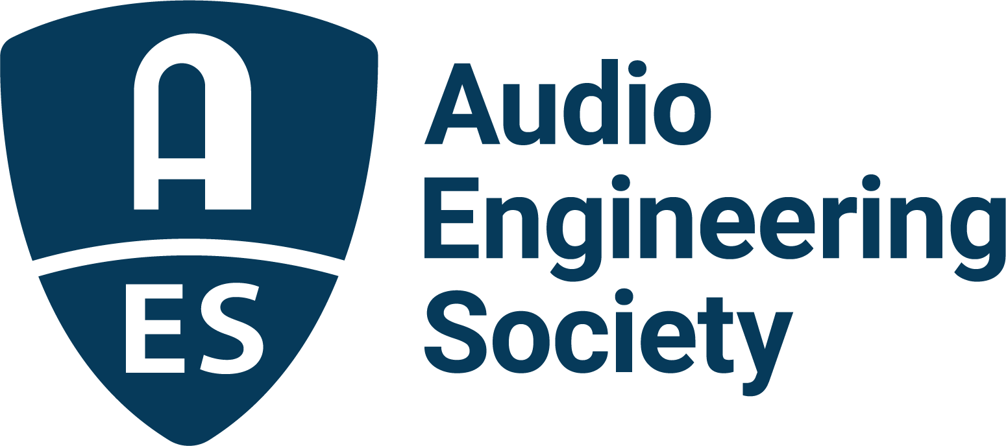

FOR IMMEDIATE RELEASE

Audio Engineering Society concludes latest international conference on headphones in Espoo, Finland

New York, NY, November 21, 2025 — The Audio Engineering Society 2025 International Conference on Headphone Technology, held across three days in August at the Aalto University Dipoli Conference Centre in Espoo, Finland, brought together nearly 200 attendees representing leading research, design, and engineering expertise in the fast-evolving field of headphone technology. The Conference’s program featured peer-reviewed papers, invited presentations, and workshops exploring the latest advances in areas including binaural rendering, spatialisation, ergonomics, personalization, psychoacoustics, room modelling, and calibration.

Conference highlights included the keynote address by AES Fellow and Past President, Dr. Sean Olive, who presented insights from over 30 years of psychoacoustics research, culminating as Harman’s leading Acoustic Research Fellow where his work led to the development of the Harman Reference Curve, a target frequency response for headphones. Additional invited conference speakers included: Naotaka Tsunoda, who spoke about headphone design; Laura Sinnott, who discussed the interface between headphones and audiology; Axel Grell, who brought attendees up to date with a tour of the history of headphones; Laura Laaksonen, Markus Vaalgamaa and Tore Stegenborg-Andersen, who addressed headphone ergonomics; and Karlheinz Brandenburg, who discussed what AI and immersive developments could bring in the future. Alongside additional sessions and on-site networking events, Conference sponsor Genelec generously invited conference attendees to an off-site social event at a new installation in Metropolia University of Applied Sciences where a tour of the extensive new recording facilities also presented the opportunity to listen to some recent spatial audio recordings.

Juha Backman, Conference Chair said, “Headphones have been at the heart of audio playback since the time of the first radios and telephones. After over a century of gradual acoustics and transducer related improvement steps, the headphone industry has taken a giant leap in integrating advanced signal processing and leading-edge communications. This has made the headphone industry a leader in both innovation and commercial growth.”

He went on to say, “The Audio Engineering Society has recognized the rapid research and innovation in headphones by dedicating to the topic a series of well-attended themed conferences in Denmark and the US. I was excited about the opportunity of hosting this event in my hometown and at my old university. The extremely professional committee, volunteers, and the facilities personnel made it possible to set up an environment that encouraged the exchange of ideas among the attendees.” Backman continues, “The papers and the friendly and open discussions in this conference give us courage to believe that the pace of headphone innovation is definitely not slowing down, and I look forward to future events.”

Genelec’s Aki Mäkivirta added, "Serving as Papers Chair has been both motivating and truly enjoyable, and I feel very fortunate to have been part of this remarkable conference on headphone technology. The program brought together an outstanding collection of scientific papers on highly relevant topics, and the presentations managed to be both informal and informative, which gave the sessions a very open and engaging character.”

Continuing, Mäkivirta espoused, “This atmosphere not only encouraged valuable exchanges of knowledge, but also created space for new friendships to form. The social events during the conference were memorable highlights, complementing the scientific sessions with moments of genuine connection. This conference gives an excellent contribution in the chain of headphone-themed conferences, and I am grateful to have shared in such an inspiring and well-executed event."

Conference sponsors were especially happy to have exhibited, specifically noting the quality of discussions from the very focussed group of attendees. Savox’s Ilkka Huhtakallio shared, “We were proud to support the AES Conference on Headphone Technology. It was a great opportunity to introduce Savox Communications to the Audio Engineering Society and engage in meaningful conversations with fellow sponsors and visitors. While headphone technology is often driven by consumer markets, we were excited to showcase how the same core technologies power our mission-critical communication solutions. Hosting the event right next to our headquarters in Espoo made it especially meaningful, allowing us to highlight our local roots to the global AES community.” Genelec, Head Acoustics, and Savox were Conference Gold sponsors. Silver sponsors were Brandenburg Labs, Hottinger Brüel & Kjær, Listen, and Yamaha. Bronze sponsors were Audio Precision, Composite Sound, and Sound Particles. Displays were also provided by Comsol and Klippel.

Photo File 1: AES_Headphone_Tech_group.JPG
Photo Caption 1: Attendees gather outside the conference hall at the 2025 AES International Conference on Headphone Technology in Espoo, Finland.

About the Audio Engineering Society
For more than 75 years, the Audio Engineering Society has served as the pivotal force in fostering the advancement in audio technologies and application and the dissemination of technical information for the audio community. Its members are affiliated with 90 AES professional sections and more than 120 AES student sections around the world where activities include guest speakers, technical tours, demonstrations, online events and social functions. Through Conventions, Conferences, Training and Development events and peer-reviewed publications, as well as the Society’s vast online technical documents, Standards and video resources, members experience valuable opportunities for professional networking and personal growth. For additional information, visit AES.org.

Join the conversation and keep up with the latest AES News and Events:
X: #AESorg (AES Official)
Facebook: facebook.com/AES.org
LinkedIn: https://www.linkedin.com/company/audio-engineering-society
Instagram: https://www.instagram.com/aes_org/

AES Marketing Communications:
Email: robert@clynemedia.com
Tel: 615-300-4666
Clyne Media, Inc.,
169-B Belle Forest Circle, Nashville, TN 37221;
Web: http://www.clynemedia.com

