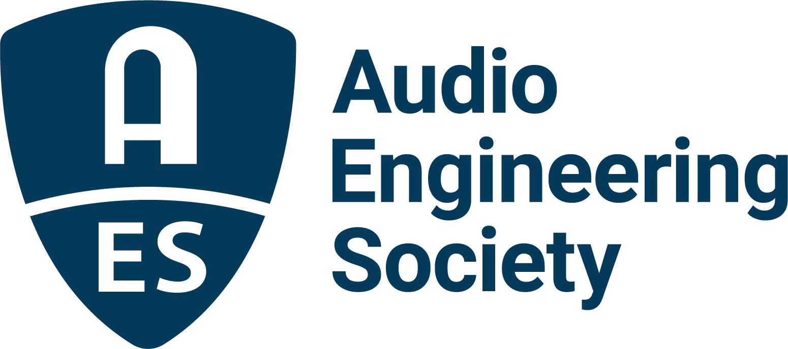

FOR IMMEDIATE RELEASE

Charting the future of personal audio: 2025 AES International Conference on Headphone Technology program now online

— Wearable audio technologies and applications take focus for leading engineers and researchers during three days of intensive presentations on assistive hearing, bio-sensing, AI integration, and next‑gen headphone design —

New York, NY, August 11, 2025 — The Audio Engineering Society has announced full Technical Program details for the upcoming 2025 AES International Conference on Headphone Technology, taking place August 27 – 29 at the iconic and experimental Dipoli student union building in the heart of Aalto University’s campus in Espoo, Finland. The complete interactive session schedule is now live online, with three packed days of keynotes, Tutorials, Paper sessions, Workshops, Posters and demos covering an extensive array of personal monitoring technologies, in addition to special events, Technical Tours of local production facilities, and social events. Registration is also available via the event website, with significant discounts for AES Members and students.

With an estimate exceeding 300 million pairs of headphones to be sold this year, the rise of smart and wearable devices is accelerating innovation, with tiny low-power processors and sensors enabling headphone features once reserved for hearing aids and critical listening applications. As these worlds continue to converge, the AES brings together leading researchers and practitioners in head-worn audio technology to chart the future of headphones. Two such significant figures in the field include Dr. Sean Olive (Harman International), renowned for his work in sound perception, who will deliver the opening keynote, sharing insights on objective headphone measurement and the listener experience of headphone sound quality; and MP3 and immersive audio pioneer Karlheinz Brandenburg (Brandenburg Labs), who will explore the future of headphone technology, from AI support to deeper immersion.

The Technical Program also features Papers and Workshops delving into dozens of specialized topics including headphone target curve selection; automated measurement systems like HeRMeS; ambient sound control innovations for noise cancellation and transparency; and explorations in spatial audio, HRTF personalization, and balance between isolation and situational awareness. Additionally, the Conference’s Workshops will include sessions on fundamentals of headphone acoustics, ergonomics, auditory modeling and audiology-informed design, while a variety of Tutorials cover topics involving integration of hearing health technologies directly into headphone engineering design, binaural audio, AI support for immersive listening, and monitoring standards for personal listening devices. The Conference will also feature a Poster expo and demonstration exhibits each day, an informal AKU barbeque pre-conference event at the Aalto University Acoustic Lab, and a Technical Tour and social event hosted by Genelec at the Metropolia University of Applied Sciences.

“Whether you’re a researcher, engineer, designer, audiologist or industry pro, this conference is a vital touchpoint for the rapidly evolving world of headphone and personal audio technology,” states Juha Backman, Conference chair. “With compelling content, global experts, and a collaborative international forum within a top-tier academic setting, this is the premier conference on head-worn hearing technology and wearable audio devices.”

Find out more and register now for the 2025 AES International Conference on Headphone Technology at https://aes2.org/event-extra/2025-aes-international-conference-on-headphone-technology/

Photo File 1: AES_2025_Headphone_Technology_Conference.JPG
Photo Caption 1: The Audio Engineering Society has announced full Technical Program details for the upcoming 2025 AES International Conference on Headphone Technology, taking place August 27 – 29 in the heart of Aalto University’s campus in Espoo, Finland.

About the Audio Engineering Society
For more than 75 years, the Audio Engineering Society has served as the pivotal force in fostering the advancement in audio technologies and application and the dissemination of technical information for the audio community. Its members are affiliated with 90 AES professional sections and more than 120 AES student sections around the world where activities include guest speakers, technical tours, demonstrations, online events and social functions. Through Conventions, Conferences, Training and Development events and peer-reviewed publications, as well as the Society’s vast online technical documents, Standards and video resources, members experience valuable opportunities for professional networking and personal growth. For additional information, visit AES.org.

Join the conversation and keep up with the latest AES News and Events:
X: #AESorg (AES Official)
Facebook: facebook.com/AES.org
LinkedIn: https://www.linkedin.com/company/audio-engineering-society
Instagram: https://www.instagram.com/aes_org/

AES Marketing Communications:
Email: robert@clynemedia.com
Tel: 615-662-1616
Clyne Media, Inc.,
169-B Belle Forest Circle, Nashville, TN 37221;
Web: http://www.clynemedia.com

