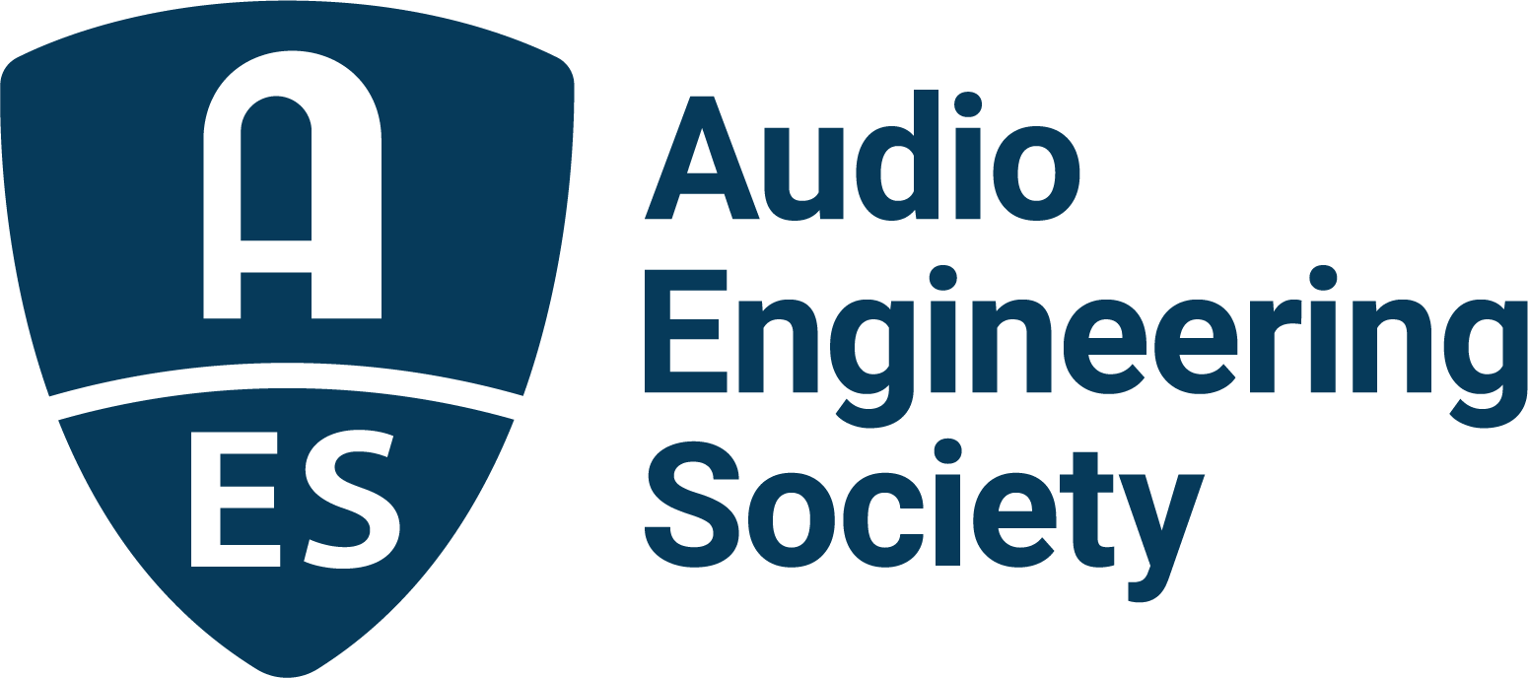

FOR IMMEDIATE RELEASE

Audio Engineering Society announces Immersive Audio Academy 12th Edition – “Immersive Audio in All Flavors”

— Online event brings leading experts together to explore diverse approaches to immersive audio production and technology —

New York, NY, April 23, 2026 — The Audio Engineering Society (AES) will present the Immersive Audio Academy 12th Edition – “Immersive Audio in All Flavors” on April 30, 2026, at 12:00 p.m. EDT, as part of its ongoing series examining current developments in immersive and spatial audio.

This online event will bring together a panel of internationally recognized experts to explore a range of approaches to immersive audio production, distribution and implementation across multiple application areas, including music, broadcast and emerging media. The session is intended to provide insights into the technologies, workflows, and creative practices shaping the field.

The panel will be hosted by mastering and immersive mixing specialist Andrés Mayo and will feature contributions from Wilfried Van Baelen (Auro Technologies, Galaxy Studios), Gary Spittle (Sonical), Jani Huoponen (Eclipsa) and Martin Rieger (VRTonung). “These elite individuals,” says AES Past President Mayo, “each bring pioneering expertise in emerging and evolving immersive audio technologies and their applications in production and delivery. This 12th Edition of The Immersive Audio Academy will expose you to captivating and thought-provoking concepts that will inspire your own creativity.”

Topics will include current hardware and software solutions supporting immersive audio workflows, the accessibility of immersive production tools, and the evolving role of spatial audio in contemporary content creation. The session will also consider future directions for immersive audio and the challenges associated with broader adoption across the industry.

The Immersive Audio Academy series is designed to support the AES mission of advancing the science and practice of audio by providing a forum for technical exchange and professional development.

For additional information and registration details, visit https://aes.org/events-calendar/immersive-audio-academy-12th-edition-immersive-audio-in-all-flavors/.

Photo File 1: AES_12thImmersiveAudioAcademy.JPG
Photo Caption 1: The AES Immersive Audio Academy 12th Edition – “Immersive Audio in All Flavors” on April 30, 2026, at 12:00 p.m. EDT – will provide insights into the technologies, workflows, and creative practices shaping and extending the adoption of immersive audio.

About the Audio Engineering Society
For more than 75 years, the Audio Engineering Society has served as the pivotal force in fostering the advancement in audio technologies and application and the dissemination of technical information for the audio community. Its members are affiliated with 90 AES professional sections and more than 120 AES student sections around the world where activities include guest speakers, technical tours, demonstrations, online events and social functions. Through Conventions, Conferences, Training and Development events and peer-reviewed publications, as well as the Society’s vast online technical documents, Standards and video resources, members experience valuable opportunities for professional networking and personal growth. For additional information, visit AES.org.

Join the conversation and keep up with the latest AES News and Events:
X: #AESorg (AES Official)
Facebook: facebook.com/AES.org
LinkedIn: https://www.linkedin.com/company/audio-engineering-society
Instagram: https://www.instagram.com/aes_org/

AES Marketing Communications:
Email: robert@clynemedia.com
Tel: 615-300-4666
Clyne Media, Inc.,
169-B Belle Forest Circle, Nashville, TN 37221;
Web: http://www.clynemedia.com

