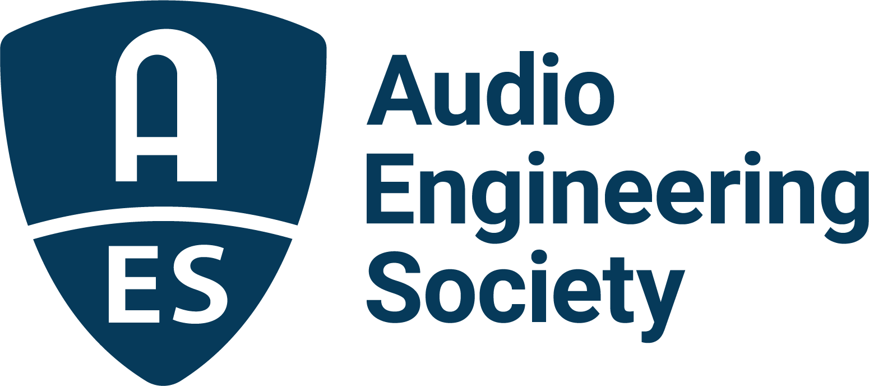

FOR IMMEDIATE RELEASE

AES Show 2025 – Long Beach propels the future of audio with a successful return to the West Coast

— The AES’s 159th International Convention delivers innovation, inspiration, and connection for the global audio community —

New York, NY, November 14, 2025 — The Audio Engineering Society is celebrating the success of the recent AES Show 2025 - Long Beach Convention, marking the Society’s first major West Coast convention in 9 years. The event, which took place at the Long Beach Convention & Entertainment Center, October 22 – 25, offered a diverse Technical Program and Exhibition in addition to unparalleled opportunities to network and interact with many of the top names in the industry. This 159th AES International Convention was headed-up by Convention Co-Chairs, Peter Doell, Michael Hagen, and Valerie Tyler, aided by a team of audio professionals who curated content, managed Paper submissions and reviews, organized schedules, supervised volunteers and scheduled the comprehensive slate of Technical Program, Special Events, Skill Building sessions, Tech Tours and student events.

“I am absolutely thrilled with the outcome of our AES Long Beach Convention and would like to express my sincere thanks to the event’s organizers, sponsors, exhibitors, and attendees, for making it a tremendous experience for all,” states AES President Gary Gottlieb. “As usual, our Technical Program presented an outstanding slate of experts from all facets of audio, and their excitement to share their research and insights was truly inspiring. That energy was equally matched on the Exhibition Floor, where gear and technology showcases offered hands-on experiences with a wide array of audio tools and services, while also providing important engagement with like-minded supporting organizations. Best of all was the chance to meet with you – the amazing body of participants that make the AES what it has grown into over the past 75-plus years. While we have so many great channels of information to learn from these days, it is a real throwback to the way AES was when we started in 1948 - the camaraderie and congeniality that has been there through all those decades was stronger than ever in Long Beach, where we all had the opportunity to be part of our vibrant community as we learn and grow, together.”

In addition to the Show’s inspiring Opening Ceremonies and Awards, highlights from the AES Show 2025 – Long Beach Special Events track offered a wide range of must-see sessions, including: a Keynote speech from multi-platinum producer, songwriter, mixer, and audio educator Warren Huart of the hit YouTube channel Produce Like A Pro; a special Keynote conversation with Multi-GRAMMY® Award–winning, platinum-selling producer Andrew Watt and Red Hot Chili Peppers drummer, Chad Smith; and the Convention’s Heyser Lecture given by AES Past President Dr. Sean Olive. Other popular sessions included “Inside the Productions of Brian Wilson” with GRAMMY®-winning engineer Mark Linett and producer Warren Huart, a look at the creative process with Sounwave in “Shaping Sound and Artist Identity” moderated by Manny Marroquin, and “Inside the Sound: Producer, Songwriter, Multi-Instrumentalist Jim-E Stack in Conversation with Recording and Mix Engineer Ian Gold.”

Hosting over 140 sessions in total, including Workshops, Panels, Paper and Poster Presentations, and Immersive Room experiences, AES Long Beach also offered a chance to hear from and network with key AES personnel. Key persons of note included: AES President, Gary Gottlieb; newly elected AES Director, AES Fellow and Past President Agnieszka Roginska; and the return of Colleen Harper as Executive Director and Graham Kirk with the new title of Director of Business Operations.

The AES continues to forge ahead with recently announced events, including this month’s online Immersive Audio Academy 11th Edition: Automotive Audio and the 2026 AES Europe Convention taking place in Copenhagen, Denmark, May 28 - 30, 2026.

Visit AES.org for the latest announcements and events.

Photo File 1: Warren_Huart.JPG
Photo Caption 1: Multi-platinum producer, songwriter and mixer Warren Huart of the hit YouTube Channel Produce Like A Pro delivers the day one Kseynote address, “From Cassette Decks to Platinum Discs,” at the AES Show 2025 – Long Beach Convention on October 23, 2025.

Photo File 2: AndrewWatt_ChadSmith.JPG
Photo Caption 2: Multi-GRAMMY® Award–winning, platinum-selling producer Andrew Watt, and Rock and Roll Hall of Famer Chad Smith - legendary drummer of the Red Hot Chili Peppers – engaged in an unforgettable Keynote event at AES Show 2025 - Long Beach on October 24, 2025.

Photo File 3: Sounwave_MannyMarroquin.JPG
Photo Caption 3: GRAMMY® award–winning producer Sounwave shares creative insights with GRAMMY-winning mixer Manny Marroquin at AES Show 2025 - Long Beach.

Photo File 4: AES_Show_2025_Long_Beach_Committee.JPG
Photo Caption 4: AES Show 2025 - Long Beach was headed-up by Convention Co-Chairs, Peter Doell, Michael Hagen, and Valerie Tyler who produced the event with a large cast of volunteers.

About the Audio Engineering Society
For more than 75 years, the Audio Engineering Society has served as the pivotal force in fostering the advancement in audio technologies and application and the dissemination of technical information for the audio community. Its members are affiliated with 90 AES professional sections and more than 120 AES student sections around the world where activities include guest speakers, technical tours, demonstrations, online events and social functions. Through Conventions, Conferences, Training and Development events and peer-reviewed publications, as well as the Society’s vast online technical documents, Standards and video resources, members experience valuable opportunities for professional networking and personal growth. For additional information, visit AES.org.

Join the conversation and keep up with the latest AES News and Events:
X: #AESorg (AES Official)
Facebook: facebook.com/AES.org
LinkedIn: https://www.linkedin.com/company/audio-engineering-society
Instagram: https://www.instagram.com/aes_org/

AES Marketing Communications:
Email: robert@clynemedia.com
Tel: 615-300-4666
Clyne Media, Inc.,
169-B Belle Forest Circle, Nashville, TN 37221;
Web: http://www.clynemedia.com

