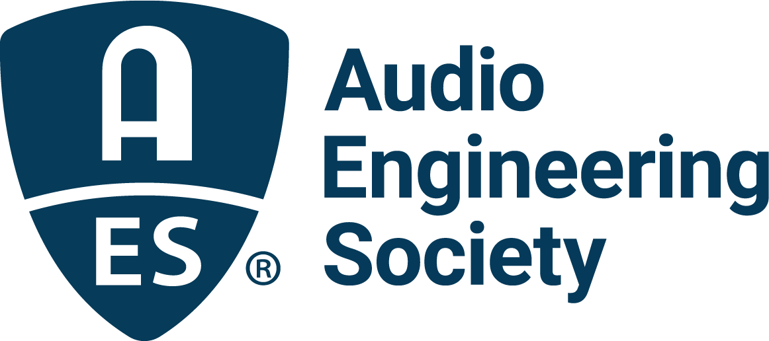

FOR IMMEDIATE RELEASE

Registration now open for the Audio Engineering Society’s return to the west coast in October for AES Show 2025 – Long Beach with featured keynote by audio production mentor Warren Huart from Produce Like A Pro

— Early Bird pricing is now available on registration for the 159th AES International Convention, basking in west coast sound while gathering audio innovators from around the world for its first convention to be held in Long Beach, CA —

New York, NY, June 30, 2025 — The Audio Engineering Society has announced its return to west coast events with the upcoming AES Show 2025 – Long Beach, taking place October 23 – 25 at the Long Beach Convention and Entertainment Center. Featuring the latest in audio innovations, research, gear, technologies, and their creative application, the AES Show will offer the renowned AES International Convention elements most in-demand by the Society’s membership and audio professionals around the world, including the unparalleled technical program slate of Workshops, Tutorials and Paper presentations plus, in advance of the Convention, optional Tech Tours of local facilities and Skill Building Workshops. Just announced, multi-platinum producer, songwriter, mixer, and audio educator Warren Huart of the hit YouTube channel Produce Like A Pro (with an audience of over 800,000 subscribers) will give the show’s opening keynote address. Registration is now open, with Early Bird pricing options available through August 27.

Serving as the flagship event of the Audio Engineering Society, this annual international gathering unites thousands of audio professionals, enthusiasts, and students from around the globe for an exclusively audio focused experience spanning the gamut of foundational and emerging audio topics. In addition to the technical program, leading manufacturers will exhibit their latest hardware and software solutions. The first announced highlight of this year’s convention is the opening keynote address by Warren Huart, whose popular Produce Like A Pro website and YouTube channel provide in-depth looks at popular recording and production techniques, as well as exclusive interviews and insights with some of the biggest names in audio engineering. In his address, titled “From Cassette Decks to Platinum Discs,” Huart will share his inspiring journey from homemade recordings in rural England to working with artists like Aerosmith, The Fray and James Blunt – a story of perseverance, creativity and finding your voice in the modern music industry. Huart will additionally host a pair of sessions during the convention that will include renowned audio pros in illuminating discussions including an in-depth session honoring the late Beach Boys’ founder Brian Wilson with Brian’s audio engineer since 1988, multi-GRAMMY® Award winner Mark Linett, who is best known for his remixing and remastering of the Beach Boys’ catalog.

“The AES Show has always been a cornerstone of our audio community,” states Huart. “For me, it’s more than just the sessions, as engrossing as the technical program is; it’s a place where I’ve built lasting friendships, shared ideas and stayed inspired. In a fast-moving industry, nothing compares to connecting face to face with others who share the same passion for sound, the same technical curiosity, and the same drive to keep learning and growing. I’m excited to speak and host panels this year, and to connect with fellow audio enthusiasts from around the world.”

Visit AESShow.com for the latest information on discounted registration options for AES Members and students, as well as additional Skill Building Workshops and Technical Tours taking place pre-convention on Wednesday, October 22.

About Warren Huart
Warren Huart is a Los Angeles-based British music producer, GRAMMY®-nominated mixer, and TEC Award-winning educator who has played a fundamental role in the creation of platinum-selling and Billboard-topping albums. He is the founder of Produce Like A Pro, and through his educational platforms—including Pro Mix Academy, Lancaster Audio, and Rate My Mix—he empowers musicians, producers, and audio professionals to build lasting careers in music.

Warren’s credits span hundreds of albums with artists who’ve gone on to sell millions and earn billions of streams. He has worked professionally in the music industry since the age of 16, toured internationally, played major festivals like Reading and River Rave, and produced music for everyone from emerging talent to chart-topping acts. After relocating to Los Angeles, he became a staff producer on The X Factor USA, crafting weekly performances for national television and helping develop artists from the ground up.

With over 20 years of experience in record production, engineering, mixing and songwriting, Warren is known for his strong work ethic, positive attitude and deep respect for the artist’s vision. He has co-owned one of Hollywood’s first multi-purpose rehearsal and recording studios, consulted for leading audio brands and built custom studio spaces from scratch. Many of his long-term collaborators have become close friends, and his work continues to shape how artists and engineers collaborate and thrive in the studio today.

Across YouTube, Instagram, Facebook, X and Threads, Warren now reaches an audience of over 1.2 million creators, helping them turn passion into visibility and skill into success. Whether working with major labels or mentoring the next generation of producers, his mission remains the same: to make music that matters and to support those who create it.

…ends 769 words

Photo File 1: AES_Show_Long_Beach_2025.JPG
Photo Caption 1: The AES Show Long Beach Convention will take place at the Long Beach Convention and Entertainment Center, October 23 – 25, with additional Skill Building Workshops and Tech Tours taking place on Wednesday, October 22.

Photo File 2: Warren_Huart.JPG
Photo Caption 2: Multi-platinum producer, songwriter and mixer Warren Huart of the hit YouTube Channel Produce Like A Pro will give the featured keynote address, “From Cassette Decks to Platinum Discs,” at the AES Show 2025 – Long Beach Convention.

About the Audio Engineering Society
For more than 75 years, the Audio Engineering Society has served as the pivotal force in fostering the advancement in audio technologies and application and the dissemination of technical information for the audio community. Its members are affiliated with 90 AES professional sections and more than 120 AES student sections around the world where activities include guest speakers, technical tours, demonstrations, online events and social functions. Through Conventions, Conferences, Training and Development events and peer-reviewed publications, as well as the Society’s vast online technical documents, Standards and video resources, members experience valuable opportunities for professional networking and personal growth. For additional information, visit AES.org.

Join the conversation and keep up with the latest AES News and Events:
X: #AESorg (AES Official)
Facebook: facebook.com/AES.org
LinkedIn: https://www.linkedin.com/company/audio-engineering-society
Instagram: https://www.instagram.com/aes_org/

AES Marketing Communications:
Email: robert@clynemedia.com
Tel: 615-662-1616
Clyne Media, Inc.,
169-B Belle Forest Circle, Nashville, TN 37221;
Web: http://www.clynemedia.com

