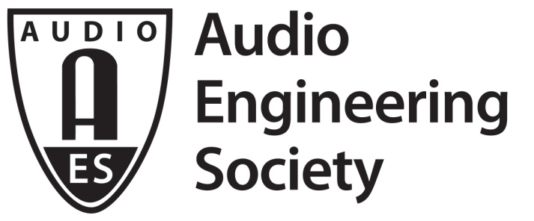

PRESS RELEASE
Contact: Robert Clyne
robert.clyne@aes.org
Tel: (615) 662-1616 x17

FOR IMMEDIATE RELEASE

Havana, Cuba, to Host AES Latin American Conference 2017 in June

New York, NY, May 25, 2017 — The 2017 Audio Engineering Society Latin American Conference is now less than a month away. The Fabrica de Arte Cubano in Havana, Cuba, is the venue for the “Conferencia Latinoamericana,” taking place June 17 and 18. “This is the first-ever international event that the Audio Engineering Society has held in Cuba,” shares Conference Co-Chair Andrés Mayo. “The rich musical pulse of the island will provide an excellent sonic backdrop for this milestone event.”

The presenter list for the Conference includes the likes of Oscar Barrientos, Hugo Caviedes, Ian Corbett, Ricardo Escallón, Tweety González, Javier Longhi, Juan “Cana” San Martín and Marcela Zorro, in addition to Co-Chairs Mayo and Valeria Palomino. Sessions will cover the tools and techniques employed in modern music production, from recording and mastering to live events. Attendees will also gain insights into developing and future audio technologies.

“The AES Latin American conference series – begun in 2007 – is an important event on each year’s calendar,” says Ms. Palomino. “It’s the gathering point for the leading audio researchers, practitioners and students to meet, share and learn.”

The 2017 AES Latin America Conference registration is under the umbrella of the multifaceted host event, AM-PM “América por su Música”. For more details and registration, visit www.americaporsumusica.com.

...ends 205 words

Photo File: AESCuba2017-LOGO.jpg
Photo Caption: The 2017 Audio Engineering Society Latin American Conference is slated for June 17 and 18 in Havana, Cuba.

Photo File: AESCUBA.jpg
Photo Caption: The 2017 Audio Engineering Society Latin American Conference is slated for June 17 and 18 in Havana, Cuba.

About the Audio Engineering Society
The Audio Engineering Society was formed in 1948 and now counts over 12,000 members throughout the U.S., Latin America, Europe, Japan and the Far East. The organization serves as the pivotal force in the exchange and dissemination of technical information for the industry. Currently, its members are affiliated with more than 75 AES professional sections and more than 95 AES student sections around the world. Section activities may include guest speakers, technical tours, demonstrations and social functions. Through local AES section events, members experience valuable opportunities for professional networking and personal growth. For additional information visit http://www.aes.org.

Join the conversation and keep up with the latest AES News and Events:
Facebook: http://facebook.com/AES.org
Twitter: #AESorg (AES Official)

AES Marketing Communications:
Email: robert.clyne@aes.org
Tel: 615-662-1616, Fax: 615-662-1636,
Clyne Media, Inc.,
169-B Belle Forest Circle, Nashville, TN 37221;
Web: http://www.clynemedia.com

