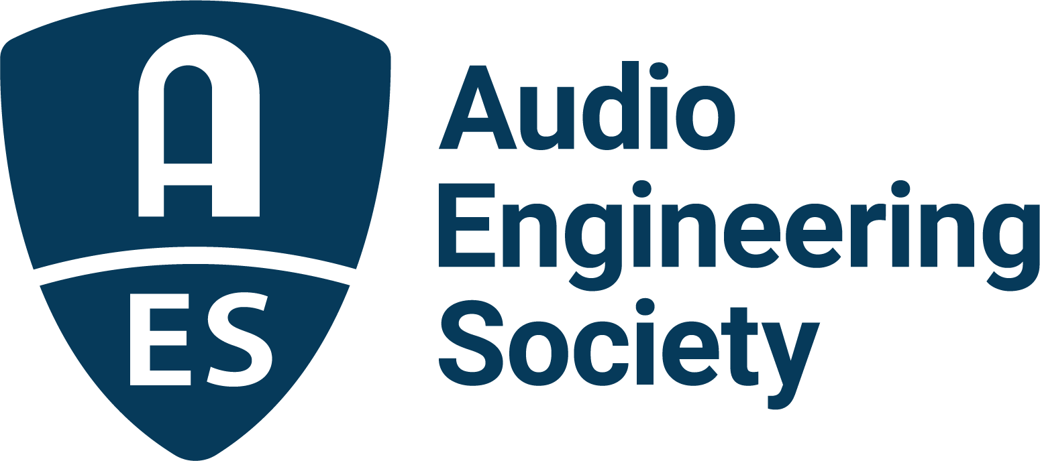

FOR IMMEDIATE RELEASE

Audio Engineering Society announces updates for AES Show Nashville 2026 and AES@NAB New York stage

— AES’s ongoing commitment to advancing audio engineering and education spans two cities in October: a focused technical program and exhibition in Nashville paired with a two-day exhibition and broadcast-centered sessions at NAB New York —

New York, NY, January 20, 2026 — The Audio Engineering Society (AES) today announced key details for the upcoming AES Show Nashville 2026, alongside confirmation of AES@NAB New York, expanding the Society’s presence to two major U.S. audio production hubs this October.

“AES is dedicated to finding more ways for members and attendees to benefit in key markets,” said Graham Kirk, AES Associate Executive Director. “This October, we are delivering a highly requested AES Show in Nashville while partnering with NAB to provide a forum for broadcast audio professionals in New York.”

AES Show Nashville: A focused audio experience in Music City
AES Show Nashville 2026 will deliver a tightly curated three-day technical program, Friday, October 30 – Sunday, November 1, paired with a two-day exhibition taking place Saturday and Sunday, designed to bring together audio professionals, technologists, creators, and educators for in-depth learning, discovery, and connection.

The exhibit floor will serve as a central hub for activity throughout the weekend and will feature the AES Main Stage, home to the opening ceremony, the show’s main keynote, and a dynamic schedule of interviews, insights, and appearances from industry leaders and “famous friends” across music, media, and technology.

Also located on the exhibit floor, the Technology Showcase will provide exhibitors with a dedicated platform to demonstrate real-world solutions, workflows, and practical user advice, offering attendees direct insight into emerging tools and techniques shaping modern audio production.

Access to the exhibit floor, Main Stage programming, and Technology Showcase will be available with the Exhibits+ badge when registration opens in April. AES Members will receive early VIP access to registration, along with first access to the Society’s exclusive hotel room rate at the Gaylord Opryland Resort. Availability at this preferred rate is limited, providing a significant benefit for members who register early.

For those seeking the most comprehensive experience, All Access registration will unlock two full floors of highly focused sessions, including keynotes, technical papers, poster presentations, and networking events. All Access badge holders will also receive first opportunity to participate in a new studio workshop event, with additional details to be announced soon.

Announcing AES@NAB New York
In addition to AES Show Nashville, the Society also confirmed its participation in the 2026 NAB Show New York, taking place the week prior, on October 21–22.

“We’ve enjoyed a strong relationship with AES for more than a decade and are pleased to welcome AES, its members and the professional audio community back to NAB Show New York. Professional audio remains a vital part of the NAB Show ecosystem, and we’re excited to continue that collaboration in 2026,” said Karen Chupka, executive vice president of NAB Show.

AES@NAB NY will feature a free-to-access exhibit floor stage open to NAB Show New York attendees, with a dedicated day of focused Broadcast Audio and Streaming sessions on Thursday, October 22. The program will highlight current challenges, workflows, and innovations impacting audio professionals working across broadcast, live production, and content delivery platforms.

For organizations seeking a New York presence within a broadcast audio-focused environment, AES will also offer exhibition space adjacent to the AES@NAB New York stage, providing exhibitors with direct engagement opportunities alongside curated educational programming.

For more information and to book your exhibit space now, contact Graham Kirk at graham.kirk@aes.org

You can find updated information on aesshow.com.

Photo File 1: AESShow_Nashville_2026.JPG
Photo Caption 1: The Audio Engineering Society will host the 2026 AES Show in Nashville, TN, at the Gaylord Opryland Resort & Convention Center, taking place October 30 – November 1, 2026, following AES@NAB New York.

About the Audio Engineering Society
For more than 75 years, the Audio Engineering Society has served as the pivotal force in fostering the advancement in audio technologies and application and the dissemination of technical information for the audio community. Its members are affiliated with 90 AES professional sections and more than 120 AES student sections around the world where activities include guest speakers, technical tours, demonstrations, online events and social functions. Through Conventions, Conferences, Training and Development events and peer-reviewed publications, as well as the Society’s vast online technical documents, Standards and video resources, members experience valuable opportunities for professional networking and personal growth. For additional information, visit AES.org.

Join the conversation and keep up with the latest AES News and Events:
X: #AESorg (AES Official)
Facebook: facebook.com/AES.org
LinkedIn: https://www.linkedin.com/company/audio-engineering-society
Instagram: https://www.instagram.com/aes_org/

About NAB Show New York
NAB Show New York is held at the epicenter of live media, entertainment and brand storytelling for content creators and media production experts. Produced by the National Association of Broadcasters taking place on Oct. 21–22, 2026, at the Javits Center, NAB Show New York is the premier East Coast event for anyone creating content for social media, live streaming, broadcast, film or user-generated content. NAB Show New York is the ultimate destination for storytellers delivering the tools, technologies, resources and connections to amplify your message and elevate your craft. Learn more at NABShowNY.com.

AES Marketing Communications:
Email: robert@clynemedia.com
Tel: 615-300-4666
Clyne Media, Inc.,
169-B Belle Forest Circle, Nashville, TN 37221;
Web: http://www.clynemedia.com

NAB Show Media Relations:
Matt Raymond (mraymond@nab.org)
Tel: 202-429-4194
www.NABShow.com

