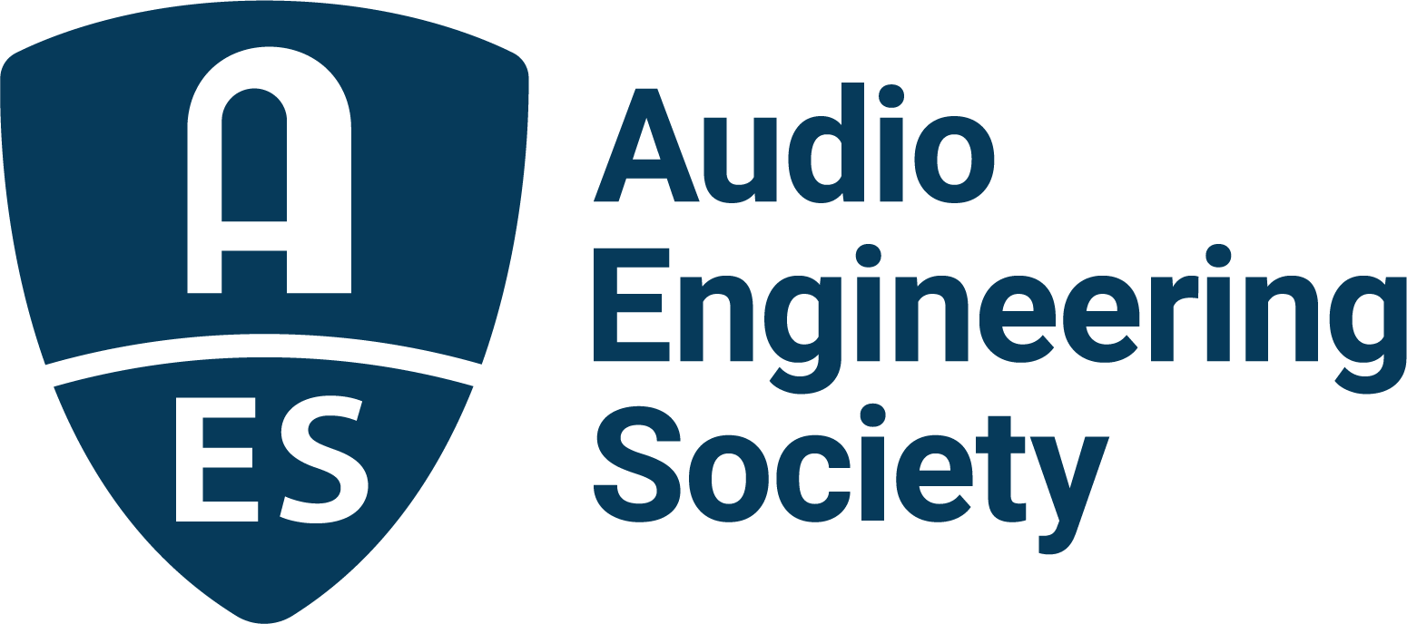

FOR IMMEDIATE RELEASE

Audio Engineering Society announces reenergized AES Show Nashville for 2026

— Global audio gathering expands into Music City with new programming, community engagement, and educational experiences —

New York, NY, December 18, 2025 — The Audio Engineering Society will host the 2026 AES Show October 30 – November 1, 2026, at the Gaylord Opryland Resort & Convention Center in Nashville, TN. Expanding on the AES’s decades of top-tier audio events around the world, AES Show Nashville will offer both attendees and exhibitors new and exciting programming which will extend beyond the normal scope of previous AES Conventions. From pre-show events and experiences, to extensive studio tours and involvement with the local audio community, the new location will open up Nashville’s rich audio legacy to the international community of AES Show attendees while also promoting the cutting-edge science and initiatives which continue to keep the AES at the forefront of audio innovation.

Nashville has earned its nickname “Music City” by way of a uniquely concentrated ecosystem of world-class studios, live music venues, leading audio education institutions, pro audio manufacturers, engineers, artists, and audio professionals where music creation and production are woven into daily life. In addition to its many world-class recording studios, production and rehearsal facilities, and local network of top engineers and producers, Nashville is also home to a host of major record labels, music award shows and specials, film and TV scoring studios, live sound venues, broadcast facilities and top-tier professionals pushing the art and science of audio to its limits.

AES Show Nashville will also take advantage of the unique offerings of the stunning Gaylord Opryland Resort and Convention Center, located just steps from the world-famous Opry House facilities, home to the Grand Ole Opry live radio broadcast, the longest-running live radio broadcast in U.S. history, starting in 1925 on WSM Radio. The AES will offer exhibitors and attendees specially-priced hotel and registration packages, affording a convenient and immersive way to experience this updated AES Show with other industry peers and pros.

For the latest information and updates, visit AESShow.com

Photo File 1: AESShow_Nashville_2026.JPG
Photo Caption 1: The Audio Engineering Society will host the 2026 AES Show in Nashville, TN, at the Gaylord Opryland Resort & Convention Center, taking place October 30 – November 1.

About the Audio Engineering Society
For more than 75 years, the Audio Engineering Society has served as the pivotal force in fostering the advancement in audio technologies and application and the dissemination of technical information for the audio community. Its members are affiliated with 90 AES professional sections and more than 120 AES student sections around the world where activities include guest speakers, technical tours, demonstrations, online events and social functions. Through Conventions, Conferences, Training and Development events and peer-reviewed publications, as well as the Society’s vast online technical documents, Standards and video resources, members experience valuable opportunities for professional networking and personal growth. For additional information, visit AES.org.

Join the conversation and keep up with the latest AES News and Events:
X: #AESorg (AES Official)
Facebook: facebook.com/AES.org
LinkedIn: https://www.linkedin.com/company/audio-engineering-society
Instagram: https://www.instagram.com/aes_org/

AES Marketing Communications:
Email: robert@clynemedia.com
Tel: 615-300-4666
Clyne Media, Inc.,
169-B Belle Forest Circle, Nashville, TN 37221;
Web: http://www.clynemedia.com

