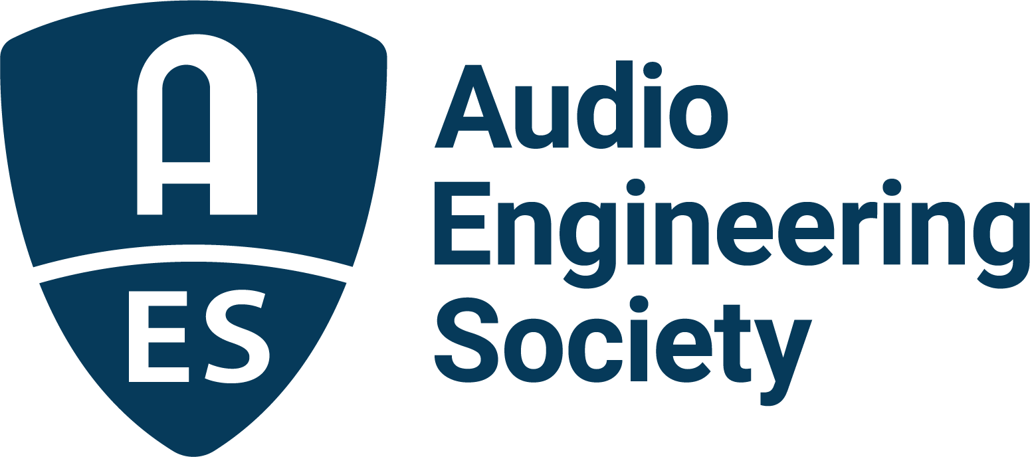

FOR IMMEDIATE RELEASE

Audio Engineering Society addresses easier to understand dialogue

New York, NY, January 6, 2026 — Audience complaints have increased as TV soundtracks evolved from the intelligible speech of the analog era to the cinematic-style wide dynamic range digital multichannel productions of today. Addressing this omnipresent issue, the AES Technical Committee for Broadcast and Online Delivery has published the comprehensive Technical Document (TD1009), “Improving Dialogue Intelligibility in Media,” which diagnoses the intelligibility problem and presents solutions.

“Dialogue intelligibility affects today’s audiences,” said Jim Starzynski, NBCUniversal Director and Principal Audio Engineer and Chair of the working group. “Increased reliance on captions has become apparent and indicates a problem. This study reveals why audiences can struggle to understand their favorite shows and offers in-depth solutions.”

Sound for picture delivered through broadcast and streaming is the primary focus of TD1009. Solutions also apply to audio-only media. Important takeaways from the study include detailing the Dialogue Intelligibility Ecosystem – dialogue’s journey from acquisition to the ear of the consumer and the application of how humans understand and interpret dialogue. Solutions presented include fostering a culture of dialogue intelligibility in the post-production process; addressing the limitations of TV sets, set top boxes and audio/video receivers; and identifying what can go wrong in distribution.

Production insiders and subject matter experts have collaborated for over two years in the development of TD1009 to guide creative professionals, content distributors, device manufacturers and consumer enthusiasts. The guide was created under the leadership of the AES Technical Committee for Broadcast and Online Delivery (TC-BOD), an international group that addresses audio quality chaired by David Bialik, Kimio Hamasaki, Matthieu Parmentier and Jim Starzynski.

The publication of TD1009 follows its initial public presentation at the AES Show 2025 – Long Beach Convention, during the session “Improving Dialogue Intelligibility in Media: A Report from the AES Broadcast and Online Delivery Technical Committee.” “With AES TD1009 now publicly released,” notes Rafael Kassier, who co-chairs the AES Technical Council with Lesley Fogle, “we encourage broadcasters, streaming platforms, content creators and audio engineers worldwide to explore and apply its recommendations to enhance speech clarity and overall listener experience.”

This paper is distributed openly by the Audio Engineering Society and may be viewed/downloaded at https://aes.org/community/technical-council/aestd1009/. The TC-BOD can be contacted by email at broadcast@AES.org.

Photo File 1: TD1009_AESShowLongBeach.JPG
Photo Caption 1: Members of the AES Broadcast and Online Delivery Technical Committee – Robert Bleidt, Richard Friedel, Scott Norcross and Scott Kramer (left to right) – made the initial public presentation of the Technical Document (TD1009), “Improving Dialogue Intelligibility in Media,” during AES Show 2025 – Long Beach in October.

About the Audio Engineering Society
For more than 75 years, the Audio Engineering Society has served as the pivotal force in fostering the advancement in audio technologies and application and the dissemination of technical information for the audio community. Its members are affiliated with 90 AES professional sections and more than 120 AES student sections around the world where activities include guest speakers, technical tours, demonstrations, online events and social functions. Through Conventions, Conferences, Training and Development events and peer-reviewed publications, as well as the Society’s vast online technical documents, Standards and video resources, members experience valuable opportunities for professional networking and personal growth. For additional information, visit AES.org.

Join the conversation and keep up with the latest AES News and Events:
X: #AESorg (AES Official)
Facebook: facebook.com/AES.org
LinkedIn: https://www.linkedin.com/company/audio-engineering-society
Instagram: https://www.instagram.com/aes_org/

AES Marketing Communications:
Email: robert@clynemedia.com
Tel: 615-300-4666
Clyne Media, Inc.,
169-B Belle Forest Circle, Nashville, TN 37221;
Web: http://www.clynemedia.com

