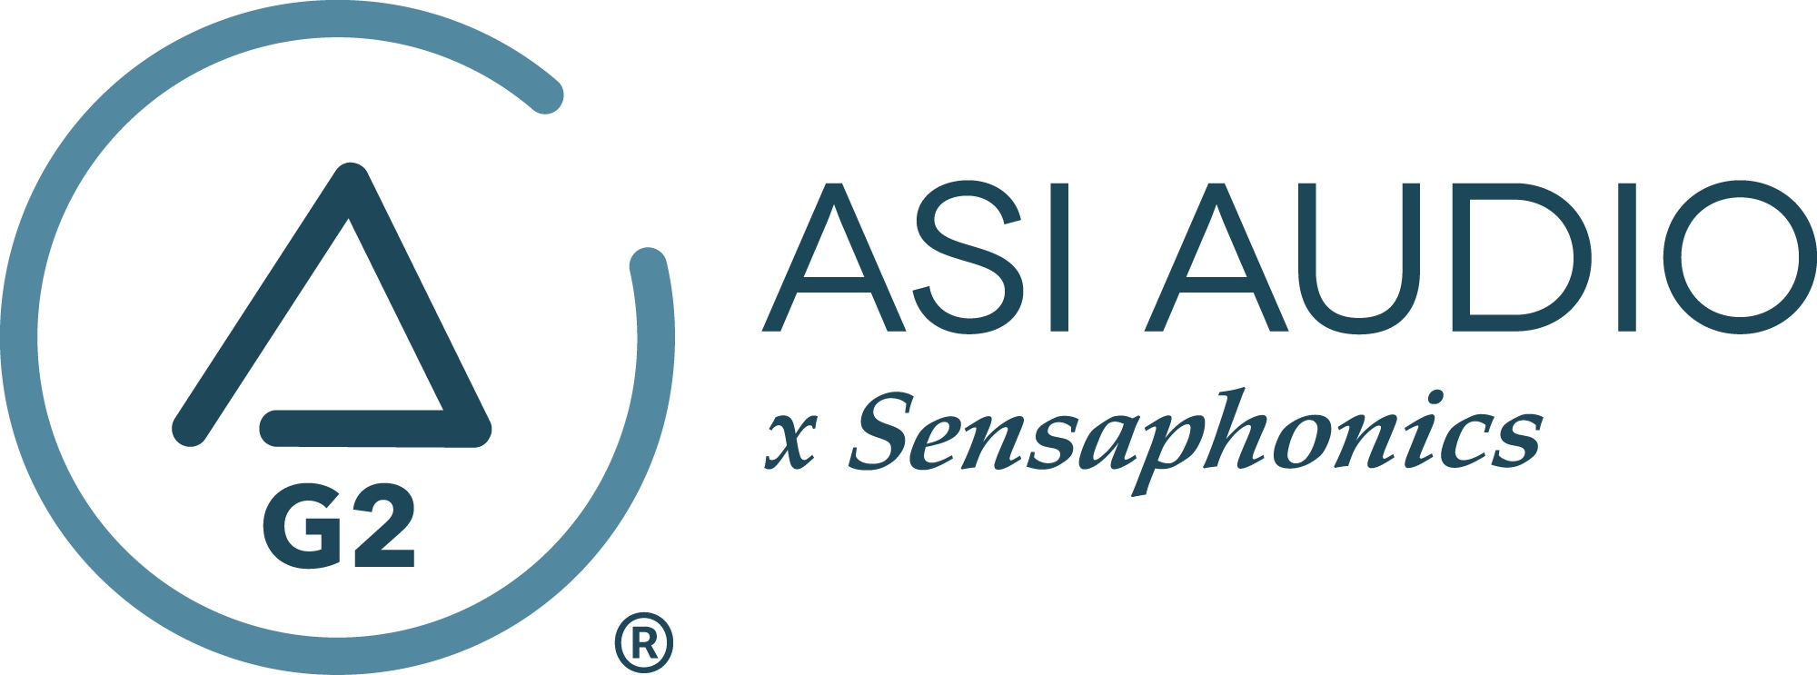 FOR IMMEDIATE RELEASE

ASI Audio offers Black Friday special on its 3DME Gen2 Active Ambient IEM System

— $100 off plus free shipping on the standard 3DME package; offer applies to any new orders placed between now and December 9, 2022 —

Beachwood, OH, November 21, 2022 — Black Friday is approaching on November 25, and ASI Audio is offering an exclusive deal on its 3DME Gen2 Active Ambient IEM System. Orders placed now through December 9, 2022, will be eligible for $100 off the normal pricing plus free shipping (within the U.S.) on the standard 3DME package.

The ASI Audio 3DME system is being increasingly adopted by a wide range of musicians and audio professionals across the industry for its flexibility and high level of control that it offers the user. Prominent users include Danny Seraphine (original drummer and a co-founder of Chicago); Little Caesar frontman Ron Young, bassist Pharoah Barrett and drummer Tom Morris; GRAMMY®-nominated bassist Felton Crews; jungle/drum-and-bass artist Spinscott; bassist Whynot Jansfeld (Wallflowers, Butch Walker); singer-songwriter Marc Lee Shannon; and rock vocalist Mitch Malloy.

About the ASI Audio x Sensaphonics 3DME Gen2 Active Ambient Monitoring System
The 3DME Music Enhancement IEM System Gen2 consists of Active Ambient earphones with embedded binaural MEMS ambient microphones, a bodypack mixer/controller/DSP processor/headphone amplifier and the Bluetooth-enabled ASI Audio App for control. The free ASI Audio App allows untethered adjustment of the system’s 7-band stereo EQ and limiter threshold. The App also offers an Audio Seal Test to confirm perfect IEM fit and allows the saving and recall of User Presets to ensure repeat access to preferred sound signatures. In operation, after locking in the preferred EQ and limiter settings, up/down switches on the bodypack make it easy to add the perfect amount of ambience to the monitor mix, so the performer can hear exactly what they want, no matter the style of music or type of venue. When used without a monitor mix, 3DME functions as variable-level, high fidelity earplugs. The universal-fit earphones supplied with 3DME can be converted to custom fit with silicone sleeves from Sensaphonics or upgraded to Custom Pro earpieces.

To learn more, visit https://asiaudio.com/.
…ends 305 words

Photo file 1: ASIAudio_Black_Friday.JPG
Photo caption 1: Orders placed between now and December 9, 2022, will be eligible for $100 off the normal pricing plus free shipping in the U.S. on the standard 3DME package.

Photo file 2: ASIAudio_3DME-Gen2_Main.JPG
Photo caption 2: ASI Audio x Sensaphonics 3DME Gen2 Active Ambient Monitoring System

Press contact:
Clyne Media, Inc.
Frank Wells, Senior Account Manager
615.585.0597
frank.wells@clynemedia.com

ASI Audio contact:
Evan MacKenzie, Vice President, Marketing and Sales
216.970.4468 ext.104
evanmackenzie@asiaudio.com

ABOUT ASI AUDIO
Founded in 2019 by the team of hearing health advocate Dr. Michael Santucci Au.D. of Sensaphonics and Think-A-Move, Ltd. (developers of innovative speech recognition products for high-volume environments), ASI Audio x Sensaphonics has combined patented technologies and market insights to create 3DME Music Enhancement, a fundamentally different approach to in-ear monitoring and hearing protection. 3DME combines Active Ambient technology and personalized sound quality via the intuitive ASI Audio app, creating a system equally useful for amplified and acoustic monitoring for musicians and concertgoers alike. Web: www.ASIaudio.com.

