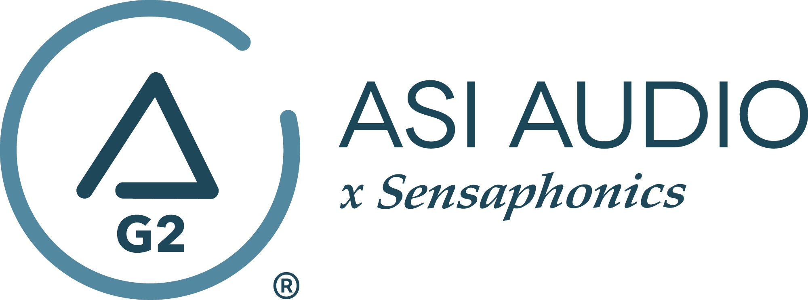 FOR IMMEDIATE RELEASE

Acclaimed rock vocalist Mitch Malloy finds new inspiration in the studio with the ASI Audio x Sensaphonics 3DME Music Enhancement IEM System

— “I don’t ever want to make a record without it moving forward. It’s basically essential to me at this point,” Malloy remarks.—

Beachwood, OH, November 15, 2022 — Mitch Malloy is one of rock’s great journeymen. An acclaimed solo artist, songwriter and producer since the early 90s, a longtime associate of Van Halen and the lead singer for iconic rock band Great White until earlier this year, Malloy has led a career that checks all the boxes for success resulting from talent and lots of hard work. One element of Mitch’s undeniable vocal prowess and stage presence is his personalized stage monitoring setup, which has evolved from his early adoption of in-ear monitors (IEM) to a finely honed signal flow involving the ASI Audio x Sensaphonics 3DME Gen2 Active Ambient Monitoring System as his IEMs of choice these days.

But as he retreated to the recording studio after a series of live dates, he felt limited by the monitoring offered by conventional “can”-type studio headphones, and he had the idea to apply his 3DME system to his studio work. The 3DME Music Enhancement IEM System Gen2 consists of Active Ambient earbuds with embedded binaural MEMS ambient microphones, a bodypack mixer/controller/DSP processor/headphone amplifier and the Bluetooth-enabled ASI Audio App for control. The system allows the user a very high, precise level of control over the balance of the mix elements and the room ambience – effectively creating a “best of both worlds” approach to monitoring via audio track elements and natural room sound. The results were a revelation to Malloy, and he feels he has uncovered new modes of expression and precision as a vocalist – impressive for such an acclaimed singer whose career has stretched decades.

“The natural mode for a singer is usually in a room with an acoustic guitar, no amplification, like when you first started singing as a kid,” Malloy notes. “Every monitoring solution, whether you’re on stage with a full band or in the studio, tries to solve the problem of recreating that feel for the singer of really being able to hear your own voice, alone in a room. Some solutions are better than others, but they almost all fall short. There is an unnatural, sterile quality to wearing cans, to the point where most of us end up sliding one cup off the ear so we can hear some of the room too. It’s just not ideal, and the performance can suffer because of it, with intonation, expression and phrasing trying to overcome the unnaturalness of it all. But now, with the 3DME, I’ve truly uncovered a radical solution for this issue, and what has resulted are some of my very finest vocal performances. This is basically what I’ve always wanted, in terms of a studio monitoring solution.”

Malloy is in the midst of self-producing his next solo album, which is entirely a one-man show, with Malloy performing all the instrument and vocal parts and writing the material. “I’ve been using the ASI 3DME system on every song. I don’t ever want to make a record without it moving forward. It’s basically essential to me at this point. Getting a great studio vocal is all about inspiration, and the vibe has to be right, and the vocal has to be prominent enough to lift over the track when you’re performing. Because of the high level of control the 3DME system gives the user, I get to make all of that happen, and I feel inspired in the studio in a way that is a real blessing. It’s relaxed, natural, and organic. My pitch is better than ever, and I’m tracking some real confident, nuanced performances. It’s made me a better performer on stage, and now it’s made me a better singer in the studio. What a gift! This thing is a real treasure.”

About the ASI Audio x Sensaphonics 3DME Gen2 Active Ambient Monitoring System
The 3DME Music Enhancement IEM System Gen2 consists of Active Ambient earphones with embedded binaural MEMS ambient microphones, a bodypack mixer/controller/DSP processor/headphone amplifier and the Bluetooth-enabled ASI Audio App for control. The free ASI Audio App allows untethered adjustment of the system’s 7-band stereo EQ and limiter threshold. The App also offers an Audio Seal Test to confirm perfect IEM fit and allows the saving and recall of User Presets to ensure repeat access to preferred sound signatures. In operation, after locking in the preferred EQ and limiter settings, up/down switches on the bodypack make it easy to add the perfect amount of ambience to the monitor mix, so the performer can hear exactly what they want, no matter the style of music or type of venue. When used without a monitor mix, 3DME functions as variable-level, high fidelity earplugs. The universal-fit earphones supplied with 3DME can be converted to custom fit with silicone sleeves from Sensaphonics or upgraded to Custom Pro earpieces.

To learn more, visit https://asiaudio.com/ and https://mitchmalloy.com/.
…ends 791 words

Photo file 1: ASIAudio_MitchMalloy_Photo1.JPG
Photo caption 1: Mitch Malloy, shown in the studio recording vocals using his ASI Audio x Sensaphonics 3DME Gen2 Active Ambient Monitoring System and the free ASI Audio App

Photo file 2: ASIAudio_MitchMalloy_Photo2.JPG
Photo caption 2: Mitch Malloy, shown in the studio using his ASI Audio x Sensaphonics 3DME Gen2 Active Ambient Monitoring System and the free ASI Audio App

Press contact:
Clyne Media, Inc.
Frank Wells, Senior Account Manager
615.585.0597
frank.wells@clynemedia.com

ASI Audio contact:
Evan MacKenzie, Vice President, Marketing and Sales
216.970.4468 ext.104
evanmackenzie@asiaudio.com

ABOUT ASI AUDIO
Founded in 2019 by the team of hearing health advocate Dr. Michael Santucci Au.D. of Sensaphonics and Think-A-Move, Ltd. (developers of innovative speech recognition products for high-volume environments), ASI Audio x Sensaphonics has combined patented technologies and market insights to create 3DME Music Enhancement, a fundamentally different approach to in-ear monitoring and hearing protection. 3DME combines Active Ambient technology and personalized sound quality via the intuitive ASI Audio app, creating a system equally useful for amplified and acoustic monitoring for musicians and concertgoers alike. Web: www.ASIaudio.com.

