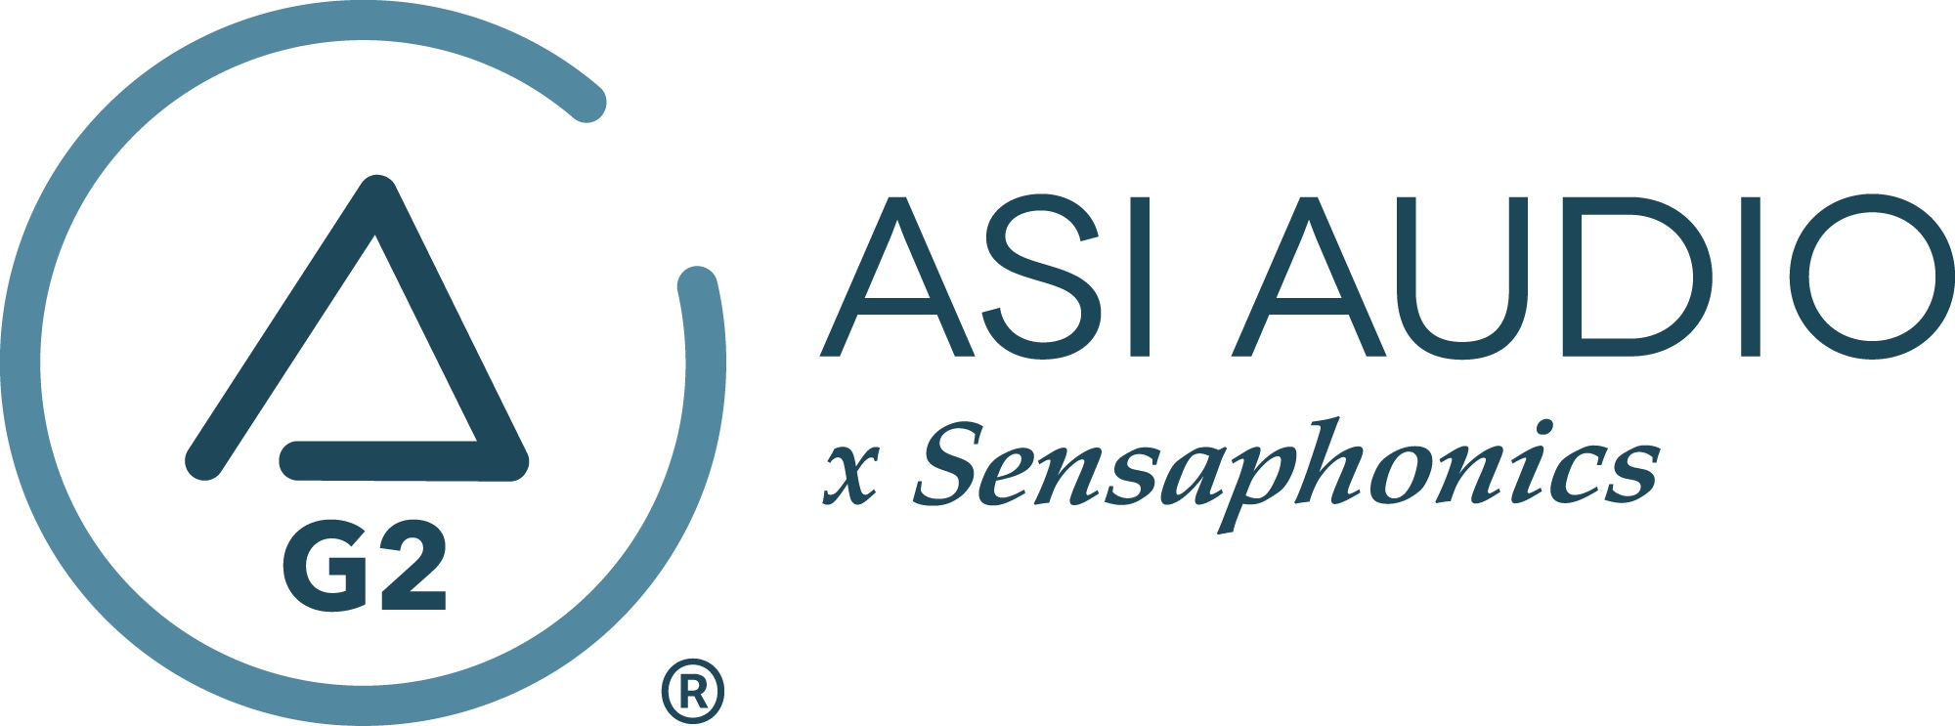 FOR IMMEDIATE RELEASE

Little Caesar bassist Pharoah Barrett chooses ASI Audio x Sensaphonics 3DME Music Enhancement IEM System

— Bassist Pharoah Barrett joins frontman Ron Young and drummer Tom Morris as hard rockers Little Caesar standardize their personal monitors with ASI’s 3DME Gen2 Active Ambient Monitoring System —

Beachwood, OH, September 12, 2022 — Currently on tour in Europe with upcoming shows in Germany, France, Austria, Spain and the Netherlands, Little Caesar bassist Pharoah Barrett is using the ASI Audio x Sensaphonics 3DME Gen2 Active Ambient Monitoring System on tour. Barrett joins Little Caesar frontman Ron Young and drummer Tom Morris, who together have standardized the band’s personal monitors with the ASI Audio system.

Ron Young has been traveling with his own wireless in-ear system since the earliest components first became commercially available. He began his relationship with ASI Audio parent company Sensaphonics over 10 years ago. “They were the only manufacturer that was doing soft silicone molded earbuds,” Young remarks. “I found that the isolation and the seal, combined with their armatures and drivers, gave me the best product. I learned very quickly, especially when you play in a hard rock band, that earbuds serve two functions. Besides monitoring, they also provide ear protection by isolation.”

At the urging of Young, bassist Pharoah Barrett started using the ASI 3DME system. “Ron turned me on to the 3DME system, and I loved the fact that I could dial in my own mix including adding ambience. I just run vocals through it – his vocal and mine. My vocals are slightly louder than his. And with the 3DME setup, I can add the ambience wherever I want it,” stated Barrett. “If you are playing live and you can’t hear the room or if you have in-ears and the room is totally muffled, that is really annoying. And that’s why people, a lot of the time, don’t wear hearing protection: because it sounds like you’re underwater. But with these ASI personal monitors, you can hear exactly what you want by dialing it in through your in-ear setup. And then after that is dialed in, you can bring the room up and hear those ambient sounds – hear what’s coming off the stage – and not be destroying your ears, which is obviously huge. For a smaller room, obviously, I wouldn’t need quite as much ambient sound because it’ll just be too much. But the ability to adjust the ambience really works great on large stages where I’ll actually turn them up a little bit. With other systems I’ve tried, if I couldn’t hear the ambient sounds on stage, I would basically pop out one of my in-ears, which honestly was not great, but it did the job. But now with the 3DME, it’s totally cool. I have the ambience all around me whenever I want it. So it’s easier to deal with, and I don’t have my left in-ear flopping around over my shoulder the whole show.”

In addition to high-quality monitoring, Barrett notes how important hearing protection has been throughout his career. “Starting with my very first tour back in the 90s, I always had ear protection of some sort. I remember at the time it was about $120.00 to get molded earplugs that I think gave me a 15 decibel reduction, which isn’t a lot nowadays, but at least it was something,” stated Barrett. “Hearing protection is monumentally important to me as it is my connection to my art. With this ASI setup, you’re not getting all that volume – especially the cymbals just ripping through your eardrums, which does a lot of damage. I’ve got drummer buddies that have had significant hearing loss, all because they’ve always used ‘cheese ball’ setups for hearing protection or none at all, which is even worse. This ASI system works, is simple to use and is a real value for what you get. Again, to be able to hear the room is a real plus, and not having to take out an ear plug to hear what is going on is huge.”

The 3DME Music Enhancement IEM System Gen2 consists of Active Ambient earphones with embedded binaural MEMS ambient microphones, a bodypack mixer/controller/DSP processor/headphone amplifier and the Bluetooth-enabled ASI Audio App for control. The free ASI Audio App allows untethered adjustment of the system’s 7-band stereo EQ and limiter threshold. The App also offers an Audio Seal Test to confirm perfect IEM fit and allows the saving and recall of User Presets to ensure repeat access to preferred sound signatures. In operation, after locking in the saved EQ and limiter settings, up/down switches on the bodypack make it easy to add the perfect amount of ambience to the monitor mix, so the performer can hear exactly what they want, no matter the style of music or type of venue. When used without a monitor mix, 3DME functions as variable-level, high fidelity earplugs. The universal-fit earphones supplied with 3DME can be converted to custom fit with silicone sleeves from Sensaphonics or upgraded to Custom Pro earpieces.

More Information: asiaudio.com

…ends 784 words

Photo file 1: PharoahBarrett_Photo1.JPG
Photo caption 1: Little Caesar bassist Pharoah Barrett, performing using the ASI 3DME Gen2 Active Ambient Monitoring System. (Photo credit: Janee Cicero)

Photo file 2: PharoahBarrett_Photo2.JPG
Photo caption 2: Little Caesar bassist Pharoah Barrett, performing using the ASI 3DME Gen2 Active Ambient Monitoring System. (Photo credit: Music Matters Media Productions, LLC)

Photo file 3: PharoahBarrett_Photo3.JPG.JPG
Photo caption 3: Little Caesar bassist Pharoah Barrett, performing using the ASI 3DME Gen2 Active Ambient Monitoring System. (Photo credit: Trees Rommelaere)

Press contact:
Clyne Media, Inc.
Frank Wells, Senior Account Manager
615.585.0597
frank.wells@clynemedia.com

ASI Audio contact:
Evan MacKenzie, Vice President, Marketing and Sales
216.970.4468 ext.104
evanmackenzie@asiaudio.com

ABOUT ASI AUDIO
Founded in 2019 by the team of hearing health advocate Dr. Michael Santucci Au.D. of Sensaphonics and Think-A-Move, Ltd. (developers of innovative speech recognition products for high-volume environments), ASI Audio x Sensaphonics has combined patented technologies and market insights to create 3DME Music Enhancement, a fundamentally different approach to in-ear monitoring and hearing protection. 3DME combines Active Ambient technology and personalized sound quality via the intuitive ASI Audio app, creating a system equally useful for amplified and acoustic monitoring for musicians and concertgoers alike. Web: www.ASIaudio.com.

