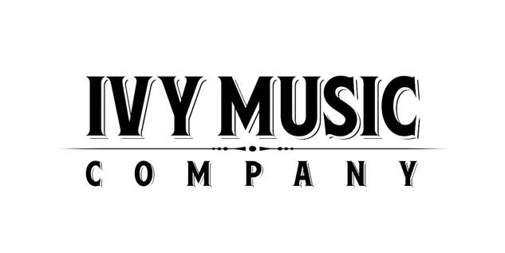
Albert Cummings’ New Video “Meet The Man” on CMT Edge this week!

– New album TEN out now –

– Second leg of tour begins May 25 in Knoxville, TN –

May 23, 2022 – Albert Cummings’ new video “Meet The Man” makes its CMT Edge debut this week. “Meet The Man” is one of the standout tracks from his new album TEN and has also been added to The CMT Edge Spotify playlist.

The video features Cummings by himself, performing the song in front of a somber backdrop, fitting the track’s emotional lyrics. “Meet The Man” sets a solemn tone, framed as a farewell from someone facing their mortality. “It is a song that has deep personal meaning to me,” notes Cummings, “but I think it’s universal and an inspirational song too, and I hope people take it that way.”

WATCH THE VIDEO

Cummings’ new album TEN hit the Billboard Charts in its first week, debuting at #2 on its Blues Chart and marking his sixth Top 5 release. The impressive new album reigned at #1 on the iTunes Blues Chart and splashed across genres, debuting at #20 on the Americana/Folk Album Chart and a slew of other charts: #23 Top New Artist, #63 Record Label Independent Current Albums, #93 Current Digital Albums.

TEN is available now on CD and all digital platforms. Produced by GRAMMY®-winner Chuck Ainlay and recorded in Nashville at Peter Frampton’s Phenix Studios, TEN presents an expansive sound venturing into rock, country, soul, blues and Americana, while his songs range from wall-ratting tunes to soft ballads, with his rugged, world-wise vocals hitting all the right moods. With thirteen original songs, TEN spotlights Cummings’ musical diversity and expressive songwriting. TEN features a guest appearance by country superstar Vince Gill on the track “Last Call”.

“Need Somebody,” the first single, continues to gain momentum across the board with increasing radio airplay nationwide, including Sirius XM’s BB King’s Bluesville and iHeartRadio’s Out of the Box. Watch the “Need Somebody” video HERE.

Praise for TEN:

“The album features 13 musically diverse tracks with Cummings at home with the countryside of blues. With Ten, it’s not so much the blending of genres that speaks the loudest but it’s the songs themselves...well-crafted with compelling melodies and a focus on storytelling.” – Rockandbluesmuse.com

“With over two decades’ worth of solo releases under his belt, his recorded body of work catalogs a guitarist that has gone from strength to strength. Renowned for his raw, off-the-cuff stage performances, what you see really is what you get with this maestro.” – Guitar Player Magazine

“...this is a special album. It’s strong songs and thoughtful guitar that transcends genre. Cummings sounds locked in and he seems to know it.” – Blues Rock Review

“He really soars on this record. Let’s call it genre-fluid, since Albert mixes it up a bit. But that guitar and those heartfelt vocals still shine through. Even better, his songwriting dazzles.” – Allthewayblue.com

"There are lots of good reasons why the blues gets associated with crossroads. Blues intersects with nearly every form of American popular music: jazz, gospel, country, rock, even mainstream pop. And standing at that crossroads is the one and only Albert Cummings, master of sound and extraordinary soloist. Cummings knows country and gospel, and he certainly rocks. But every note he plays is rooted in the blues. With every song, he reminds us, all over again, of the essentials." – Music Existence

Cummings kicks off the second leg of his North American tour this week in Knoxville, TN, followed by a string of dates through November in cities including Nashville, TN; Huntsville, AL; Atlanta, GA; Charlotte, NC; Chicago, IL, Cape Cod, MA; Quebec, Canada; and more.

Tour Dates 2022
May 25 – Open Chord Music – Knoxville, TN
May 26 – City Winery Nashville – Nashville, TN
May 27 – Sidetracks Music Hall – Huntsville, AL
May 28 – Downtown Brilliant – Brilliant, AL
May 29 – The Spinning Jenny – Greer, SC
May 31 – Eddie’s Attic - Decatur, GA
June 1 – Isis Music Hall – Asheville, NC
Jun 2 – US National Whitewater Center – Charlotte, NC
Jun 3 – Blue Note Grill – Durham, NC
Jun 4 – Flat Iron Crossroads – Gloucester, VA
Jun 16 – Tally Ho Theatre – Leesburg, VA
Jun 17 – Mauch Chunk Opera House – Jim Thorpe, PA
Jul 13 – Shepard Park – Lake George, NY
Jul 14 – Bousquet Mountain Summer Concert Series – Pittsfield, MA
July 15 – Bandshell Concert Series – Reading, PA
Jul 29 – Head of Falls and Riverwalk – Waterville, ME
Jul 30 – The Music Room – West Yarmouth, MA
Aug 7 – Donnacona Park – Quebec, QC (Canada)
Aug 27 – Market Square – Kingston, ON (Canada)
Sep 7 – SPACE – Evanston, IL
Sep 10 – Riverside Park Band Shell – Murphysboro, IL
Sep 14 – Dosey Doe Big Barn – The Woodlands, TX
Sep 30 – Thrasher Opera House – Green Lake, WI
Oct 1 – Franke Center – Marshall, MI
Nov 11 – Colonial Theatre – Laconia, NH

Visit Albert Cummings on social media:
Facebook Instagram Twitter

Photo file 1: AlbertCummings_MeetTheMan.JPG
Photo caption 1: A still from the music video for “Meet The Man” by Albert Cummings

Photo file 1: AlbertCummings_Ten_COVER_3000pxls.JPG
Photo caption 1: Cover art for Albert Cummings’ album TEN. Photo credit: Nick Spanos

