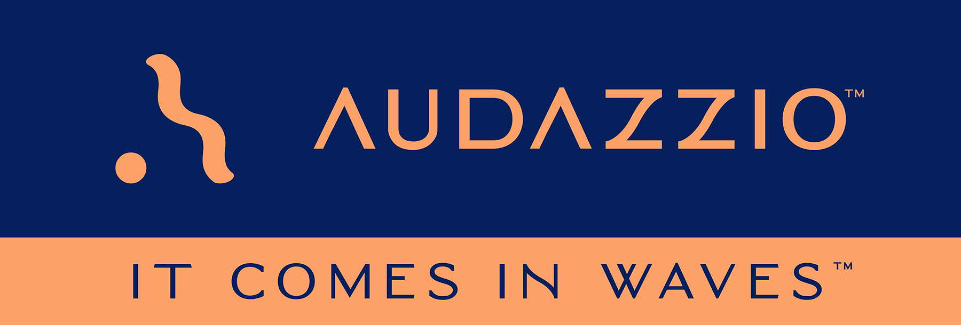

FOR IMMEDIATE RELEASE

Audazzio Announces Partnership with The Montag Group

Company engages The Montag Group, a Wasserman company and industry leader in talent and strategic advisory services within the sports media sector, to help drive adoption of Audazzio proprietary technologies across the live event and sports markets

Audazzio “Live QR™” technology leverages ultrasonic, data-encoded sound waves to instantly create valuable second-screen opportunities on viewer phones and tablets, with benefits for broadcasters, sponsors and consumers alike

San Antonio, TX (May 9, 2022): Following closely on the heels of closing a $1.4 million second round of funding, Audazzio, an innovative software startup and recent participant in Comcast NBCUniversal’s SportsTech Accelerator program, is pleased to announce it has retained the services of The Montag Group, the leading sports media talent representation firm whose clients include well-known U.S. sports broadcasters, sports executives and coaches. The announcement was made by Danny Abelson, Audazzio Chief Operating Officer, and further underscores the company’s ongoing strategic business plan as it continues the rollout of its proprietary “Live QR™” technology, which leverages ultrasonic, data-encoded sound waves to instantly create valuable second-screen opportunities on viewer phones and tablets.

“We have hired The Montag Group to serve as business development consultants for Audazzio, for which The Montag Group is uniquely qualified, because of their experience helping technology companies pioneer solutions in the sports and entertainment markets, due primarily to Sandy Montag's remarkable relationships within our industry,” stated Danny Abelson. “Sandy, along with Matt Kauffman and their team, recognized Audazzio as a company that had a unique technological offering, and they believed that The Montag Group has the foundational understanding of how to deploy that technology in the industries they serve. After having the chance to meet them personally in Los Angeles, it became immediately obvious to me that Audazzio would meaningfully benefit from this relationship.”

Sandy Montag, President of The Montag Group, agreed, remarking that “since the inception of The Montag Group in 2015, we have prided ourselves on a strong track record of delivering unique value to our industry through the clients that we have chosen to represent. We are excited for the opportunity to partner with Audazzio, as they are well-positioned to provide meaningful solutions to fan engagement-related challenges that networks, leagues and teams are facing every day.”

Matt Kauffman, Vice President of TMG Consulting, a core vertical within The Montag Group dedicated to building and accelerating businesses, added, “As we’ve proven to be a valuable commercial growth partner across our roster of startup clients, the nature of this ecosystem requires us to apply a great deal of scrutiny to any nascent technology that we consider partnering with. In the case of Audazzio, we were impressed by the rock-solid foundation of engineering and operational expertise that they already have installed within their organization, and we believe their product to be ripe for acceleration across the sports and entertainment landscape.”

In much the same way that a QR code graphic provides a unique digital fingerprint for a variety of uses, the Audazzio Live QR™ algorithm encodes data as sound that is inaudible to the human ear but perfectly discernable by mobile devices – opening the door to a whole world of applications for savvy broadcasters, sponsors and beyond. Audazzio provides clients with tools to facilitate focused messaging directly to fans in real time, either at home or in a stadium or arena. And crucially, it provides clients the ability to understand exactly who is engaged with a game or event, creating proximity marketing opportunities previously unavailable to sponsors and broadcasters. Sports broadcast and in-person event experiences are obvious areas of application for this technology; however, this only scratches the surface of the potential of these technologies, with active workshopping underway for uses far beyond sports and telecast.

For more information on Audazzio, please visit www.audazzio.com.
For a video primer on Audazzio Live QR™ technology, visit www.audazzio.com/explainer.

Photo file: Audazzio_SecondScreen.JPG
Photo caption: Audazzio Live QR™ technology leverages ultrasonic, data-encoded sound waves to instantly create valuable second-screen opportunities on viewer phones and tablets.

FOR MORE INFORMATION PLEASE CONTACT:
Robert Clyne | Clyne Media, Inc. | 615.662.1616 | robert@clynemedia.com
Michele Klumb | Audazzio | Vice President of Marketing | 855.697.6627 | michele@audazzio.com
Matt Kauffman | The Montag Group | 650.504.6511 | Matt@themontaggroup.com

About The Montag Group
The Montag Group is a premier talent management, strategic consulting, content development and media strategy agency positioned in the epicenter of sports, entertainment and lifestyle. A core vertical within The Montag Group, TMG Consulting, is a team of thought leaders dedicated to building and accelerating businesses – operating as a dynamic think tank, supported by vast experience, connections and insights to guide leading brands, leagues, teams, media entities and emerging technologies. In 2021, The Montag Group was acquired by Wasserman.

About Audazzio
Audazzio is an innovative media company that was a recent participant in the Comcast NBCUniversal’s SportsTech Accelerator program. Based in San Antonio, TX, Audazzio delivers groundbreaking technologies that enable broadcasters and event producers to seamlessly change the content on a fan’s mobile device, in real time, fully coordinated with their broadcast or event. In much the same way that a QR code graphic provides a unique digital fingerprint for a variety of uses, the Audazzio Live QR™ algorithm encodes data as high-frequency sound that is inaudible to the human ear, but perfectly discernable by mobile devices. By leveraging Live QR™ technology, marketers have access to an entirely new channel to reach consumers’ mobile devices, at critical moments in an event or broadcast, when they crave more information and storytelling. Audazzio can deliver any web page, at any time, to any device within range of the Live QR™ signaling, while giving clients access to the information on exactly who is engaged with a game or event – opening the door to a whole new world of applications for savvy broadcasters, sponsors and beyond.

